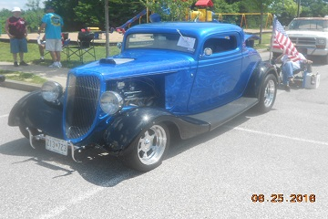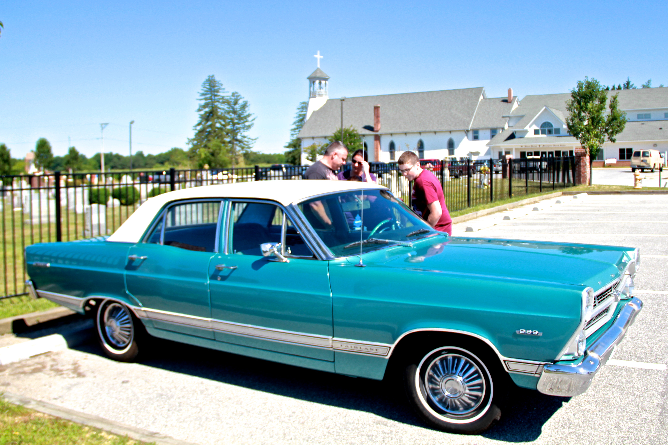  St. John’s Summer Classic Car Show  Rain Date: November 6th  Show Hours 8am-3pm-Registration until Noon  $20.00 Registration at gate/$15.00 Early Registration – Make Checks payable to Knights of Columbus and mail to Bill Cameron,23980 Rustic Way ,Hollywood, MD 20636 ( Must be received by Sept. 17 2021 )Spectator Fee $3.00 each/Children under 12 Free  Event is Peer Judged  OPEN TO ALL YEARS AND MAKES  For more information call: Bill Cameron 240-434-1647  For more info call: Bill Cameron 240-434-1647  Name____________ Club _______________  Address__________ Make______________  City_____________ Model______________  Zip_____________ Year_______________  Phone#__________ Email_______________  Liability: In acceptance of the right to participate. I hear by release St. John Francis Regis Parish/ Church /School and everyone connected with management or presentation from any and all known and unknown liabilities that may be suffered by my party (myself, my property, and those persons accompanying me to this event.)I further will ensure that my party will observe and obey all safety and traffic regulations, fire ordinances, and will maintain conduct befitting a representative of the Street Rodding/Classic Car Sport. I am aware that said management will do all in its power to safeguard the persons and property involved in this event and cooperate with participants /spectators to ensure a successful event.  Signature:_______________________________________ | OCT 30, 2021  * Trophies to Top 20  * Best in Show  * Grand Knights Choice  No Alcohol / No Burnouts  St. Johns Church  43950 St. Johns Rd.  Hollywood, MD.  20636  ────  One More Point Here!  ────  Add More Great Info Here!  ────  You Have Room for Another One Here!  Company Name  Street Address  City, ST ZIP Code  Telephone  Web Address  Dates and Times

Name______________________________ Club______________________________________

Address____________________________ City___________________________ Zip________

Phone_____________________________ E-mail_____________________________________

Make_____________________ Model _________________________ Year________________

Liability: In acceptance of the right to participate, I hear by release St. John Francis Regis Parish/Church/School and everyone connected with management or presentation from
any and all known and unknown liabilities that may be suffered by my party ( myself, my property, and those persons accompanying me to this event. ) I further will ensure that my party will observe and obey all safety and traffic regulations, fire ordinances and will maintain conduct befitting a representative of the Street Rodding/Classic Car Sport. I am aware that said management will do all in its power to safeguard the persons and property involved in this event and cooperate with participants/spectators to ensure a successful event.

Signature______________________________________________

