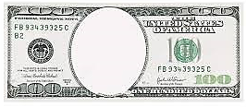
Continentals
Bank
War
Tariff
Of
abominations
American
System
Hamilton’s
plan
Mercantilism

