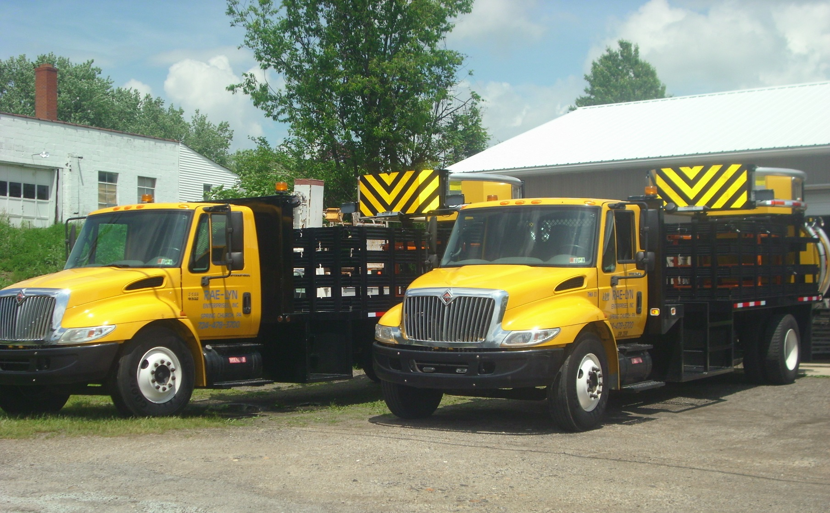
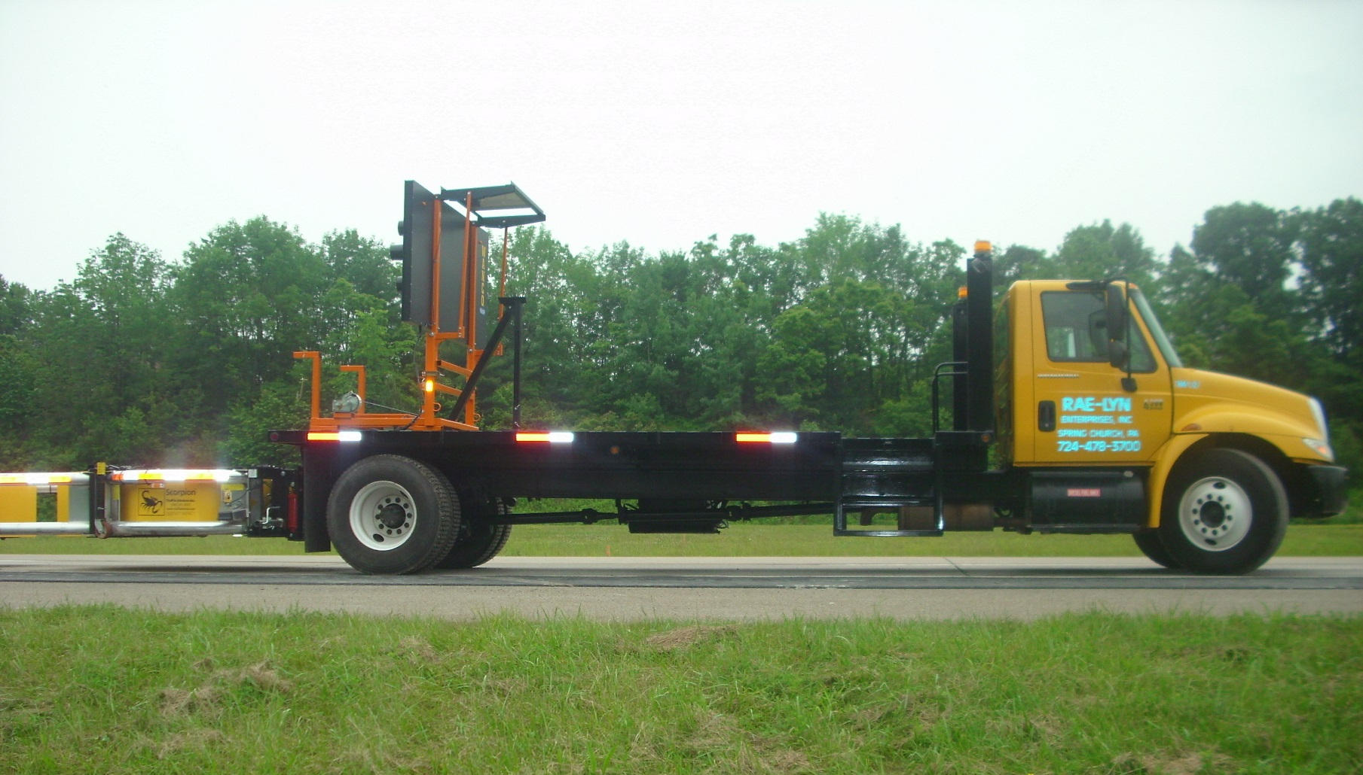
Truck Mounted Attenuators are now required if you are working on a road with a speed limit of 45 mph or greater.

