Edgewater Park Elks 2550
VETERANS DINNER
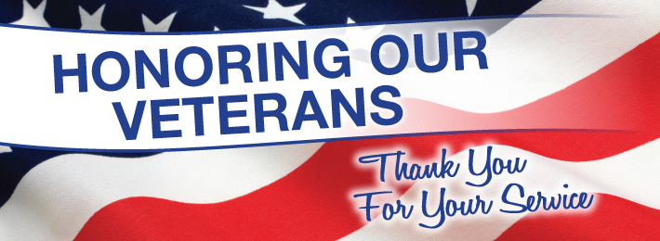
FREE TO ALL VETERANS
$10.00 GUESTS
DATE: NOVEMBER 18TH, 2016
TIME 5:00PM – 8:00PM
315 GREEN ST.
EDGEWATER PARK, NJ 08010
(Across from Beverly National Cemetery)

FOR MORE INFORMATION PLEASE CONTACT
ELKS LODGE (609) 871-3231
OR
BOBBI HOROWITZ RIGG AT (609) 871-0547 OR (609) 206-6401

