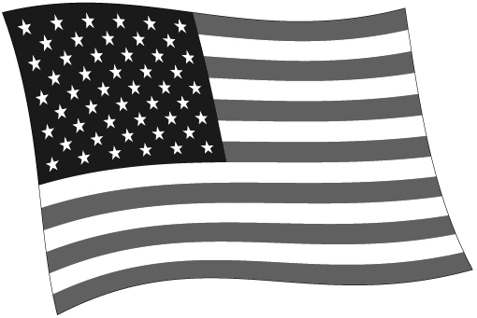
PRESIDENTS

President | Party | Term | Significant Conflict/Crisis? | Significant Accomplishment
George Washington |  | 1789-1797
John Adams |  | 1797-1801
Thomas Jefferson |  | 1801-1809
James Madison |  | 1809-1817
James Monroe |  | 1817-1825
John Quincy Adams |  | 1825-1829
Andrew Jackson |  | 1829-1836
Martin Van Buren |  | 1837-1841
William Henry Harrison |  | 1841
John Tyler |  | 1841-1845
James K. Polk |  | 1845-1849
Zachary Taylor |  | 1849-1850
Millard Fillmore |  | 1850-1853
Franklin Pierce |  | 1853-1857
James Buchanan |  | 1857-1861
Abraham Lincoln |  | 1861-1865
 |  | 1865
Andrew Johnson |  | 1865-1869
Ulysses S. Grant |  | 1869-1873
 |  | 1873-1877
Rutherford B. Hayes |  | 1877-1881
James A. Garfield |  | 1881
Chester A. Arthur |  | 1881-1885
Grover Cleveland |  | 1885-1889
Benjamin Harrison |  | 1889-1893
Grover Cleveland |  | 1893-1897
William McKinley |  | 1897-1901
Theodore Roosevelt |  | 1901-1905
 |  | 1905-1909
William Howard Taft |  | 1909-1912
Woodrow Wilson |  | 1913-1917
Woodrow Wilson |  | 1917-1921
Warren G. Harding |  | 1921-1923
Calvin Coolidge |  | 1923-1925
Herbert Hoover |  | 1929-1933
Franklin D. Roosevelt |  | 1933-1937
 |  | 1937-1941
 |  | 1941-1945
 |  | 1945
Harry S. Truman |  | 1945-1949
 |  | 1949-1953
Dwight D. Eisenhower |  | 1953-1961
John F. Kennedy |  | 1961-1963
Lyndon B. Johnson |  | 1963-1965
 |  | 1965-1969
Richard M. Nixon |  | 1969-1973
 |  | 1973
Gerald Ford |  | 1974-1977
Jimmy Carter |  | 1977-1981
Ronald Reagan |  | 1981-1985
 |  | 1985-1989
George H. Bush |  | 1989-1993
Bill Clinton |  | 1993-1997
 |  | 1997-2001
George W. Bush |  | 2001-2009
Barack Obama |  | 2009-2016

