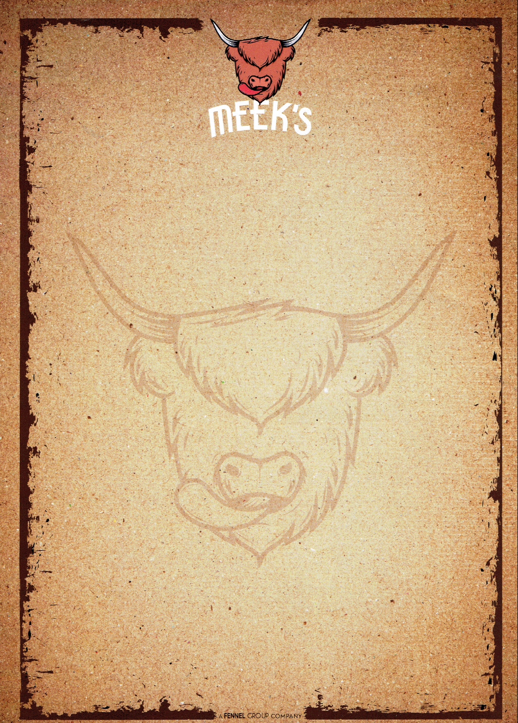

BBQ MENU

Welcome to your summer! – Our fully catered BBQ menus below will give you a no hassle experience as our skilled team provide a locally sourced, beautifully seasoned feast for your event.
The package includes all equipment, set up, service, professional BBQ equipment and that delicious food you’ve come to expect from The Fennel Group.

MEEKS BBQ & GRILL
CLASSIC MENU
(£20 per person) for 40+ guests
Classic 4oz beef burger in brioche bun
Bratwurst hot dog
Peri Peri chicken kebab
Vegetarian burger (falafel & spinach)
Loaded fries (Peri Peri, garlic & herb, beef chilli) (requires electric on site)

TOPPINGS AND SIDES
Pulled pork, chilli, coleslaw, dressed salad, fried onions, cheddar cheese
(Includes staff, set-up, disposables & sauces)

Staff, BBQ equipment, paper plates, gazebo, set up & clean down are all inclusive.

These menus provide 1 of each item per person (unless stated). We are happy to discuss varying these menus to suit and extra items can be added/swapped for a fully tailored experience.

Events / Festivals / Shows

Our professional team can cater BBQ and hog roast for any size of show, from food forums to music festivals – we have experience in many types of events such as Meldrum Sports & the Banchory Beer Festival. For details and prizes please contact us on 01467 67 00 65.

