Sea Turtle’s AUGUST 2024
SUNDAY |  |  | MONDAY | TUESDAY | WEDNESDAY | THURSDAY | FRIDAY | SATURDAY
 |  | 28 | 29 | 30 | 31 | 1 | 2 | 3
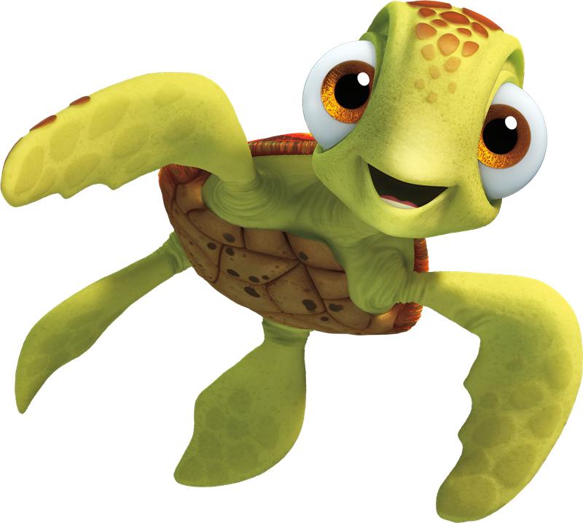  This Photo by Unknown Author is licensed under CC BY-NC |  |  |  |  |  | Sooke Pothole’s  Top | Mt Doug  Tinker Town
 | 4 |  | 5 | 6 | 7 | 8 | 9 | 10
 |  |  | Closed  BC Day | Glen lake Water Park | Royal Bay Beach  Crazy Hair Day | Langford Water Park | Esquimalt Lagoon
 | 11 |  | 12 | 13 | 14 | 15 | 16 | 17
 |  |  | Sooke Pothole’s Stairs | Bamberton Beach | Central Saanich Park | Shawnigan Lake | Esquimalt Water Park | 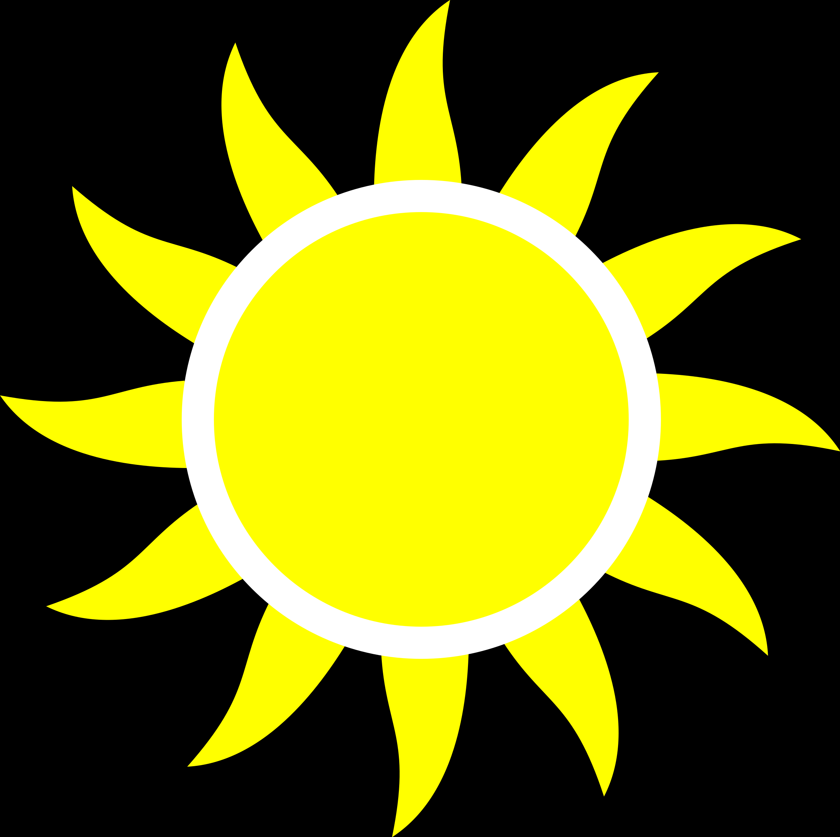
 | 18 |  | 19 | 20 | 21 | 22 | 23 | 24
 |  |  | Gyro  Park | Sydney Water Park | Langford Lake Dock | Sooke Water Park | Lookout  Lake
 | 25 |  | 26 | 27 | 28 | 29 | 30 | 31
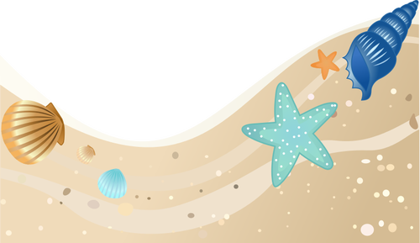  This Photo by Unknown Author is licensed under CC BY-NC |  |  | Cloverdale Water Park | Aylard  Farm | Beckwith Water Park | Lookout  Lake | Island View Beach  Hotdog Day

