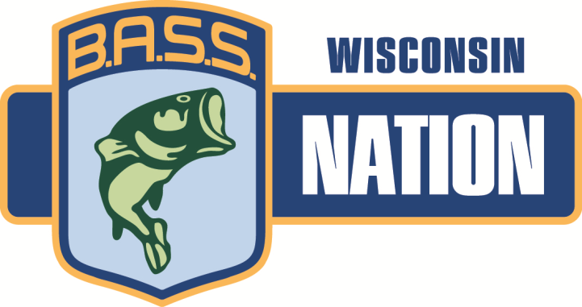

2017 Wisconsin BASS CLASSIC TOURNAMENT
Lake Puckaway
Saturday/Sunday May 20th, 21st

Headquarters/Pre-Tournament meeting: Mike & Cathy’s Good Old Bar/Restaurant
W995 W North Shore Dr.
Montello, Wisconsin 53939
(608-297-2464)
Pre-Tournament Meeting: Friday May 19th – 7:00PM
Saturday/Sunday start times TBA at that meeting
All WBN tournament rules and regulations will apply and are posted on the WBN website: www.wisconsinbassnation.com.
All participants must be WBN members in good standing. Copies of B.A.S.S. cards are not required to be submitted with this form but it is suggested that they be brought to the pre-tournament meeting in case of questions.
Each club is able to submit as many 3 teams of boaters/non-boaters as their club roster will allow. 3 teams is the MAX. 1 < 12. 2 > 12. 3>24.
There is no cut off for this tournament, however participants must be off the water Friday the 19th no later than 5p.m.
5 fish limit.
Any questions please contact Kyle Carpenter at: 920-819-5731 Email – kylecarpenter95@gmail.com
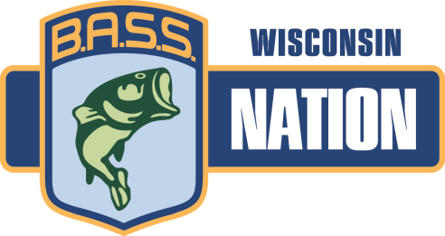
2017 Wisconsin BASS CLASSIC TOURNAMENT ENTRY FORM
All entrants must be members of the same WBN club per the BASS website roster
Club: _________________________________
Boater: Name: _________________________________
Non-boater: Name: _________________________________
Boater: Name: _________________________________
Non-boater: Name: _________________________________
Boater: Name: _________________________________
Non-boater: Name: _________________________________
*Boaters that have not previously submitted a current copy of boat insurance with a minimum of $300,000 Liability MUST submit that document with this entry form. Please insure that the expiration date is not prior to this tournament. Copies of boat insurance are retained for the current year.
Tournament Entry: $150 boaters / $100 non-boaters
Having acquainted myself with the rules, I have completed this application and submit it for my Tournament entry. By signing this application, I hereby agree to be bound by and comply with all Tournament rules and regulations. I expressly assume all risks associated with the Tournament and hereby release W.B.N., the host, B.A.S.S. sponsors, and tournament officials from all claims of injury and/or damage incurred in connection with this tournament. I further understand and agree that the Tournament Committee reserves the right to reject my application for any reason. I am currently a member in good standing of B.A.S.S. and the Wisconsin B.A.S.S. Nation.
Signatures (6)___________________________________________________________
-----------------------------------------------------------------------------------------------------------
Entry Forms must be turned in NLT 6:00pm on April 28th , 2017. Make check or money order payable to “WBN” and mail check, entry form, AND COPY OF BOAT INSURANCE (if needed) to:
Chris Fredrick
910 S. Cedar Ave - Marshfield, WI 54449

