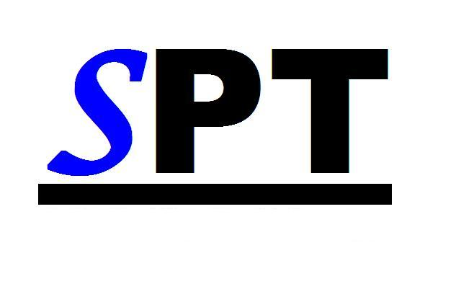
Schultz Physical Therapy
1255 East Canal Street, Ohio 45764
Phone (740)753-4567 Fax(740)753-4626

NOTICE OF PRIVACY PRACTICES

This notice describes how medical information about you may be used and disclosed and how you can get access to this information.

The terms of this Notice of Privacy Practices apply to Jeromy Schultz, D.P.T. and also the staff operating as a health care facility. The members of this clinic will share personal health information of patients as necessary to carry out treatment, payment, billing, and health care operations as permitted by law.

We are required by law to maintain the privacy of our patients' personal health information and to provide patients with this notice of our legal duties and privacy practices with respect to your health information. We reserve the right to change the terms of this notice. A copy of any revisions will be available to our office.

USES AND DISCLOSURES FOR TREATMENT: We will make uses and disclosures of your health information as necessary for your treatment. Including but not limited to insurance billing, referral to another health care provider, and any legally requested inquiry (such as court ordered), home health, physical therapy, laboratories and hospitals, etc.

We may need to release information for clinical improvement, professional peer review, business management, accreditation and licensing, etc.

With your approval, we may from time to time disclose your health information to designated family, friends, and others who are involved in your care. This approval must be in writing, and have a beginning date and an ending date.

Certain aspects and components of our services are performed through contracts with outside persons or organizations, such as auditing, accreditation, legal service, etc. In all cases, we require the business associates to appropriately safeguard the privacy of your information.

We may contact you to provide appointment reminder or test results. You have the right to request the messages not be left on your voice mail or sent to particular address. We will accommodate reasonable requests. You may request all confidential communications in writing and sent to 147 Columbus Road, Athens, Ohio, 45701, or stop by the office to pick up a form.

All medical record requests must be made in writing; a minimum of one week and a maximum of thirty days to copy all medical records is required. If records are not being sent to another physician or clinic there will be a $15.00 charge for your records. This must be paid prior to the release of your records.

We may release your health information for public activities, such as reporting of disease, injury, birth and death, and for required public health investigations such as reporting to the Ohio Cancer Incidence Surveillance System or the Ohio Trauma Registry.

We must report any abuse, wounds and injuries to the authorities.

We may release your personal records to Workers' Compensation agencies if necessary for your Workers' Compensation benefit determination.

Please report any violation to the Privacy Office.

You have the right to request amendments to your health information. This must be done in writing, signed by you and must state the reasons for the amendment/correction request. We are not obligated to make all requested amendments but will give each request careful consideration.

Please sign below showing that you have read this Notice of Privacy Practices.

Signature of Patient Date

