Two-Way Virtual Programming
‘How-to’ Guide for Zoom Meeting, including YSF Child-Safe Security Controls
YMCA OF SAN FRANCISCO
__________________________________________________________________________

The purpose of this guide: To provide proactive and responsive steps to implement two-way interactive Meetings in Zoom, including YSF Child-Safe Security Controls

Table of Contents
- Child-Safe Roles in Zoom Meeting
  - Hosts
  - Co-Hosts
  - Participants
- Basic Child-Safe Controls while in Zoom Meeting
  - How-to Sign-in to Zoom Meeting (General)
  - How-to Navigate the Meeting Control Panel (General)
  - How-to Manage the Waiting Room (General and Child-Safe)
  - How-to Manage Participants (General)
  - Participant Permissions (Child-Safe)
  - How-to Remove Unwanted Participants (Child-Safe)
  - How-to Lock Your Zoom Meeting (Child-Safe)
  - How-to Chat Participants (General and Child-Safe)
  - How-to Screen Share (General and Child-Safe)
- Advanced Child-Safe Controls while in Zoom Meeting
  - How-to Assign Co-Hosts (General)
  - How-to Manage Breakout Rooms (General and Child-Safe)
  - Breakout Room Limitations (General)
  - How-to Share Files to Participants in Chat (General and Child-Safe)
  - How-to Screen Share with Annotation (General)
  - Optional How-to Use Closed Captioning (General)
  - Optional How-to Use and Edit Polls (General)
- Chrome Books and Zoom
  - Getting Started on Chrome OS
  - Configuration for Chrome OS
  - New Updates for Chrome OS
  - Zoom Rooms on Chrome OS

Child-Safe Roles in a Zoom Meeting
__________________________________________________________________________
The Host has full control in a Zoom meeting. The Co-Host has medium control. The Participant has limited control. The table below compares the meeting controls available to the Hosts, Co-hosts and Participants.
Note:
- Co-Hosts cannot be assigned ahead of time.
- The Host must assign a Co-Host(s) in the Meeting.
- There is no limit to the number of Co-Hosts allowed in a meeting.
- Co-hosts cannot Start a meeting.
- If the Host needs someone else to start a meeting, they can assign an alternative host.

Feature | Host | Co-Host(s) | Participant(s)
Start the  meeting | ✔
Mute/unmute themselves | ✔ | ✔ | ✔
Start/stop their own video | ✔ | ✔ | ✔
View Participant  list | ✔ | ✔ | ✔
Share  screen | ✔ | ✔
Annotate on  Shared Screen |  | ✔ | ✔
Request or give remote control | ✔
Chat with Participants | ✔ | ✔
Save  Chat | ✔ | ✔
Create or Edit  Polls | ✔
Start  Polling | ✔ | ✔
Answer  Polls |  |  | ✔
Assign someone to enter closed captions | ✔
Enter closed  captions | ✔ | ✔
End  meeting | ✔
Reactions and  nonverbal feedback | ✔ | ✔ | ✔
Managing participants | ✔
Mute or unmute Participants | ✔ | ✔
Stop Participant Video | ✔ | ✔
Ask Participant to Start Video | ✔ | ✔
Spotlight  a video | ✔ | ✔
Promote participant to Host or Co-Host | ✔
Change who Participant can Chat | ✔ | ✔
Remove  Attendees | ✔ | ✔
Put Participants on hold | ✔ | ✔
Rename  Participants | ✔ | ✔
Invite others  to join | ✔ | ✔
Assign Participants to Breakout Rooms | ✔
Mute controls for participants | ✔ | ✔
Start cloud  recording | ✔ | ✔
Start local  recording | ✔ | ✔
Live stream on Facebook | ✔
Live stream on YouTube | ✔
Custom live  stream | ✔

Basic Child-Safe Controls in Zoom Meeting
__________________________________________________________________________
How-to Sign-in and Start a Zoom Meeting (General)
- Visit zoom.us and select sign in from the header bar
- Enter your assigned email address and password
- Upon sign in, you’ll be brought to your Profile page
- Select Meetings from the left-side menu bar
- Locate your assigned meeting link and select Start

How-to Navigate the Control Panel (General)
- Watch this 10-Minute YouTube Video Tutorial: https://youtu.be/ygZ96J_z4AY

How-to Manage the Waiting Room (General and Child-Safe)
- Watch this 60-second YouTube Video Tutorial: https://youtu.be/ySas2Rgi6yA
Note: Under YSF Child-Safe Security Controls, it is recommended you admit Participants individually to the Meeting. This is to prevent Unwanted Participants from entering the Meeting.
Reference: the How-to Remove Unwanted Participants section of this guide for steps to Remove Unwanted Participants from Your Meeting.

How-to Manage Participants (General)
- Select Participants from your bottom bar controls
- Your Participants list will appear on the right-side panel of the Zoom interface
- From the Participant list you can hover over any Participant to:
  - Mute/Unmute
  - Start/Stop Video
  - Spotlight Video
  - Make Host
  - Make Co-Host
  - Allow Record
  - Rename
  - Put on Hold
  - Remove
Note: The Order of Your Participants List
  - You
  - The host (if you’re not the host)
  - Co-Host
  - Phone numbers with no names
  - Unmuted participants (sorted alphabetically)
  - Muted participants (sorted alphabetically)
Participant Permissions (Child-Safe)
Under YSF Child-Safe Security Controls, when Participants enter your meeting:
- Their own microphone and video are automatically disabled (off)
- They can opt to enable their own microphone or video at any time
- They will automatically see the Host, Co-Host(s) and other Participants
- They can automatically offer emoji Reactions: an applause, thumbs-up or hand raise
- They can automatically Chat to the Host and Co-Host(s)
- They cannot Chat to other Participants publicly or privately

How-to Remove Unwanted Participants (Child-Safe)
Under YSF Child-Safe Security Controls, Hosts and Co-Hosts must protect youth against Unwanted Visitors, Guests or Participants entering or staying in a Zoom Meeting.
To remove unwanted Meeting Participants:
- Open your Participants icon from the bottom control panel (if not already open)
- Hover over the Participant’s name
- Select More
- Select Remove
Note: Once a Participant has been Removed, he/she/they cannot rejoin the Meeting
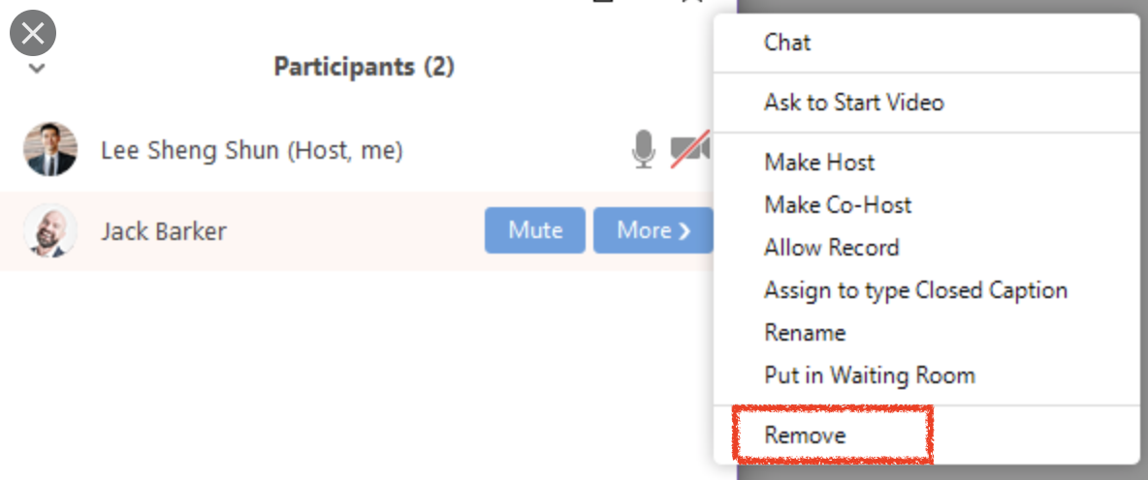

How-to Lock Your Zoom Meeting (Child-Safe)
Under YSF Child-Safe Security Controls, it is recommended the Host or Co-Hosts Lock Meeting after all confirmed participants are present in the Meeting. This prevents unwanted Participants from entering the Meeting after it starts.
To Lock Your Zoom Meeting:
- Open your Participants icon from the bottom control panel (if not already open)
- Select the More dropdown tab
- Select Lock Meeting
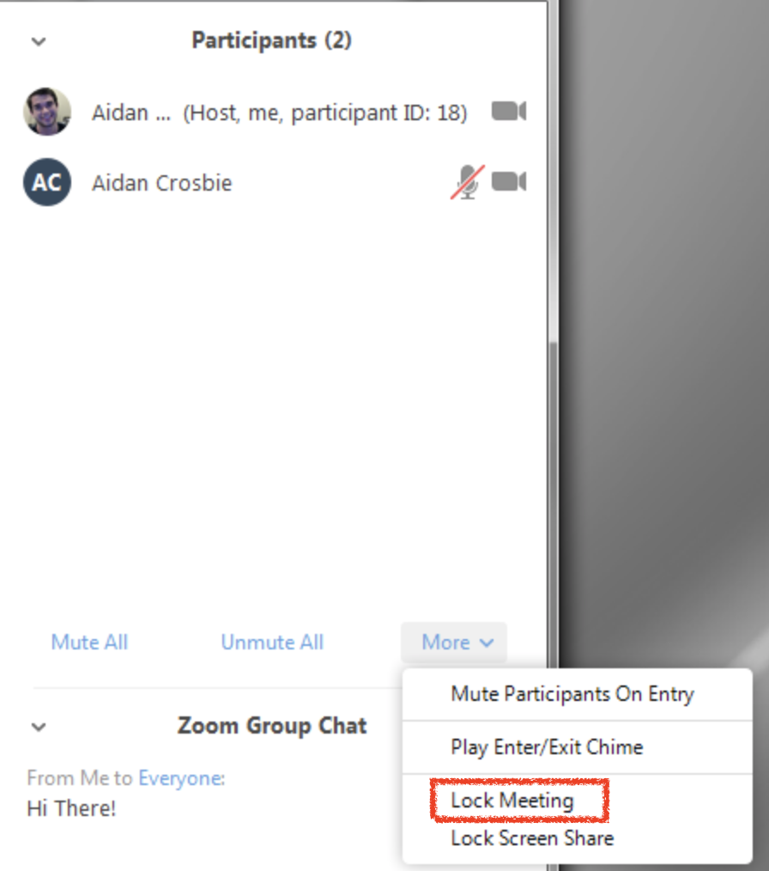

How-to Chat Participants (General and Child-Safe)
- From the Bottom Panel of the Host Control Center, select Chat
- The chat box will appear on the right-side panel
- In a Child-Safe Meeting:
  - The Host can chat to Co-Hosts, All Participants, Individual Participants or to Everyone
  - Co-Hosts can Chat to the Host and to Participants
  - Participants can Chat to the Host and Co-Hosts
  - Participants cannot Chat to other Participants publicly or privately

How-to Screen Share (General and Child-Safe)
Watch this 60-second YouTube Video Tutorial: https://youtu.be/YA6SGQlVmcA
- Click the Share Screen icon from the bottom control panel
- Zoom allows for screen sharing on desktop, tablet and mobile devices running Zoom
- In a Child-Safe Meeting:
  - The Host and Co-Host can Screen Share
  - Participants cannot Screen Share, but they can Annotate on a Shared Screen

Advanced Child-Safe Controls in Zoom Meeting
__________________________________________________________________________
How-to Assign Co-Host in Meeting (General)
There are two ways the Host can Assign a user as a Co-Host.
- In the meeting, hover over the user's video and click the three dots. Choose Make Co-Host.
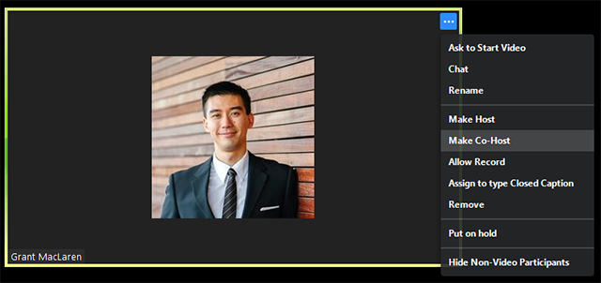
Alternatively, you can use the Participants window.
- Select Participants from the bottom panel. Hover over the user’s name and choose More. Click Make Co-Host.
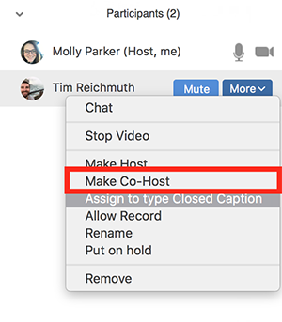
How-to Manage Breakout Rooms (General and Child-Safe)
- Watch this 3-minute YouTube Video Tutorial: https://youtu.be/jbPpdyn16sY
- Under YSF Child-Safe Security Controls, it is recommended the youth-to-adult ratio be 2 or more youth-to-2 adults (where a Technical Host can serve as the second adult that moves between single room and breakout rooms during virtual programming) - for questions on youth-to-adult ratios, contact Jackie O’Brien at JOBrien@ymcasf.org

Breakout Room Limitations
- Participants using Chromebooks or Chrome OS are unable to join breakout Rooms, but the main room can be used as an alternative session for these Participants.
- If the meeting is being cloud recorded, it will only record the main room, regardless of what room the meeting host is in. If local recording is being used, it will record the room the participant who is recording is in. Multiple participants can record locally.
- You can create up to 50 breakout rooms.

How-to Share Files to Participants in Chat (General and Child-Safe)
- Select Chat from your Bottom Control Panel
- Locate the Share button
- Select the File to Share
- Press Send from the Chat
- In a Child-Safe Meeting:
  - Participants can Share Files in Chat, but it is only shared with the Host and Co-Hosts

How-to Screen Share with Annotation (General)
- Watch this 5-minute YouTube Video Tutorial: https://youtu.be/QGQkAsKtriU
- Annotation Features vary slightly depending on the device the Host and Co-Hosts use
- Read this post to understand how to Annotate on your personal device

Optional How-to Use Closed Captioning in Meeting (General)
- Watch this 90-second YouTube Video Tutorial: https://youtu.be/a06O8JmpPZA
- TIP! Closed Captioning is a valuable feature for supporting ESL Learners

Optional How to Use and Edit Polls (General)
- Read this post on How to Use and Edit Polls

Chrome Books and Zoom Functionality
__________________________________________________________________________
Zoom functionality on Chrome Books is unique – if you are a Chrome Book User, review these resources:
- Getting Started on Chrome OS
- Configuration on Chrome OS
- New Updates for Chrome OS
- Zoom Rooms on Chrome OS

