
Morgan Home Supply
Wall Cabinet (12-inch Depth) Kitchen & Vanity Cabinetry
Types | Available Width (inch) | Height (inch) | QTY. | Shipping | Price
 | 9 | 30
 | 12 | 30
 | 15 | 30
 | 18 | 30
 | 21 | 30
 | 9 | 36
 | 12 | 36
 | 15 | 36
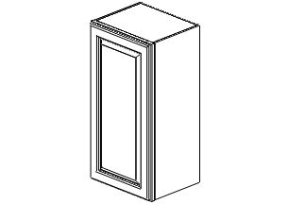 | 18 | 36 |  |  | .
 | 21 | 36
 | 9 | 42
 | 12 | 42
 | 15 | 42
 | 18 | 42
 | 21 | 42
Types | Available Width (inch) | Height (inch) | QTY. | Shipping | Price
Refrigerator Wall (24-inch depth)  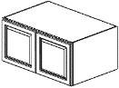 | 30 | 21
 | 36 | 21
 | 36 | 24
304-379-8888
681-285-8819
Info@morganhomesupply.com
www.morganhomesupply.com
Types | Available Width (inch) | Height (inch) | QTY. | Shipping | Price
Corner Wall  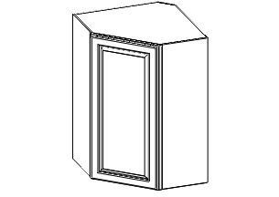 | 24 | 30
 | 24 | 36
 | 24 | 42

Types | Available Width (inch) | Height (inch) | QTY. | Shipping | Price
Microwave Shelf | 27 | 30
 | 27 | 36
 | 27 | 42
 | 30

Types | Available Width (inch) | Height (inch) | QTY. | Shipping | Price
Wall Blind Corner  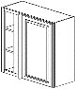 | 27 | 30
 | 27 | 36
 | 27 | 42

Base Cabinets (24-inch Depth)
Types | Available Width (inch) | Height (inch) | QTY. | Shipping | Price
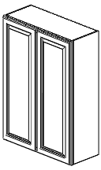 | 24 | 30
 | 27 | 30
 | 30 | 30
 | 33 | 30
 | 36 | 30
 | 24 | 36
 | 27 | 36
 | 30 | 36
 | 33 | 36
 | 36 | 36
 | 24 | 42
 | 27 | 42
 | 30 | 42
 | 33 | 42
 | 36 | 42
Types | Available Width (inch) | Height (inch) | QTY. | Shipping | Price
Angled Triangle Wall  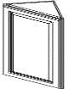 | 24 | 30
 | 24 | 36
 | 24 | 42
Types | Available Width (inch) | Height (inch) | QTY. | Shipping | Price
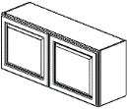 | 30 | 12
 | 36 | 12
 | 30 | 15
 | 36 | 15
 | 30 | 18
 | 36 | 18
 | 30 | 24
 | 36 | 24
Types | Available Width (inch) | Height (inch) | QTY. | Shipping | Price
Class Holder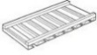 | 30

Types | Available Width (inch) | Height (inch) | QTY. | Shipping | Price
Wall Open End Shelves  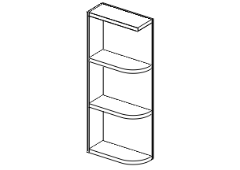 | 12 | 30
 | 12 | 36
 | 12 | 42
Types | Available Width (inch) | Height (inch) | QTY. | Shipping | Price
Wine Rack  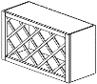 | 30 | 15
 | 30 | 18
Types | Available Width (inch) | Height (inch) | QTY. | Shipping | Price
Base Spice | 9 | 34-1/2
Types | Available Width (inch) | Height (inch) | QTY. | Shipping | Price
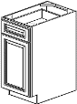 | 9 | 34-1/2
 | 12 | 34-1/2
 | 15 | 34-1/2
 | 18 | 34-1/2
 | 21 | 34-1/2
Types | Available Width (inch) | Height (inch) | QTY. | Shipping | Price
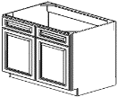  Sink Base | 33 | 34-1/2
 | 36 | 34-1/2
Types | Available Width (inch) | Height (inch) | QTY. | Shipping | Price
Lazy Susan | 33 | 34-1/2
 | 36 | 34-1/2
Types | Available Width (inch) | Height (inch) | QTY. | Shipping | Price
Pantry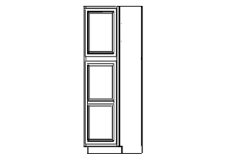 | 18 | 84
 | 18 | 90
 | 18 | 96
Types | Available Width (inch) | Height (inch) | QTY. | Shipping | Price
Double Oven Cabinet | 33 | 84
 | 33 | 90
 | 33 | 96

Types | Available Width (inch) | Height (inch) | QTY. | Shipping | Price
Blind Base corner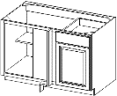 | 39 | 34-1/2
 | 43 | 34-1/2
Types | Available Width (inch) | Height (inch) | QTY. | Shipping | Price
Base End Shelf | 10 | 34-1/2

Types | Available Width (inch) | Height (inch) | QTY. | Shipping | Price
 | 24 | 34-1/2
 | 27 | 34-1/2
 | 30 | 34-1/2
Bath Vanity (21-inch Depth)
Types | Available Width (inch) | Height (inch) | QTY. | Shipping | Price
Pantry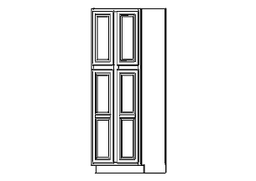 | 24 | 84
 | 24 | 90
 | 24 | 96
 | 30 | 84
 | 30 | 90
 | 30 | 96
Types | Available Width (inch) | Height (inch) | QTY. | Shipping | Price
Vanity Sink Base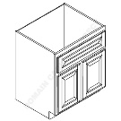 | 24 | 34-1/2
 | 30 | 34-1/2
 | 36 | 34-1/2

Types | Available Width (inch) | Height (inch) | QTY. | Shipping | Price
Vanity Combo single sink  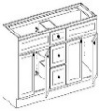 | 60 | 34-1/2

Types | Available Width (inch) | Height (inch) | QTY. | Shipping | Price
Sink Base | 30 | 34-1/2
Types | Available Width (inch) | Height (inch) | QTY. | Shipping | Price
Corner Sink Base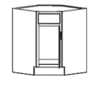 | 36 | 34-1/2
Types | Available Width (inch) | Height (inch) | QTY. | Shipping | Price
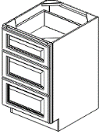  Drawer Base – 3 drawers | 12 | 34-1/2
 | 15 | 34-1/2
 | 18 | 34-1/2
 | 21 | 34-1/2
 | 24 | 34-1/2
 | 27 | 34-1/2
 | 30 | 34-1/2
 | 36 | 34-1/2

Types | Available Width (inch) | Height (inch) | QTY. | Shipping | Price
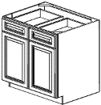 | 33 | 34-1/2
 | 36 | 34-1/2
 | 42 | 34-1/2
Types | Available Width (inch) | Height (inch) | QTY. | Shipping | Price
Vanity Drawer Base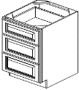 | 12 | 34-1/2
 | 15 | 34-1/2
 | 18 | 34-1/2
Types | Available Width (inch) | Height (inch) | QTY. | Shipping | Price
Vanity Combo single sink  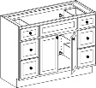 | 60 | 34-1/2
Options | Item # | QTY. | Shipping | Price
Dish Washer Panel ½” with 3” solid  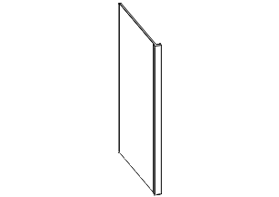 | DWP
Crown Molding 115mm | CM8 3-1/4”
Crown Molding 73mm  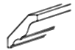 | CM8 2-7/8”
Rope Molding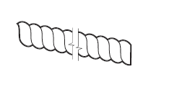 | RM8
Dentil Molding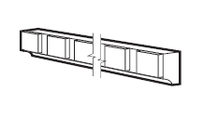 | DM8
Glass Door | W1530MD
 | W1536MD
 | W1542MD
 | W1830MD
 | W1836MD
 | W1842MD
 | W3030MD(Pair)
 | W3630MD(Pair)
 | W3036MD(Pair)
 | W3636MD(Pair)
 | W3042MD(Pair)
 | W3642MD(Pair)
 | WDC2430MD
 | WDC2436MD
5mm skins ¼” thickness | BP4896
Scribe Moulding ¾” wide x 96” long x ¼” thick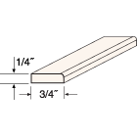 | SM8
Outside Corner Moulding | OC8

Types | Available Width (inch) | Height (inch) | QTY. | Shipping | Price
Vanity Combo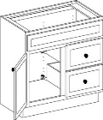 | 30 (Left Door) | 34-1/2
 | 30 (Right Door) | 34-1/2

Types | Available Width (inch) | Height (inch) | QTY. | Shipping | Price
Vanity Combo | 36 (Left Door) | 34-1/2
 | 36 (Right Door) | 34-1/2
 | 42 (Left Door) | 34-1/2
 | 42 (Right Door)
Accessories
Options | Item # | QTY. | Shipping | Price
Toe tick | TK8(1/4”)
Toe tick | TK8(1/2”)
Wall filler | WF330
 | WF630
 | WF342
 | WF642
Base Filler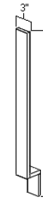 | B3
 | BF6
Long Filler | F396
 | F696
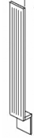  Fluted Base Filler | A3BF
Fluted Wall Filler | A30WF
 | A42WF
Post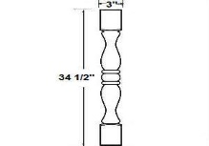 | TP3
Arched Valance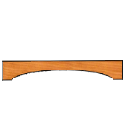 | VAA48
Refrigerator Panel ½”, 24” Deep | RP96

Types | Available Width (inch) | Height (inch) | QTY. | Shipping | Price
Vanity Tall | 18 | 84

Types | Available Width (inch) | Height (inch) | QTY. | Shipping | Price
Vanity Combo single sink  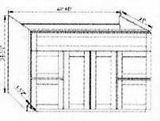 | 48 | 34-1/2
Options | Item # | QTY. | Shipping | Price
Ligt Rail Molding Big  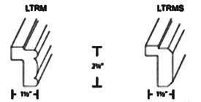 | LRM8
9”H x 6”W x 5 ½”D simple Curve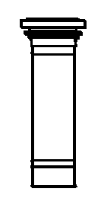 | Corbel1
False Door | WEP1230 WEP1242(11 5/8” W)
 | WEP1236 WEP1242(11 5/8” W)
 | WEP1242(11 5/8” W)
 | WEP2430(23 5/8” W)
5mm Wall Skin, Base Skin and Tall Panel | WSK1230
 | WSK1236
 | WSK1242
 | BSK
 | TSK2496
3” H Roll Out Tray with DTC Ball Bearing Guides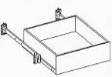 | ROT18
 | ROT24
 | ROT30
 | ROT36
Trash Can 18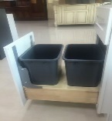 | Trash Can 18
Mirror  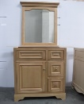 | M3030(30”Wx30”H)
 | M3630(36”Wx30”H)
Medicie Cabinet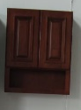 | BV2126(21”Wx26”H)

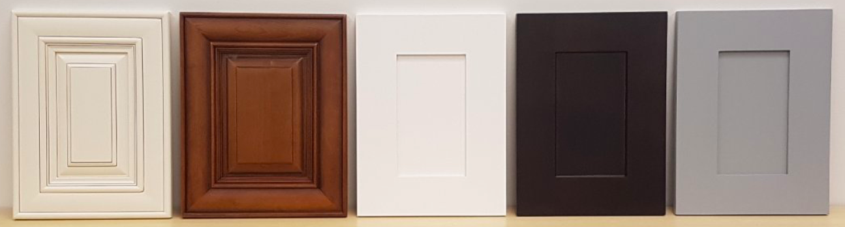

Morgan Home Supply LLC
3248 Moyers Road
Bruceton Mills, WV 26525
Phone: +1(304)3798888/(681)2858819
Email: info@morganhomesupply.com
Website: www.morganhomesupply.com

