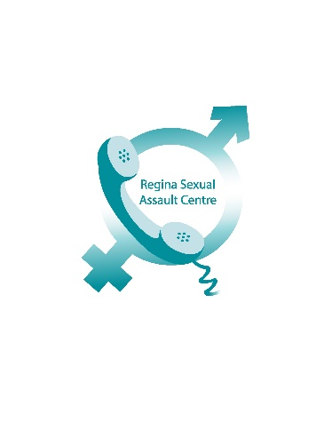
RSAC 1830 MacKay Street
Phone: (306) 522-2777 Regina, SK S4N 6R4
Monday – Friday www.reginasexualassaultcentre.ca
9:00 – 4:30 rsac@sasktel.net

Regina Sexual Assault Centre (RSAC) Statement Regarding
Conviction of Former Executive Director

FOR IMMEDIATE RELEASE

Regina, SK – Today, the former Executive Director of the Regina Sexual Assault Centre was convicted on charges of fraud. Although staff are relieved that this process is behind us, and thankful for the thorough work of the police and prosecutor, it has been emotional for all.

It was deeply distressing to learn that a trusted individual who we saw at work each day, could be capable of such wrongdoing. Most significantly, Ms. House did not just steal from an organization; she stole from each individual who came through our doors or called our crisis line. She stole from the very people she was employed to help.

Ms. House’s actions have damaged the reputation and integrity of an organization that has operated for over forty years; however, RSAC would like the public to know that the actions of this single individual in no way reflect our Values, Mission and Vision. We are a staff of committed, compassionate individuals who continue to educate and provide counselling and advocacy for those who have experienced sexual and inter-personal violence.

Our agency has made significant improvements to financial oversight to ensure that this cannot happen again, and we have increased our Board capacity to include additional community members with extensive Risk Management and External Auditing experience. Our valuable funders and donors are crucial in assisting us in continuing our work and we hope people will see the situation for what it was; one person.

Since September 2017, our agency has participated in ten public events, delivered twenty-seven children’s presentations, received over twenty new clients and provided over two hundred counselling sessions. Saskatchewan has one of the highest rates of child sexual abuse and sexual assault and we remain committed to providing free, qualified counselling to any individual who has been impacted, as well as continuous education and outreach with community agencies and the public.

With adversity comes opportunity, and RSAC is making the most of this opportunity to refocus our efforts on advocating for the clients we serve and our community. Recent media stories, such as Harvey Weinstein and the social media hashtag (#metoo), further exemplify how pervasive sexual abuse is in our society, and how very real and vital our work is.

Questions can be forwarded to the Executive Director at lisa.rsac@sasktel.net or by phone at 306-522-2777 during office hours.

