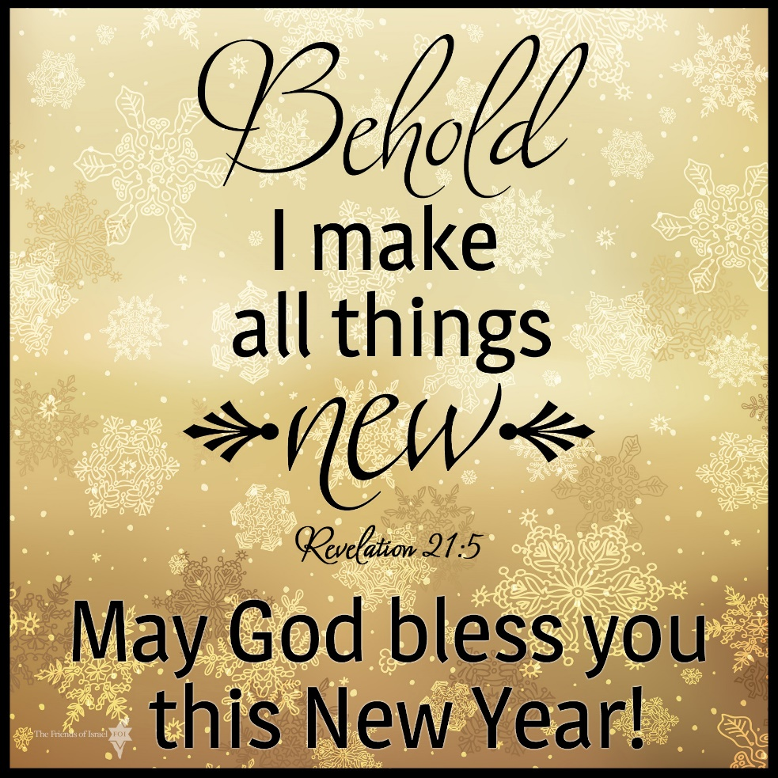

Carson City United Methodist Church

January 08, 2023

January 08, 2023
Call to Worship
Greeting/Announcement
Call to Worship
L: We believe in one Lord, Jesus Christ, the only Son of God, eternally begotten of the Father, God from God, Light from Light, true God from true God, begotten, not made, of one being with the Father. Through him all things were made.
P: For us and for our salvation he came down from heaven. By the power of the Holy Spirit, he became incarnate of the Virgin Mary, and was made man.
L: For our sake he was crucified under Pontius Pilate, he suffered death and was buried.
P: On the third day he rose again in accordance with the scriptures.
L: He ascended into heaven and is seated at the right hand of the father.
P: He will come again in glory to judge the living and the dead. His kingdom will have no end.
*Hymn: Go Tell it on the Mountain UMH 251

Opening Prayer: (unison) (Francis of Assisi 1182-1226)
Lord, make us instruments of Your peace; Where there is hatred, let us sow love; Where there is injury, pardon; Where there is error, truth; Where there is doubt, faith; Where there is despair, hope; Where there is darkness, light; And where there is sadness, joy. Heavenly Father, Grant that we may not so much seek to be consoled as to console; To be understood as to understand; To be loved as to love. For it is in giving that we receive; It is in pardoning that we are pardoned; And it is in dying that we are born to eternal life. AMEN.

Contemporary Song: Always (Chris Tomlin)

Offering

Doxology UMH 95

Offertory Prayer

Sharing of our Joys and Concerns

Call to Prayer: Emmanuel, Emmanuel UMH 204

Pastoral Prayer

Gospel Reading: MATTHEW 24:35

Old Testament: PSALM 8:2

Epistle Lesson: REVELATION 21:1-7

Children’s Church

Contemporary Song: Don’t Lose Heart (Steven Curtis
Chapman)

MESSAGE

*Hymn: My Hope is Built UMH 368

Benediction

CCUMC – Announcements & Upcoming Events:

As a courtesy to others please silence or shut off cellphones

==============================================
Humans Relations Day: Sun, Jan 15th. This collection benefits neighborhood ministries through community developers, supports community advocacy through United Methodist Voluntary Services and works with at-risk teens through the Youth Offender Rehabilitation Program. To donate envelopes are available in both of the Brochure stands located on tables by North & South door in the Welcome Center.
==============================================
OFFICE CLOSED Mon, Jan 16th
==============================================
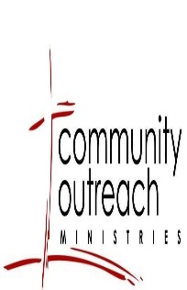
Funds were used for three families this Christmas. Please note, the Community Outreach Fund is a ministry we desire to use throughout the year, not just at Christmas. If you see a need in our community anytime during the year, please reach out to Pastor Ian.

==============================================

Serving & Supporting Sunday Worship
Audio/Video: Pat Monroe

Joys, Concerns & Prayer Request
For those battling cancers:
Jim Dunlap, Carolyn Nykerk, Dillan Abell,
Amorena Newman-Wojciakowski, Cheryl Meyers

For those who need support, guidance or have health concerns: Heather Kile, Doug Soper

Weekly Giving
12/04/22 | 12/11/22 | 12/18/22 | 12/25/22
$4,252.57 | $1,525.00 | $2,001.94 | $3,033.97

01/01 $3557.47

Nursery Schedule
01/08 Maryann Severson 01/15 Chris Benjamin
01/22 Collin Benjamin 01/29 Maryann Severson

Lighting of Candles

Passing of Collections Plate
01/08 Reagan

Our Church in Ministry This Week
Sun: Women’s Group
Mon: PT Class 6:30 pm-8:00 pm
Tue: NO A.R.K
Tue & Thu: COA Meal 10:00 am–2:00 pm
Sat: Euchre 5:00-8:00 pm

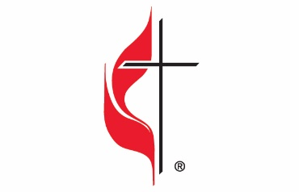

Carson City United Methodist Church
Location: 119 East Elm St., Carson City, MI
Mail: PO Box 298, Carson City, MI 48811
Phone: 989-584-3797 Email: carsoncityumc@gmail.com
Website: carsoncityumc.com
Sunday Worship Service: 10:30 am
Office Hours: Monday-Thursday, 9:00 am-12:00 pm
After hours by appointment
Pastor: Ian McDonald 906-322-5318
Secretary: Bonnie Seaman 989-763-1674

Weekly Sunday Bulletin now available on our website
@ www.carsoncityumc.com

“Heavenly Father, thank You for the home I have in You ”

