Buying Your Own Archery Kit

So you've had enough of using your club bow and want to get one of your own. Entering the world of buying archery kit can be daunting as all your kit needs to be right for you so i've made this guide to try and help you through it, hope this helps.

Choosing your Bow
You may have seen the cheaper fiberglass bows on the market but for the best resualts to cost ratio I would recommend a standard take down recurve bow. These bows are perfect for developing a good technique and you still have the option of adding most of the extras too. There are 3 thing you'll need to know when choosing one of these bows.

Draw length
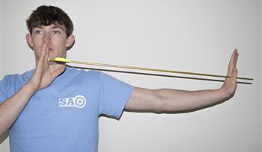
Draw length is the distance from the front edge of your riser to your anchor point on your face at full draw in inches. Its is important you get a reliable draw length because this is going to determine the length of your arrows to short and you arrow will fall of the rest! A good way of measuring is pictured opposite.

Step one
Are you Right or Left handed? You're right handed if you draw the string with your right hand and
hold the bow with your left. When you're buying you may see RH and LH this simply means Right
Handed and Left Handed.
Step two
Your arrow Length Bow Length
​ 14-18 48"
18-20 54"
20-22 58"
22-24 62"
24-26 64"
26-28 66"
28-30 68"
30+ 70"

Bow Length, Bow length is the total length of your bow from tip to tip, it is determined by the
draw length and using the chart aside. If in doubt go for the long bow.
Step three
Poundage is the weight of your pull when you draw the string, selecting poundage is important because you don't want to go too high and do yourself an injury and not be able to pull your bow. The poundage of bows is measured at 28 inches draw the rule of thumb is that for every inch you draw more then 28 inches is plus 2 lbs weight and for every inch you draw less than 28 it's minus 2 pounds weight. The recommended weight to start off for adult male is 28lbs and female is 24lbs. So if you have a 29 inch draw and wanted a to pull 28lbs you would get a 26lbs bow. The change the weight of your bow you can just replace the limbs.
​

Arrows
When choosing your first set of arrows there is one key thing you have to keep in mind and that is the length. It is important that you don't get arrows that are too small for you because you simply wont be able to use them. Your arrow length is about 1 inch more then your draw length. When you are new to the sport it is a good idea to go a bit longer, maybe 1.5-2 inches more then you draw as this gives you the chance to settle into your techqunic and strech your draw.
For your first set of arrows I recommend the Easton Neos as they are durable, cheap and come in a range of lengths.

