LONG BRANCH DOLPHINS
Orders Due To Shawn Guth Spiritwear Chair

2019 Spiritwear Order Form

Family Name: _____________________________________________

Swimmer’s Name(s): _______________________________________

Email Address: ____________________________________________

Phone #: _________________________________________________

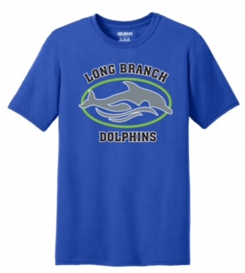
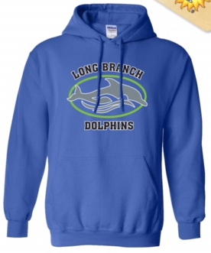
Performance T-shirt – Royal Blue $15.00 Hooded Sweatshirt – Royal Blue $25.00
Youth S ______ Youth S ______
Youth M ______ Youth M ______
Youth L ______ Youth L ______
Adult S ______ Adult S ______
Adult M ______ Adult M ______
Adult L ______ Adult L ______
Adult XL _____ Adult XL ______
TOTAL x $15 = __________ TOTAL x $25 = __________

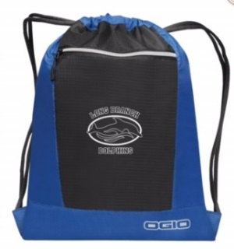
Drawstring Bag – Royal Blue/Black $20.00 Embroidered Towel – Royal Blue $35.00
(Logo AND Swimmer first name included)
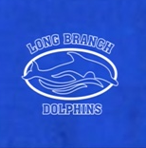
Quantity: Quantity:
_______ ________
Name: _______________

Name: _______________

TOTAL x $20 = _________ TOTAL x $35 = _________

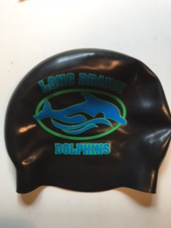
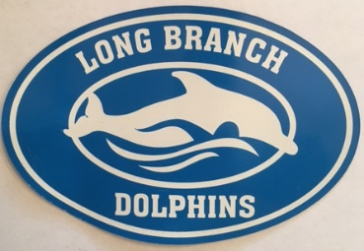
Oval Car Magnet – Royal Blue $5.00 Silicone Swim Cap – Black $12.00

Quantity: Quantity:
_______ _______

TOTAL x $5 = _________ TOTAL x $12 = _________

TOTAL ITEMS ORDERED: _______________ TOTAL AMOUNT DUE: $_________________
CHECK NUMBER: _____________________ TOTAL PAID: $__________________________

Please make checks payable to LONG BRANCH DOLPHINS (and notate “spiritwear”)
Questions? Contact Shawn Guth at shawn.guth@verizon.net (c) 703.622.1688

