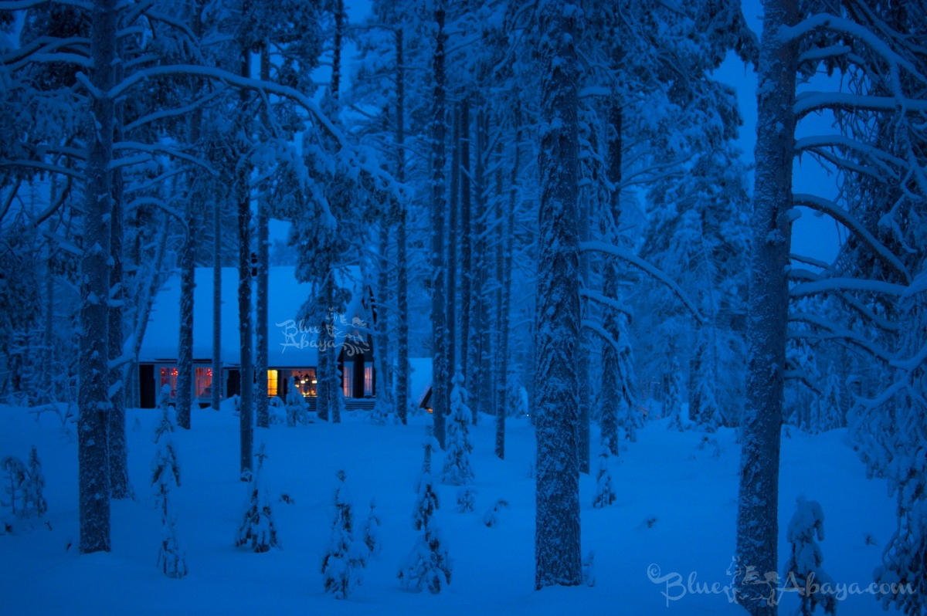
This Photo by Unknown Author is licensed under CC BY-NC-ND
Day 4: Celebrate Hospitality
Winter has special significance in the Christian tradition, write Gary Schmidt and Susan Felch in Winter: A Spiritual Biography of the Season:
“This is a season that, in making us aware of our individual vulnerabilities, encourages a communal understanding; the winter, with its incipient danger and threat, reminds us of those most vulnerable to such threats. So, it is entirely appropriate that for Orthodox Christians, one of the hallmarks of the winter feasts is the celebration of hospitality. An ode sung at Compline (praying the hours) on the third day of the Prefeast of Christmas proclaims: ‘Come, O faithful, let us enjoy the Master’s hospitality, the banquet of immortality.’ For Christians, winter is the season in which God shows hospitality to humankind through the incarnation, but it is also the season in which we are enjoined to reflect that hospitality by opening hearts and hands to God and neighbor.”
People of all traditions can transform the isolation and chills of the winter season by offering hospitality to others through dinner parties. Try to invite somebody you don’t know very well each time. Find out what you can do to support the “hospitality” organizations that are providing food, shelter, legal, and financial services to homeless people, immigrants, and refugees.

