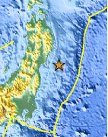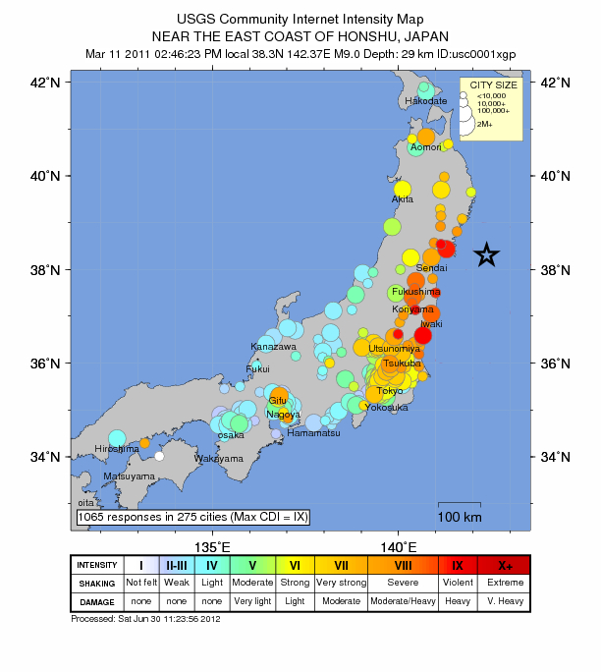
Japanese Tsunami 2011
http://earthquake.usgs.gov/earthquakes/?source=sitenav
http://www.geography.learnontheinternet.co.uk/topics/japan_earthquake.html
http://www.authorstream.com/Presentation/pacific2000-887841-japan-tsunami-2011/
When did it happen?
Where did it happen?
Why did it happen?
What happened?
Why was it so devastating?
How had the Japanses prepared for it?
What went wrong?

