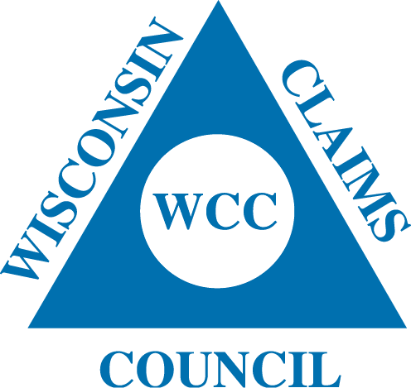

Wisconsin Claims Council

Sponsorship Registration

Thank you for agreeing to sponsor a seminar with the Wisconsin Claims Council! Our goals are to provide outstanding training programs, foster sound inter-company relations and improve public relations in the insurance claims industry.

The Wisconsin Claims Council offers several seminars throughout the year with high quality speakers and networking opportunities with our sponsors for a charge far less than other organizations. These seminars are conducted in Madison, Milwaukee, Eau Claire and Sheboygan.

Sponsorship for a seminar to the Wisconsin Claims Council is $500.00.

Check out our website at www.wisccc.com for updated seminar information.

Please complete, detach and return the bottom portion with your company sponsorship check for $500.00 made payable to: Wisconsin Claims Council.

Company Name: ___________________________________________________________________________________
Address: __________________________________________________________________________________________
City: ______________________________________ State: _______________________ Zip: _______________________
Contact Person Name: ___________________________________ Phone Number: _______________________________
E-mail Address: ____________________________________________________________________________________
You have permission to list our company as a sponsor on the WCC web site with a link to our company’s site. _____________ (please initial)

Return your payment and registration to:

Susan McClone
c/o Wisconsin Claims Council
PO Box 1029
Fond du Lac, WI 54936

