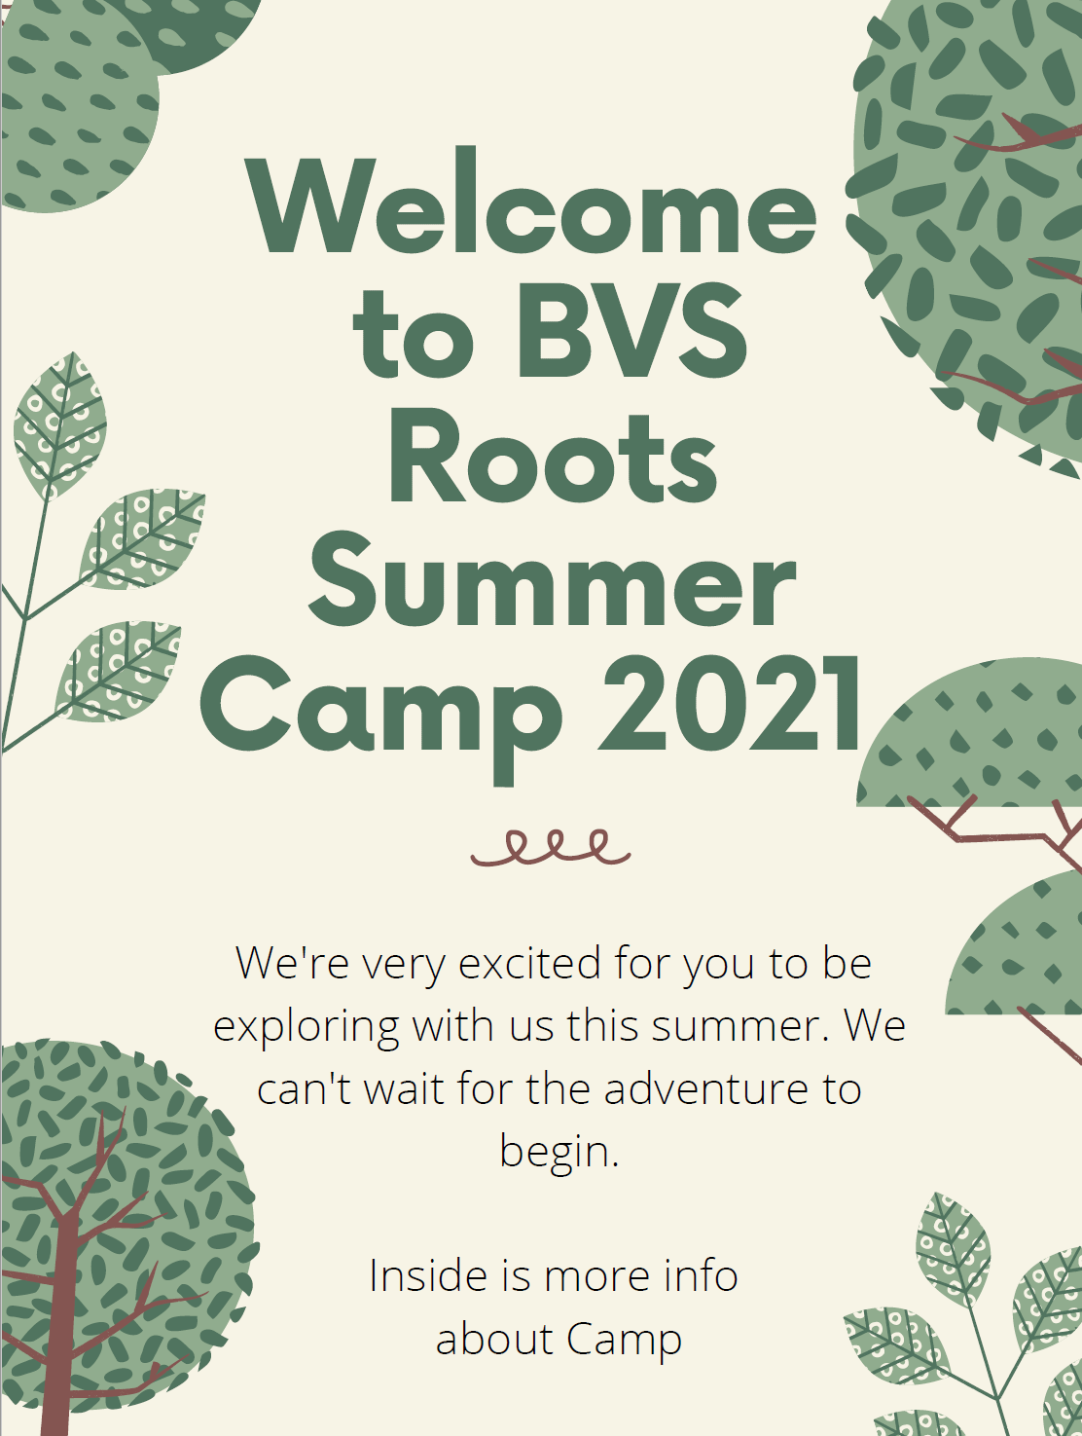
Welcome Explorers!
We’re extremely excited you’re joining us for Summer Camp. We have many fun things planned.
Daily Activities will begin at 9am and will include gardening, games, swimming, crafts, low ropes course, cooking, baking, hiking, free time and so much more!
We will have weekly field trips including paid trips and some free trips. There’s more information about this below.
Stay up to date and see what your child is doing on the Brightwheel App. We will post pictures and updates about our calendar, events, and lunch menu through here. If family members have any questions or comments for the teachers, this is the best way to reach us.

Drop Off & Pick Up
BVS Roots is open from 7am-5pm daily.
Approximate time for drop off and pickup can be added into Pickup Patrol. You will be getting an email invitation describing how to sign up and use it.
Drop off will be in the right main door of our building. If we are outside in the backyard, you may put your things in your cubby and bring your child to the backyard through the building to a staff member.
Family members MUST BE in the building before 5pm for pickup.
You will be charged $5 every minute you are late to pick up and payment is due directly to the teacher at pickup. If the family member doesn’t have cash or a check, Venmo is required.
If the family member is late more than 2 times, your child will be asked to leave the program.
Behavior Issues
Coupled with the hot summer’s heat and being with others who have emotional needs, there is a possibility of conflict between campers and sometimes staff. BVS Roots staff is trained to talk through the emotions of all the parties involved to understand the situation. Positive peer discussion, along with staff assistance will help resolve the conflict.
If the behavior is repeated, we will ask for family members to come in and help rectify the situation.
If the situation is not solved, we will kindly ask for the child to be removed from our program.
Field Trips
BVS Roots has two types of field trips for our campers.
We will be providing free field trips sponsored by BVS Roots and family paid field trips.
Campers are not required to attend field trips. If family members chose not to include their child in a field trip, the child will stay back at basecamp with a staff member.
Field Trips are as follows;
Barrington Town Forest Hiking Trail Free
Pawtuckaway State Park Hiking Trails Free
Stratham Hill Park Free
Raynes Field Loop Free
Dover Community Trail Free
Willard Pond Trail with Low Ropes Course Free
Wallis Sands Beach Free
Fort Foster State Park Free
White Lake State Park Free
Ellacoya State Park Free
Packers Falls Free
Ocean Life Demonstration & Beach Clean Up with Blue Ocean Society Free
Barrington Fire Department Tour/Visit Free
Barrington Police Department Tour/Visit Free
Hilltop Fun Center- Unlimited Mini Golf, Go Karts, & Laser Tag $41
Miller’s Wildlife $23
Seacoast Science Center at Odiorne Point $10
***Saco River Tubing 1 Mile Float $15
***Gunstock Aerial Adventure Explorer’s Course $25 for ages 6-11
-add Mountain Coaster & Scenic Lift +$20 for unlimited rides

In order to get a count of campers who are interested please let us know which field trips your child will be attending or not attending by email by
Friday June 18th 2021.
We will be booking our field trips that day.
***These trips will be at the end of our Summer Camp as our last celebration of Summer! We will be choosing the one the majority of our campers are interested in.

Things to Bring
Here’s a list of things to keep in your cubby throughout your BVS Roots Adventures
- Bathing Suit
- Towel
- 2 Changes of Clothes (underwear, socks, shirt, shorts)
- Hat/Sunglasses
- Sweatshirt
- Sunscreen
- Bug Spray
- Water bottle
- Sneakers
- Water Shoes
- Mask (for field trips)

Please make sure to write your child’s initials or name in their personal items

Please pack some snacks with utensils (if needed) every day. We will have some at basecamp but on field trip days we might not have the ability to supply the amount we need

