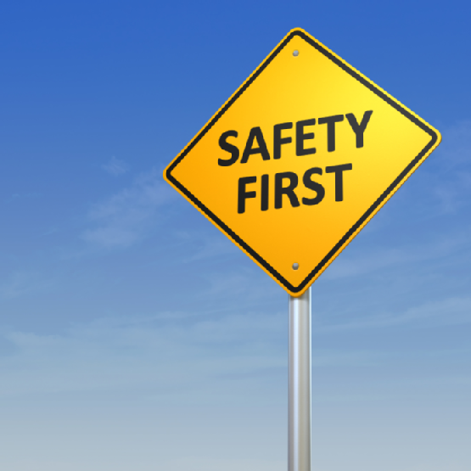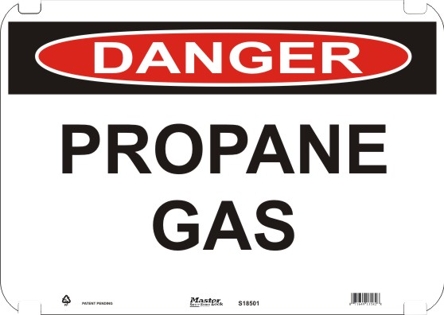

#### Propane…

**\*Propane has a strong, unpleasant smell like rotten eggs, a skunk’s spray, or a dead animal. Propane manufacturers add the smell deliberately to help alert customers to propane leaks, which can create a safety hazard.**

**\*Severe freeze burn or frostbite can result if propane liquid comes in contact with your skin.**

**\*Propane is ﬂammable when mixed with air (oxygen)**

**\* Propane may accumulate in low-lying areas such as basements, crawl spaces, and ditches, or along ﬂoors.**

http://www.amerigas.com/pdfs/AmeriGas-Propane-Safety-Brochure.pdf

1. NO FLAMES OR SPARKS: Immediately put out all smoking materials and open flames. Do not operate lights, appliances, telephones, or cell phones
2. LEAVE THE AREA IMMEDIATELY: Get everyone out of the building or away from the area where you suspect the gas leak.
3. SHUT OFF THE GAS: Turn off the main gas supply valve on your propane tank, IF IT IS SAFE TO DO SO (turn the valve to the right, clockwise)
4. REPORT THE LEAK: Call your propane retailer immediately from a neighbor’s home. Call 911 or local fire department if retailer cannot be reached.
5. DO NOT RETURN TO THE BUILDING OR AREA: Stay away from the area until your propane retailed determines that it is safe.
6. GET YOUR SYSTEM CHECKED: Before you attempt to use any propane appliances, a propane certified retailer or qualified service technician must check you in.

# IF YOU SMELL PROPANE (gas)…

* What to Do in Case of Emergency
* How to Use Propane Safely
* Appliance Safety and Maintenance Tips

**Provided by:**

**FHSU Nursing Students**

**Propane Safety**