REGULAR MEETING
DECEMBER 21, 2023

The Regular Meeting of the Town Board of the Town of Hampton, County of Washington and the State of New York was held at the Town Hall, 2629 State Route 22A, Hampton, New York, on the 21st day of December, 2023.

PRESENT: David K. O’Brien------------Supervisor
Donald Sady----------------- Councilman
Tamme Taran----------------Councilwoman
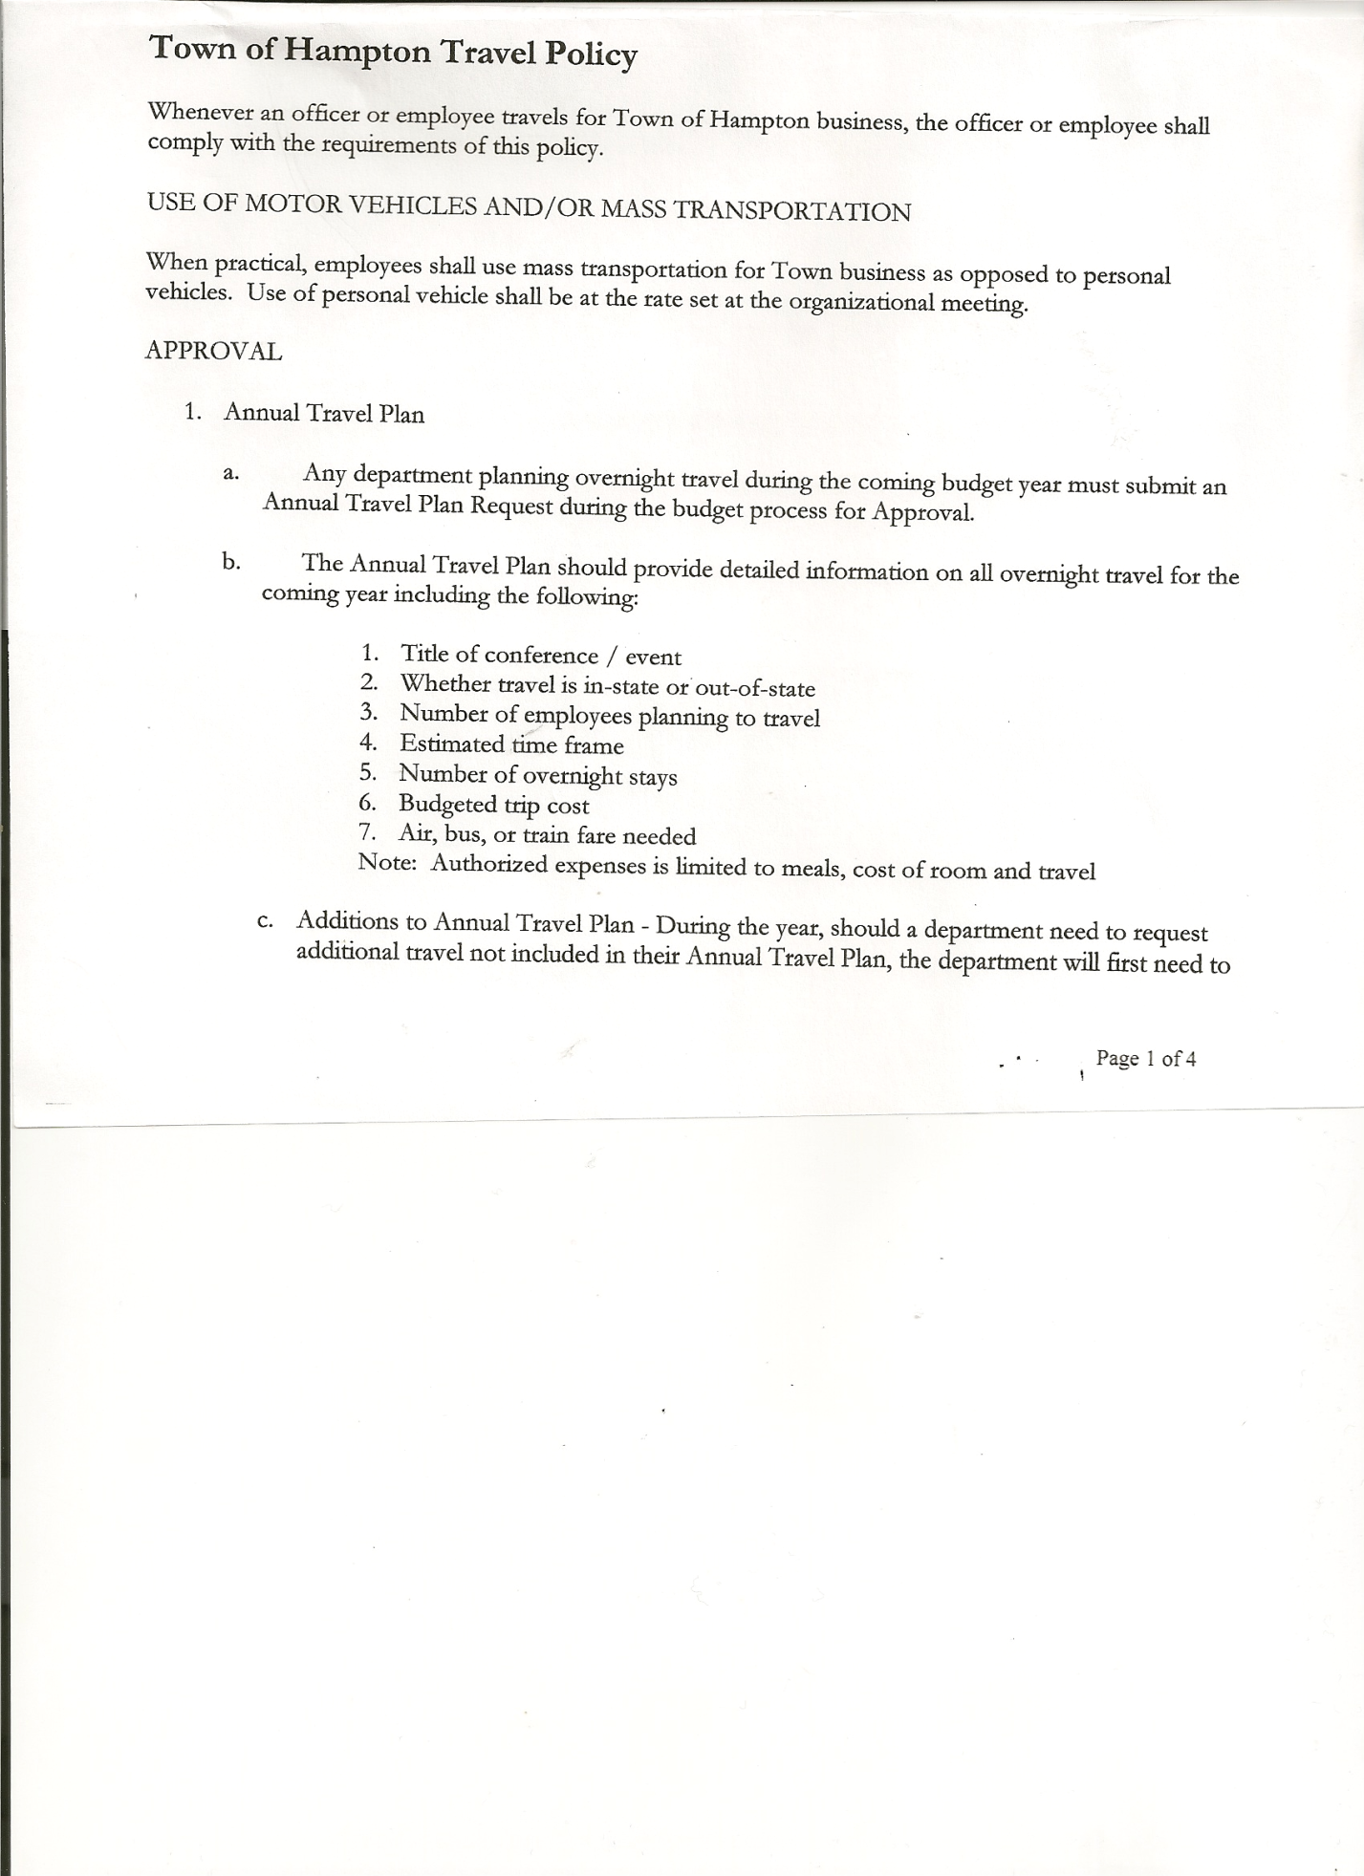
Michael Pietryka------------Councilman - absent
Andrea Kugler---------------Councilwoman - absent
Rebecca Jones---------------Town Clerk
Camilla Shaw----------------Deputy Town Clerk
Tyler McClure---------------Highway Superintendent

Planning Board Member (s):… Bonnie Hawley, Chair; Ginny Kinsey, Matthew Pratt and Rene Rountree
Others present at the Town Hall: see attached sheet

The Regular Meeting was called to order by Supervisor O’Brien at 7:30pm, followed by the Pledge of Allegiance. Location of Fire Exits were given. Quorum of board members present.

Supervisor O’Brien asked for a moment of silence in memory of Jim Kelley, Mike Wood,
John Kashavsky (Eileen Spillane’s uncle), Lewis “Pete” Pratt & Lillian Pomainville (Uncle and Aunt of Town Clerk Jones)

RESOLUTION NO. 104-2023
APPROVAL OF THE MINUTES
On a motion of Councilwoman Taran, seconded by Councilman Sady, the following resolution was ADOPTED: AYES 3 O’Brien, Sady, Taran
NAYS 0
ABSENT 2 Pietryka, Kugler
RESOLVED, that the Regular Town Board Meeting Minutes for November 16th, 2023 are approved.

Dog Control Report….no report

Tax Collector Report…..no activity. The Town Clerk/Collector had Board Members review and sign bank reconciliation statements for the Tax Collector Account November 30, 2023.

Bonnie Hawley, Chair Planning Board….last meeting for the year. Briefly spoke about the 250th celebration for Washington County which is planned for 2026.

Tyler McClure, Highway Superintendent submitted his report, copy of which, is attached.
Considering a uniform contract, the price would be approximately $504.00 per year per person.

TOWN BOARD MEETING
DECEMBER 21, 2023 PAGE 2

SUPERVISOR’S REPORT/COUNTY UPDATES/COMMUNICATIONS

RESOLUTION NO. 105-2023
APPROVAL OF SUPERVISOR’S MONTHLY REPORT
On a motion of Councilwoman Taran, seconded by Councilman Sady, the following resolution was ADOPTED: AYES 3 O’Brien, Sady, Taran
NAYS 0
ABSENT 2 Pietryka, Kugler
RESOLVED that, the Supervisor’s Monthly report be accepted as submitted for NOVEMBER
10/31/23 11/30/23
ACCOUNT BALANCE RECEIPTS DISBURSEMENTS BALANCE
General Fund $ 62,909.85 $ 7,894.36 $ 14,027.29 $ 56,776.92
Highway Fund $126,080.49 $ 114,514.77 $143,337.64 $ 97,257.62
Equipment Reserve$149,991.68 $ 2.85 $ 94,307.00 $ 55,687.53
Fire #1 $ 23,185.50 $ 0.00 $ 0.00 $ 23,185.50
Fire #2 $ 7,680.50 $ 0.00 $ 0.00 $ 7,680.50
Cemetery $ 2,025.76 $ .81 $ 0.00 $ 2,026.57
Totals $371,873.78 $122,412.79 $251,671.93 $ 242,614.64
All Board Members present signed Supervisor’s Report.

RESOLUTION NO. 106 OF 2023

MOTION BY: Councilwoman Tamme Taran
SECONDED BY: Councilman Donald Sady

RESOLUTION ACCEPTING THE PROPOSED
AGRICULTURAL AND FARMLAND PROTECTION PLAN

WHEREAS, pursuant to Section 272-a of the Town Law of the State of New York, the Town Board of the Town of Hampton has the authority to adopt a Comprehensive Plan; and
WHEREAS, in accordance with this authority and Article 25-AAA of NYS Agriculture and Markets Law the Town has been pursuing the development of a town-level plan to protect and enhance agricultural uses in the Town; and
WHEREAS, the Town Board having previously tasked the Town of Hampton Planning Board with the development of an Agricultural and Farmland Protection Plan (the “Plan”); and
WHEREAS, the Planning Board obtained public input through various outreach efforts, and consulted with local officials, departments and committees, Washington County and other municipal representatives, businesses, property owners, environmental organizations, civic groups; and
WHEREAS, the Planning Board, completed their research, prepared the draft Plan, issued a positive recommendation, and have submitted the draft Plan to the Town Board for their consideration and approval; and
WHEREAS, the Town Board hereby classifies the proposed action of adopting the Plan as a Type I SEQR action pursuant to 6 NYCRR § 617.4(b)(1) and a Long Environmental Assessment Form has been prepared for this action.

TOWN BOARD MEETING
DECEMBER 21, 2023 PAGE 3

NOW, THEREFORE BE IT
RESOLVED, the Town Board hereby accepts the draft Agricultural and Farmland Protection Plan; and be it further
RESOLVED, that a public hearing shall be noticed and held by the Town Board on January 18th, 2024 at 7:10p.m to consider the draft Agricultural and Farmland Protection Plan and to hear all interested persons; and be it further
RESOLVED, the Town Clerk is hereby authorized and directed to publish notice of said hearing in the Manchester Newspapers (Granville Sentinel & Whitehall Times), the official Town newspaper, and to post copies of such notice in the manner required by law; and be it further
RESOLVED, the Town Clerk shall forward the draft Agricultural and Farmland Protection Plan together with all requisite materials to the Washington County Planning Board for their review and comment; and be it further
RESOLVED, that this resolution shall take effect immediately.
DATED: December 21, 2023 Supervisor O’Brien AYE
Councilman Sady AYE
Councilwoman Taran AYE
Councilman Pietryka ABSENT
Councilwoman Kugler ABSENT

RESOLUTION 107-2023
PUBLIC HEARING-PROPOSED AGRICULTURAL AND FARMLAND PROTECTION PLAN
On a motion of Councilman Sady, seconded by Councilwoman Taran, the following resolution was ADOPTED: AYES 3 O’Brien, Sady, Taran
NAYS 0
ABSENT 2 Pietryka, Kugler
RESOLVED, to set a Public Hearing on the proposed Agricultural and Farmland Protection Plan for January 18, 2024 at 7:10pm at the Hampton Town Hall.

RESOLUTION NO. 108 OF 2023

MOTION BY: Councilwoman Tamme Taran
SECONDED BY: Councilman Donald Sady

RESOLUTION PROPOSING THE ALTERATION OF
FIRE PROTECTION DISTRICT NUMBER 1 AND
FIRE PROTECTION DISTRICT NUMBER 2

WHEREAS, the Town Board of the Town of the Hampton (the “Town”) is evaluating the Town’s existing Fire Protection District boundaries and are examining whether it is in the public interest to amend the same; and
WHEREAS, pursuant to Town Law §172-C, the Town Board of the Town of Hampton may upon motion alter the boundaries of the Town’s Fire Protection Districts; and
WHEREAS, the Town Board is desirous of expanding Fire Protection District 1 to encompass the whole Town; and
WHEREAS, the Town Board is further desirous of excluding all areas presently served by Fire Protection District 2 and thereby dissolving the same; and

TOWN BOARD MEETING
DECEMBER 21, 2023 PAGE 4

WHEREAS, pursuant to Town Law §172-C, the Town Board of the Town of Hampton shall hold a public hearing to consider whether it is in the public interest to alter the boundaries of the Town’s Fire Protection Districts.
NOW, THEREFORE BE IT
RESOLVED, that a public hearing shall be noticed and held by the Town Board on January 18th, 2024 at 7:20p.m to consider the proposed alteration to the Fire Protection District boundaries for Fire Protection Districts 1 and 2 and to hear all persons interested in such alteration of boundaries; and be it further
RESOLVED, the Town Clerk is hereby authorized and directed to publish notice of said hearing in the Manchester Newspapers (Granville Sentinel & Whitehall Times), the official Town newspaper, and to post copies of such notice in the manner required by law; and be it further.
RESOLVED, that this resolution shall take effect immediately.
DATED: DECEMBER 21, 2023 Supervisor O’Brien AYE
Councilman Sady AYE
Councilwoman Taran AYE
Councilman Pietryka ABSENT
Councilwoman Kugler ABSENT

RESOLUTION 109-2023
PUBLIC HEARING – PROPOSED ALTERATION OF FIRE PROTECTION DISTRICT# 1 AND FIRE PROTECTION DISTRICT #2
On a motion of Councilwoman Taran, seconded by Councilman Sady, the following resolution was ADOPTED: AYES 3 O’Brien, Sady, Taran
NAYS 0
ABSENT 2 Pietryka, Kugler
RESOLVED, to set a Public Hearing on the proposed Alteration of Fire Protection District#1 and Fire Protection District#2 for January 18th, 2024 at 7:20pm at the Hampton Town Hall.

Annual Audits: Councilman Pietryka & Councilman Sady---Budget Officer
Councilwoman Kugler & Councilwoman Taran----Town Clerk & Tax Collector
Supervisor O’Brien-----Judge

PUBLIC/COUNCIL COMMENTS
Ballard Road by County Route 18 issue, hard to make that turn. Tyler with check with the County if it can be widened.

RESOLUTION NO. 110-2023
AUDIT OF CLAIMS
On a motion of Councilman Sady, seconded by Councilwoman Taran, the following resolution was ADOPTED: AYES 3 O’Brien, Sady, Taran
NAYS 0
ABSENT 2 Pietryka, Kugler
RESOLVED that the bills have been reviewed by the Town Board and are authorized for payment in the following amounts.
General Fund No.137 through No. 156 $ 39,523.78
Highway Fund No.135 through No. 153 $ 45,121.02
Total both funds $ 84,644.80

TOWN BOARD MEETING
DECEMBER 21, 2023 PAGE 5

The Town Clerk’s report for November 2023 was submitted to the Board. The Town Clerk had Board Members review and sign bank reconciliation statements for the Town Clerk Account and Special Clerk Account dated November 30, 2023.

RESOLUTION NO. 111-2023
MEETING ADJOURNED
On a motion of Councilman Sady, seconded by Councilwoman Taran the following resolution was ADOPTED: AYES 3 O’Brien, Sady, Taran
NAYS 0
ABSENT 2 Pietryka, Kugler
RESOLVED that the meeting adjourned at 8:03pm.

Respectfully submitted,

Rebecca S. Jones, RMC
Town Clerk

