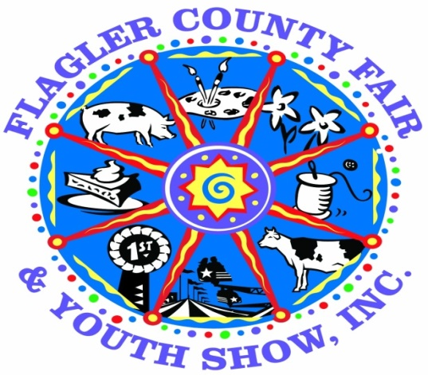
The Agriculture Committee is pleased to announce the continuation of our
“Country Critter Competition”
at the FLAGLER COUNTY FAIR AND YOUTH SHOW

The purpose of this competition:
- Encourage participation from youth in our community who have little knowledge of agriculture
- Allow youth to have a competitive animal project without raising a live animal
Rules:
- Entries may be submitted by 4H and FFA members only.
- Age Divisions (as of September 1, 2020)
Cloverbuds 5-7 Junior 8-10 Intermediate 11-13 Senior 14-18
- Exhibitors will be limited to one entry in their age division.
- Entries will be judged and awarded Ribbons and Cash Prizes.
- Placing/Awards in each age division will be:
1st Place – Blue Ribbon & $10.00 Cash Reward
2nd Place – Red Ribbon & $5.00 Cash Reward
3rd Place – White Ribbon & $3.00 Cash Reward
- An overall “Best of Show” winner will be awarded a rosette and $25.00 cash award
- Critters have a maximum size of 3’ x 3’ x 2’ (LxWxH)
- Critters will be judged on creativity, attractiveness, originality, neatness and age specific entries.
- All critters will be on display at the fairgrounds during the upcoming Flagler County Fair & Youth Show
- Points will be based on age specific entries. Entry must look like the exhibitor actually made the float according to their age division.
Important Dates & Deadlines:
- Drop Off: Monday April 5th from 1pm-6pm in the Cattlemans Hall
- Pickup: Once judging and ribbons are complete.
- Judging: Tuesday April 6th

Contacts for this Competition:
Penny Buckles – Fair Manager (386) 931-6597
Ennasea Coute – (386) 627-4122
Email: flaglerctyfair@bellsouth.net Website: www.flaglercountyfair.com

