August 22, 2021

13th Sunday after Pentecost

Carson City United Methodist Church

10:00 am
Prelude/Greeting
*Indicates stand as you are able

Call to Worship
From Psalm 8

L: Lord, our Lord, how majestic is your name in all the earth!
You have set your glory in the heavens.

P: Through the praise of children and infants you have established a stronghold against your enemies, to silence the foe and the avenger.

L: When we consider your heavens, the work of your fingers, the moon, and the stars, which you have set in place,

P: who are we that you are mindful of us?

L: You have made us a little lower than the angels and crowned us with glory and honor.

P: We are the living stones in your temple.

*Hymn: Standing on the Promises UMH 374

Opening Prayer: (unison)
O Gracious and Holy God, give us diligence to seek you, wisdom to perceive you, and patience to wait for you. Grant us Lord, a mind to meditate on you; eyes to behold you; ears to listen for your word; a heart to love you; and a life to proclaim you; In Jesus, precious and Holy name who lives and reigns with you in unity with the Holy Spirit we pray. AMEN.
*Hymn: Less Like Me (Zach Williams)

Gospel Reading: JOHN 4:23-24
Old Testament: JEREMIAH 31:33-34
Epistle Lesson: EPHESIANS 2:21-22

THE MESSAGE

Hymn: This train is bound for Glory (VBS)

Sharing of our joys and concerns

Call to Prayer: Turn Your Eyes Upon Jesus
UMH 349

Pastoral Prayer

Offering/Offertory Prayer

Doxology UMH 94

*Hymn: Sent Forth by God’s Blessing UMH 664

BENEDICTION

CCUMC – Announcements

========================================
Ad Board, Finance & Town Hall meeting will be held on
8/25/21 starting @ 6:00 pm.
========================================
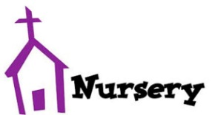
Nursery returns on Sunday, 9/12/21. The schedule will be posted on the Nursery window at the
end of August.
========================================
Effective Sunday, 9/12/21, we will continue with one Worship Service, but it will start at 11:00 am.
=========================================
Come join the fun on Sun, Sep 12th @ 9:30 am for lots of activities to welcome back our Sunday “Cool” Hour. Kids, Teens,
and/or Adults are invited.
=========================================
Upcoming UMW Soup Luncheons: Sep 17th & Oct 15th.
=========================================
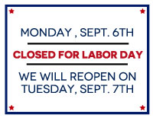

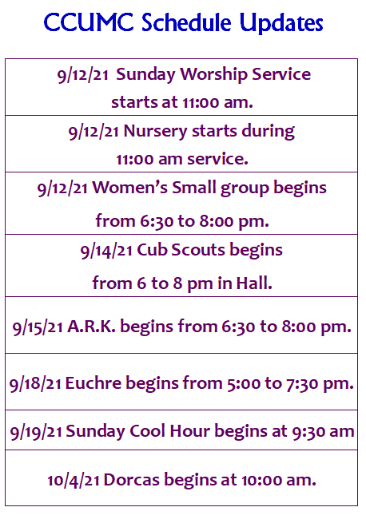

Serving and Supporting Sunday Worship
Audio/Video: Pat Monroe

Joys, Concerns & Prayer Request
For those battling cancers: Wendy Crawfis,
Beth Grienke, Kale Litwiller, Jim Dunlap,
Carolyn Nykerk, & Ray Seaman

For everyone who needs support,
guidance or has health concerns.

Monthly Giving
8/1 $2095.57 8/8 $4100.63
8/15 $2070.57

Upcoming
8/25 Ad Board, Finance & Town mtg 6:00 pm
9/01 UMW Leadership mtg 10:00 am
9/06 Labor Day – Office Closed

Our Church in Ministry This Week

Mon 6:30 pm | Personal Transformation Class

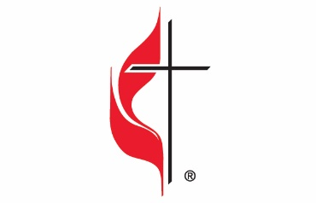

Carson City United Methodist Church
Location: 119 East Elm St., Carson City, MI
Mail: PO Box 298, Carson City, MI 48811
Phone: 989-584-3797 Email: carsoncityumc@gmail.com
Website: carsoncityumc.com
Office Hours: Monday-Thursday, 9:00 am-12:00 pm
After hours by appointment
Pastor: Ian McDonald 906-322-5318
Secretary: Bonnie Seaman 989-763-1674

Weekly Sunday Bulletin now available on our website
@ www.carsoncityumc.com

“Dear God, thank You for the encouragement
we receive from scripture.
Help us to persevere in doing good”

