REGULAR MEETING
OCTOBER 15, 2020

A Regular Meeting of the Town Board of the Town of Hampton, County of Washington and the State of New York was held at the Town Hall and via Zoom, 2629 State Route 22A, Hampton, New York on the 15th day of October 2020.

Due to the Corona Virus, occupancy inside the Town Hall is limited at this time. Supervisor O’Brien did provide a link to join the meeting via Zoom.

PRESENT: David K. O’Brien------------Supervisor
Tamme Taran----------------Councilwoman
Donald Sady-----------------Councilman
Andrea Sweeney------------Councilwoman – absent
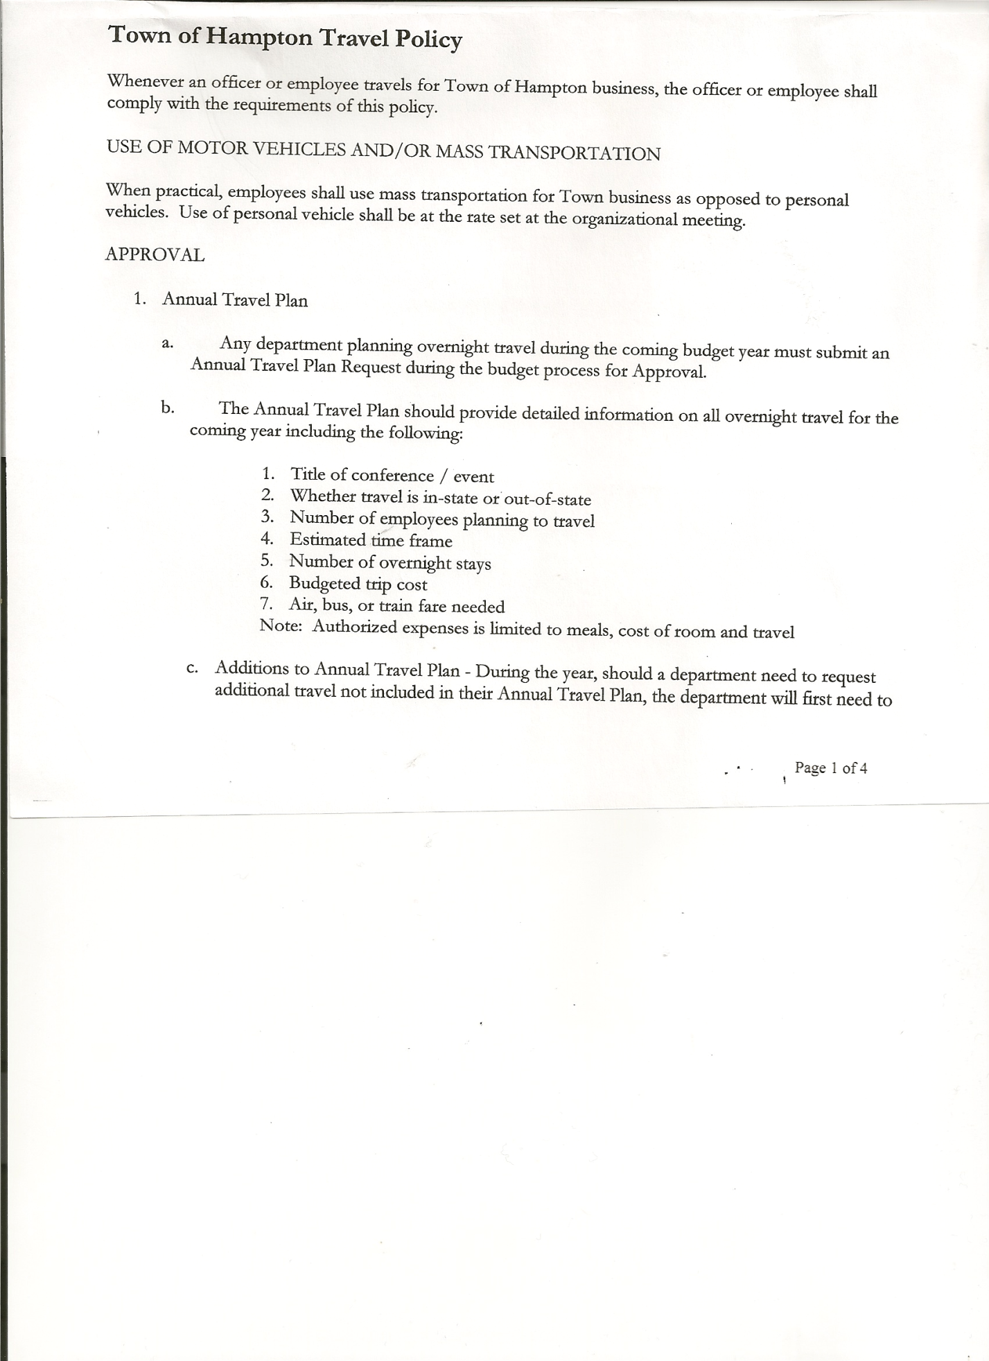
Michael Pietryka------------Councilman
Rebecca Jones---------------Town Clerk
Camilla Shaw----------------Tax Collector/Deputy Town Clerk
Herbert Sady, Jr.-------------Highway Superintendent – via zoom

Planning Board Member(s): Bonnie Hawley (via Zoom)
Others present at the Town Hall: John Grady (Land Surveyor); Artie Pratt and Leonard Reed

The Regular Meeting was called to order by Supervisor O’Brien at 7:30pm, followed by the Pledge of Allegiance. Location of Fire Exits were given. Quorum of board members present.

RESOLUTION NO. 83-2020
APPROVAL OF THE MINUTES
On a motion of Councilwoman Taran, seconded by Councilman Sady, the following resolution was ADOPTED:
By Roll Call Vote: Supervisor O’Brien AYE
Councilman Sady AYE
Councilwoman Taran AYE
Councilman Pietryka AYE
Councilwoman Sweeney ABSENT
RESOLVED, that the Regular Town Board Minutes for September 17th, 2020 and the Special meeting on October 8th, 2020 are approved.

Larry Carman, Dog Control Officer – no report submitted

Tax Collector’s Report – no activity. Submitted Bank Statement to the Board for review and signatures.

TOWN BOARD MEETING
OCTOBER 15, 2020 PAGE 2

PERMITS AND SUBDIVISONS

John Grady, representing Caitlin Young brought before the board plans for a Subdivision regarding property located at 1462 Carver Falls Lane.

RESOLUTION NO. 84-2020
SHORT ENVIRONMENTAL ASSESSMENT FORM - NEGATIVE DECLARATION
On a motion of Councilman Sady, seconded by Councilwoman Taran, the following resolution was ADOPTED:
By Roll Call Vote: Supervisor O’Brien AYE
Councilman Sady AYE
Councilwoman Taran AYE
Councilman Pietryka AYE
Councilwoman Sweeney ABSENT
RESOLVED, that the Short Environmental Assessment Form for Caitlin Young is complete and to adopt a negative declaration and finding that there will be no adverse environmental impacts and to consider it a minor subdivision, therefore waving the public hearing.

RESOLUTION NO. 85-2020
APPROVAL OF SUBDIVISION- YOUNG
On a motion of Councilman Sady, seconded by Councilman Pietryka, the following resolution was ADOPTED:
By Roll Call Vote: Supervisor O’Brien AYE
Councilman Sady AYE
Councilwoman Taran AYE
Councilman Pietryka AYE
Councilwoman Sweeney ABSENT
RESOLVED, to approve Young subdivision.

Bonnie Hawley, Chair gave Planning Board Report…

- Planning Board met on October 14th…three members were unable to attend.
- 54 surveys were received so far. They read through them.
- In two weeks (October 28th) they will meet and tabulate the results.

Herbert Sady, Jr., Highway Superintendent submitted his report, copy of which, is attached.

On hiring a new highway worker, there is one who has a permit, but needs a vehicle to take the test with. Possibility of using a town truck for that. Supervisor O’Brien inquired if the county has anyone who trains people that might be available to help.

TOWN BOARD MEETING
OCTOBER 15, 2020 PAGE 3

SUPERVISOR’S REPORT/COUNTY UPDATES/COMMUNICATIONS

RESOLUTION NO. 86 -2020
APPROVAL OF SUPERVISOR’S MONTHLY REPORT
On a motion of Councilman Sady, seconded by Councilwoman Taran, the following resolution was ADOPTED:
By Roll Call Vote: Supervisor O’Brien AYE
Councilman Sady AYE
Councilwoman Taran AYE
Councilman Pietryka AYE
Councilwoman Sweeney ABSENT
RESOLVED that, the Supervisor’s Monthly report be accepted as submitted for SEPTEMBER
08/31/20 09/30/2020
ACCOUNT BALANCE RECEIPTS DISBURSEMENTS BALANCE
General Fund $ 59,825.65 $ 590.26 $ 11,353.80 $ 49,062.11
Highway Fund $ 54,560.70 $ 2.17 $ 16,702.48 $ 37,860.39
Equipment Reserve $ 54,888.88 $ 2.25 $ 0.00 $ 54,891.13
Fire #1 $ 21,224.00 $ 0.00 $ 0.00 $ 21,224.00
Fire #2 $ 5,000.00 $ 0.00 $ 0.00 $ 5,000.00
Cemetery $ 1,738.34 $ 1.15 $ 0.00 $ 1,739.49
Totals $197,237.57 $ 595.83 $ 28,056.28 $ 169,777.12

Supervisor O’Brien reported that the County Budget is up about 1.6%.

RESOLUTION NO. 87 -2020
BOARD OF ASSESSMENT REVIEW MEMBER-REAPPOINTMENT
On a motion of Councilwoman Taran, seconded by Councilman Sady, the following resolution was ADOPTED:
By Roll Call Vote: Supervisor O’Brien AYE
Councilman Sady AYE
Councilwoman Taran AYE
Councilman Pietryka AYE
Councilwoman Sweeney ABSENT
RESOLVED, to reappoint Leonard Reed to the Board of Assessment Review for the term 10/01/2020 to 09/30/2025.

The Town Clerk’s report for September 2020 was submitted to the Board. The Town Clerk had Board Members review and sign bank reconciliation statements for the Town Clerk Account and Special Clerk Account dated September 30th, 2020.

TOWN BOARD MEETING
OCTOBER 15, 2020 PAGE 4

RESOLUTION NO. 88-2020
AUDIT OF CLAIMS
On a motion of Councilwoman Taran, seconded by Councilman Sady, the following resolution was ADOPTED:
By Roll Call Vote: Supervisor O’Brien AYE
Councilman Sady AYE
Councilwoman Taran AYE
Councilman Pietryka AYE
Councilwoman Sweeney ABSENT
RESOLVED that the bills have been reviewed by the Town Board and are authorized for payment in the following amount
General Fund No. 91 through No.103 $ 1,665.50
Highway Fund No. 98 through No.105 $ 3,107.73
Total both funds $ 4,773.23

RESOLUTION NO. 89-2020
MEETING ADJOURNED
On a motion of Councilwoman Taran, seconded by Councilman Sady, the following resolution
was ADOPTED:
By Roll Call Vote: Supervisor O’Brien AYE
Councilman Sady AYE
Councilwoman Taran AYE
Councilman Pietryka AYE
Councilwoman Sweeney ABSENT

RESOLVED that the meeting adjourned at 8:00pm.

Respectfully submitted,

Rebecca S. Jones, RMC
Town Clerk
Assisted by Camilla Shaw,
Deputy Town Clerk

