How do I… verify an email address?

Verifying your email address will allow you to receive Ceridian messages/notifications directly to your email, and to reset your password if forgotten.
You can access your email address by selecting the “Profile & Settings” option on the menu panel.
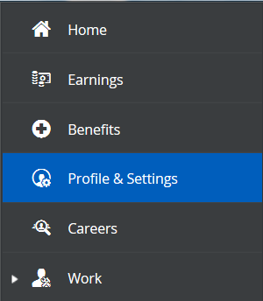
Click “Edit” next to “Contact Information”.
Select the type of email address, enter in your email address, then select the “Alerts” check box. This will allow you to select the “Verify” option.
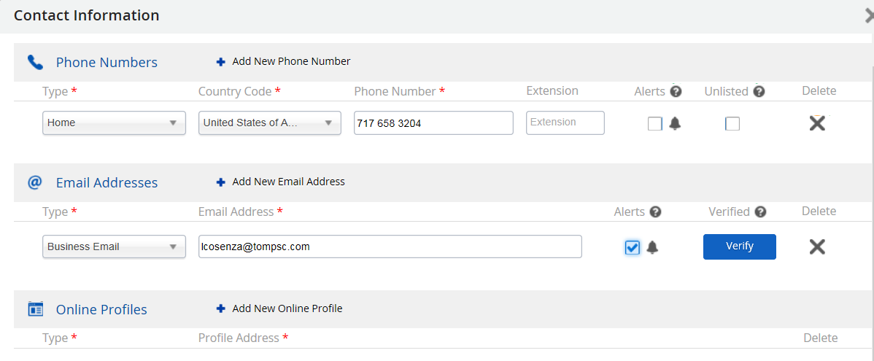
Click “Save” after entering your information.
Note: After entering and saving your email address, you may have to log out then log back in to be able to select “Verify”.

You may add more than one email address to Ceridian, but you may only have one address verified.

