April 21, 2021
Dear Tennis Supporter,

Hello friends of tennis! I have been slow to engage with social media platforms but recently I discovered I can re-watch classic tennis matches on YouTube and I have been glued to my television in the evenings watching great tennis matches like the 5-set Wimbledon serve and volley battle between Edberg and Becker, the 6-hour, 22 minute, McEnroe Davis Cup victory versus Mats Wilander, and the 1988 Wimbledon Ladies’ Singles Championship when Steffi Graff finally ended Martina Navratilova’s streak of 6 straight Wimbledon singles titles. There is one thing I have noticed from all of these matches. Namely, good tennis is timeless and a special blessing no matter what decade you are in. My fellow instructors and THJTA board members feel the same about our local tennis organization, the Terre Haute Junior Tennis Association. We are entering our 36th year of uninterrupted summer tennis camps, lessons, and tournaments. What we have learned in this time is that classic tennis fundamentals and values never go out of style.

The THJTA was built from the very beginning to be a program for EVERYONE. We have a pathway that starts with beginning elementary age tennis clinics and moves all the way to advanced state-level high school players. We have never turned anyone away for inability to pay and have offered thousands of hours of free instruction in the past and hundreds of scholarships. There is quite simply a place for everyone in our programs because everyone is important and everyone has a place in the great game of tennis. If you have never hit a ball over the net before, you will make your first shot with us. If you are willing to spend your time to work on your game in the summer, we will give you the best chance to accomplish your goals on your team and for your team.

We did not break our recent record this past summer for unique summer tennis participants of 478 players set in the summer of 2019 in large part due to the circumstances of the past year, but Covid-19 did not shut us down either. We limited our program offerings to be safe for our players but we still had daily tennis clinics meeting for the whole summer. Last summer was the first time I was not on court with the THJTA in the past 20 summers. I am very grateful for the outstanding leadership of my friend and fellow THJTA officer and instructor, Dallas Kelsey, for navigating the many challenges Covid-19 presented in 2020 to our camp and the world. He and all of the THJTA instructors and board members worked very hard to make sure tennis was available last summer and a safe option for those who were able to play.

For this next summer we are planning to expand our programs back to their usual complement and multiple locations. We exist to help people learn and improve at tennis and to share our deep appreciation with our students of how special a game tennis is for those who love it. Please take a few moments to read through our donor brochure and consider helping us with a financial donation of any size for the coming summer. The support of the people and organizations listed in this brochure is crucial to our ability to sustain and grow our programs. I hope for the coming summer things start to feel truly back to normal and we will see hundreds of our players experience classic moments in their own tennis. Thank you very much for your consideration. Best wishes to you and your family for a summer full of family, fun, friends, and tennis!

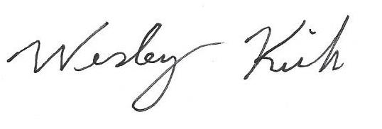
Sincerely,

Wesley Kirk
President
Terre Haute Junior Tennis Association

