Pierceton Days Car & truck Show
Friday – July 28th 2023
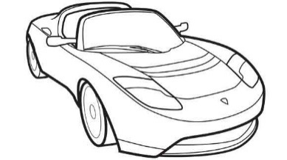

Registration 1pm to 5pm-Judging Begins at 5pm
At the tent in McHatton Sadler Funeral Chapel parking lot

* Parking places will be based on arrival * SR 13 will open up for parking on the road at 1pm *

Plaques awarded to the top category winners for cars and trucks!

Best of Show $250 for cars/trucks
People’s Choice $100 for cars/trucks

Awards will be announced at DJ Booth at 8:30pm

Preregistration: $10.00
Registration day of show: $15.00
(Make Checks Payable to Pierceton Chamber of Commerce)

Mail entry forms to Pierceton Chamber of Commerce PO Box 49 Pierceton, IN 46562

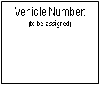
Name: _________________________________________________________
Car / Truck

Phone number: ___________________________________________________

Year / Make / Model: _______________________________________________

Entrants and participants by execution of the entry form release and discharge the Pierceton Days Festival and anyone else connected with the management of the car show from all known and unknown injuries, losses, judgements, and/or claims from any causes whatsoever that may be suffered by a participant to his/her property or person. I also acknowledge that we will be parked as we arrive and that I will follow the direction of staff onsite during the parking procedures.

Signature: _______________________________________ Date: _________________________________

For more information, contact Pierceton Chamber of Commerce at 1-574-797-3033

