

2022
Liberation Club Doubles Cup

A beautiful sunny evening was enjoyed by the 13 teams that took part this year.

Despite matches being timed at just 30 minutes (plus 1 additional end) many matches made it to thirteen points. Some big wins for the top teams in Round 1 as holders Andrew & Callum won 13 – 3 over last years third place team Daniel & James.

Mark Nicol & Matt Pinel won 13 – 1 against Dawn & James Gennoe and this result was matched by Geoffroy & Matt over Branden & Tim and Laurent & Toby over Andrew & Lorna with Toby hitting two spot carreaux on consecutive ends to gain five and four point ends respectively making a big difference in the match.

Neil & Ross did have a 13 point match but it end 8 – 5 to them over Graeme & Keith. With Gavin & James losing 7 – 10 to Alan & Joey.

In Round 2 Dawn & James got off the mark with a 12 – 6 win over Branden & Tim and Graeme & Keith also won over Andrew & Lorna. James & Gavin came back from 5 – 2 down against Laurent & Toby to win 13 – 6.

A big match between Geoffroy & Matt Buesnel against Mark & Matt Pinel saw the latter win 10 – 5. A close match between Andrew & Callum winning 9 – 6 over Alan & Joey. Neil & Ross also moved on to two wins with a big 13 – 4 win over Cassie & Jean.

Neil & Ross continued to dominate the qualifying rounds beating champions Andrew & Callum 13 – 4 and Mark & Matt also made it three wins winning big 13 – 3 over Alan & Joey.

Laurent & Toby got they game back together winning 12 – 6 over Cassie & Jean as did Geoffroy & Matt winning 9 – 6 over Dawn & James.

Another 9 – 6 win for Gavin & James over Daniel & James and Graeme & Keith moved into contention for a qualifying spot with a big win 13 – 3 over Branden & Tim.

In the final qualifying round Laurent & Toby beat Graeme & Keith 13 – 5 to finish fifth with Graeme & Keith finishing sixth.

Neil & Ross beat Mark & Matt 13 – 7 to finish on four wins from four and ranked first with Mark & Matt finishing second.

Andrew & Callum won 13 – 7 to finish third with their opponents Gavin & James finishing seventh qualifying with two wins.

Geoffroy & Matt and Alan & Joey both won their matches 13 – 2 as they both qualified in forth and eighth place respectively. But despite winning their last match

Dawn & James missed out in nineth.

Final Swiss Rankings

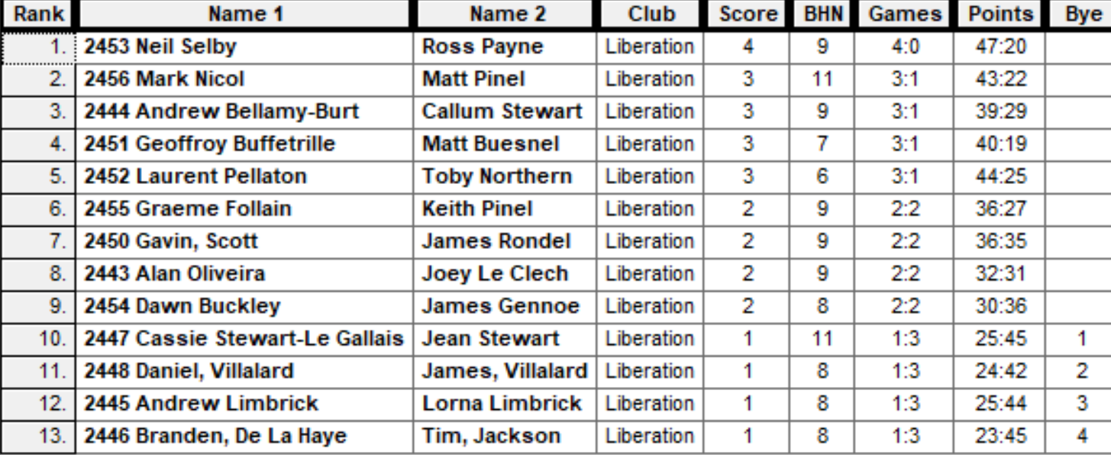

Quarter Finals

Ranked 1st Neil & Ross v Alan & Joey Ranked 8th

Ranked 2nd Mark & Matt v Gavin & James Ranked 7th

Ranked 3rd Andrew & Callum v Graeme & Keith Ranked 6th

Ranked 4th Geoffroy & Matt v Laurent & Toby Ranked 5th

The top ranked team broke the Swiss curse winning the quarter final match 13 – 8 over Alan & Joey.

Two shocks though as Mark & Matt were beaten 10 – 7 against Gavin & James who produced their best game of the tournament and Graeme & Keith knocked out the holders Andrew & Callum in a nail biter 12 – 11.

Laurent & Toby had a big lead going into the final two ends with Geoffroy & Matt only picking up 1 point needed a four point end just to tie and despite having a decent chance, couldn’t pull it off as last years runners up went out.

Semi Finals

Ranked 1st Neil & Ross v Laurent & Toby Ranked 5th

Ranked 6th Graeme & Keith v Gavin & James Ranked 7th

Neil and Ross showed composure in the opening ends to take a four-nil lead, but that was all they ended up win as a combination of placing and firing saw Laurent & Toby score eleven consecutive points and with a seven point lead didn’t need to play the last end.

Gavin & James kept up their good form to make their first final in the Club Doubles Cup winning 13 – 6 over Graeme & Keith.

The third place play off was won by Neil & Ross, taking the match 13 – 9 over Graeme 7 Keith for a good tournament for both teams.

The final was played to an exceptional standard with some brilliant placing on both sides from Laurent and James and great shooting from Gavin and Toby and despite just fractions being in each end Laurent & Toby moved 9 – 0 up before two ends saw Gavin & James get three points, but that was the end of the comeback as Toby sealed the win placing two boules on the coche at 9 meters to seal his fifth win in the competition and Laurent first win and Laurent forth title already this year!

Special thanks to all those who helped set up and prepare for the competition and tidy up at the end.

Photo below.

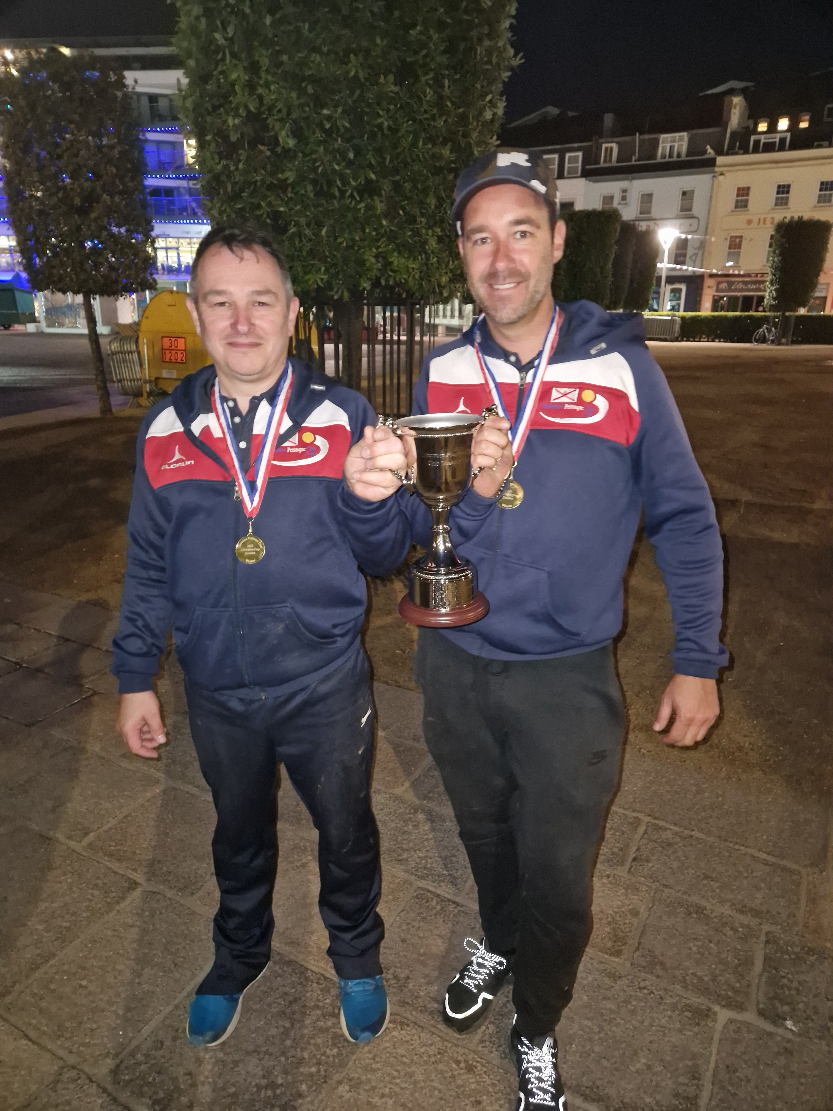

Sponsored by



CoinShares | Digital Asset Investment Strategies for Professionals 🚀

NEXT WEEK - CLUB DOUBLES CUP

Club email address - liberationpc@gmail.com

Club Website - www.liberationpetanque.co.uk

Kind Regards

Toby Northern

Chairman

Liberation Petanque Club

