Shiitake Mushroom Varieties

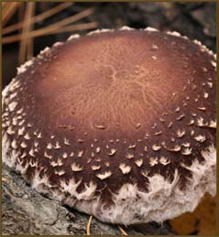
X

Shiitake - Snow Cap (from Field & Forest Products)
Snow Cap™ produces beautiful, uniform, thick fleshed caps tufted with white lacey ornamentation. A long natural outdoor season makes it a favorite for those who like to visit their logs regularly. Heaviest fruiting occurs early spring and late fall. Possibly the best winter strain in the South. Cold weather strain.

XX

Shiitake Sawdust Spawn (from Fungi Perfect)

Latin Name: Lentinula edodes; Fruiting Temperature: 55–75 °F
This is an all-weather strain. It can fruit from 50–80 °F but performs best at 58–60 °F. An ideal candidate for indoor cultivation on supplemented sawdust. Incubation time is about 6 weeks (on alder)
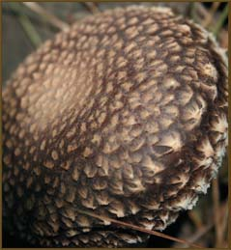

XX

Shiitake - Night Velvet (from Field & Forest Products)
This Warm Weather strain behaves more more like a Wide Range strain: fast spawn run and good response to force fruiting. Produces well in both northern and southern states, growing big, plump mushrooms that are like picking apples.

