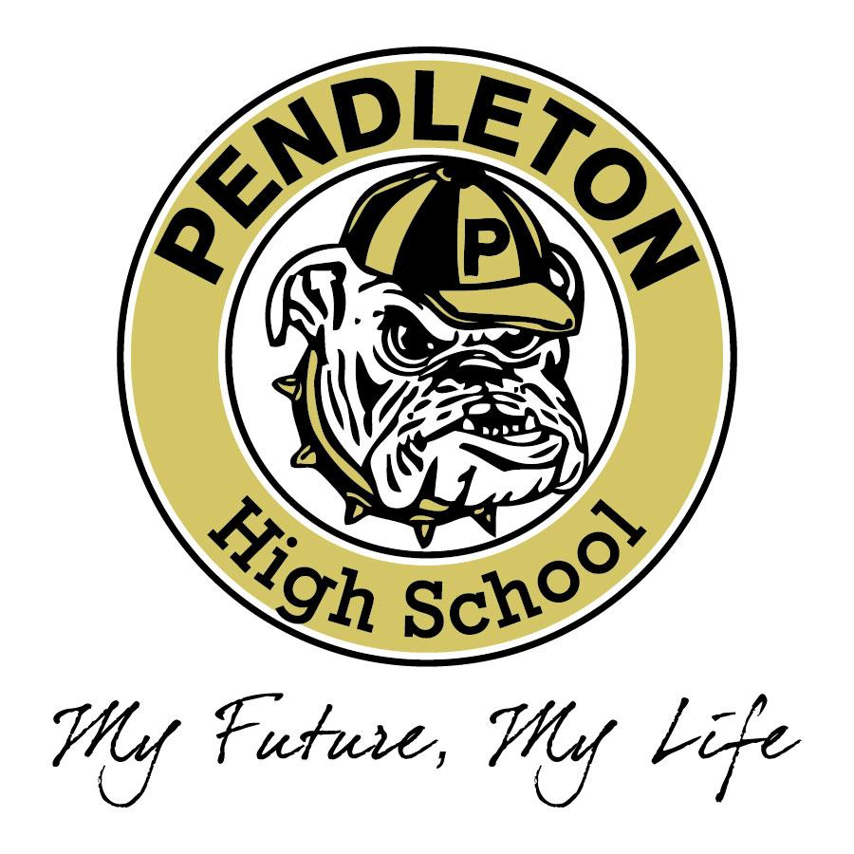
Pendleton High School
Senior Capstone

Course Description
The Senior Capstone is designed to prepare students for college level learning and career success after high school in a global society. Students will select a topic that relates to one of the Schools of Study endorsed by Pendleton High School and Anderson School District Four. Students will be immersed in a personalized learning environment that promotes academic achievement and personal development while being equipped with a variety of skills that will have direct application after high school graduation. Skills will be mastered through a series of rigorous assignments with high expectations. Students will not only complete the Senior Capstone with college or career readiness as a goal, they will also have mastered essential communication skills to aid them in pursuit of productive citizenship. In order to complete course assignments, students must rely on many of the skills that they have acquired over the past twelve years. Students must also learn to solve problems and to manage time wisely. The rigorous broad-based research required is typical of what one may be asked to do after leaving high school, whether to go to college, to the military, or to the workplace. Students will be confident, productive citizens after leaving Pendleton High School. Successfully completing the Senior Capstone is a rewarding culmination of a student’s secondary education.

What is the Senior Capstone?
The Senior Capstone is a process that gives students the opportunity to choose a topic of interest, to conduct research, to design a related project, and to present the results to the school and to the community while learning and putting into practice essential career and technical communication skills. Students will choose a topic that relates to their School of Study: School of Arts, Communications and Humanities (ARCH), School of Health, Human Development and Public Service (HHDPS), or School of Science, Technology, Engineering and Mathematics (STEM).

Course Assignments
- Topic Submission with Project Proposal
- Declaration Speech
- Letter of Intent
- Mentor Information Sheet
- Research Checkpoints
- Mentor Interview
- Research Paper
- Cover Letter
- Resume
- Reference List with Letter
- Personal Interview
- Hands-on Project
- Work Log
- ePortfolio
- Capstone Presentation
- Reflection Journal
- Self-Evaluation

Assignment Descriptions (*Honors Level Requirement)

- Topic Submission/Project Proposal
Students will submit a topic submission form that aligns with the Schools of Study endorsed by Pendleton High School to the Capstone Project Advisory Committee (CPAC) detailing their wishes and plans for the topic of study they have chosen. The CPAC will review all submissions within one week and approve or decline each topic. If a student’s topic is declined, they will meet with the Capstone teacher and resubmit to the CPAC for approval. *Honors students will submit an essay outlining their entire Senior Capstone Project.

- Declaration Speech
Students will prepare and present a 2-3 (*4-5) minute speech in class declaring their intentions and plans for completing their project.

- Letter of Intent
Students will write a formal business style letter of intent to their teacher documenting their intentions for their project.

- Mentor Information Sheet
Students must secure a mentor to assist them in the completion of their project. A mentor information sheet, completed by the student and their mentor, will be turned in to their teacher and then the CPAC.

- Research Checkpoints
Students will spend significant time on the research process for their Senior Capstone Project. Students must meet graded checkpoints in a timeline manner in order to keep up with the process. Checkpoints include: research question, research outline, works cited with at least 5 sources (*7 sources), annotated bibliography, rough draft progress, rough draft, and peer editing.

- Mentor Interview
Students will conduct an interview with their mentor to be used as source material during their research. Mentor interview documentation will be submitted to their teacher and included in their works cited and annotated bibliography.

- Research Paper
Students will write and submit a 4-5 (*6-7) page research paper on their topic following MLA format and guidelines.

- Cover Letter
Students will research a career field related to their School of Study then complete a cover letter tailored to a specific job description.

- Resume
Students will create an original resume following a template that could be used as a professional and academic resume upon graduation.

- Reference List and Reference Letter
Students will create a list of professional references with contact information and ask one of these references to write and submit a reference letter on their behalf outlining their character and work ethic.

- Personal Interview
Students will go through the personal interview process with a professional who has knowledge of their field of interest. Students will be required to schedule their interview during a specific time frame.

- Hands-on Project
The hands-on project serves the purpose of developing a project outside of the normal school day that furthers the research paper. This is completely student driven. Once the student determines what they would like to complete their hands-on project on, they must secure a person who will oversee the progress towards completion of the hands-on project. This person will be the student’s mentor. The actual project and requirements will vary from student to student based on their topic of selection in their School of Study. The time that students spend on the hands-on project will be documented in a work log.

- Work Log
Students will keep a detailed work log to document the hours they spend on their hands-on project. Students must spend a minimum of 10 hours (*15 hours) on their hands-on project.

- ePortfolio
An electronic portfolio will be completed and available for view by teachers, judges, students, and community members by the end of the process. The eportfolio will include all of the work the student has completed throughout the Senior Capstone Project process.

- Capstone Presentation
Students will present their research along with their hands-on project in an audio/visual presentation format in 4-7 minutes (*5-8 minutes) to a panel of judges. The student presentation will be followed by a 5 minute question and answer session between the judges and the student.

- Reflection Journal
A reflection journal will be kept by the student throughout the Senior Capstone Project process. After completing the final presentation, the reflection journal will be submitted into the Capstone teacher.

- Self-Evaluation
A formal self-assessment will be completed by the student after completion of the Senior Capstone Project.

How are teachers and community members involved?
- Students will select a mentor who has expertise in the area that they choose for their project. This person will guide them through the hands-on component of the Senior Capstone Project. The mentor will initial and sign the student’s work log verifying that the student has spent at least 10 (*15) hours completing the project. (The mentor is not required to spend the full amount of hours working with the student. Mentors, as experts in their field, will be able to verify student work hours - independent and supervised - and will help the student be accountable for his/her work and progress toward their goal.) The mentor may not be a peer or a relative of the student. Family and friends will be expected to support students in other ways.

- A Panel of Judges from the community will evaluate student presentations. Each panel of judges will be made up of at least four members including two members of the PHS faculty. PHS will provide the panel of judges.

- The Senior Capstone teacher will guide students through the entire process. He/she will not serve as a mentor, or presentation judge. The teacher will give students the necessary information and instruction to help them make their Senior Capstone Project a successful, rewarding experience. The Senior Capstone teacher will be responsible for grading all Senior Capstone Project work and assignments.

PHS Senior Capstone Project Timeline

Assignment | Due
Topic Submission and Proposal Letter | Week 2
Letter of Intent | Week 3
Declaration Speech | Week 3
Mentor Information Sheet | Week 4
Research Checkpoints | Week 5-9
Final Research Paper | Week 10
Cover Letter, Resume, and References | Week 11
Personal Interview | Week 11
Work Log | Week 12
ePortfolio | Week 13-14
Practice Presentation | Week 15
Final Presentation | Week 16
Reflection Journal/Self-Assessment | Week 16

Some Senior Capstone Project Topics and Related Research Ideas

Project Topic | Research Paper Topic | School of Study
Become Healthcare Volunteer | Alternative Medical Treatments
Assist as an After-school Care Volunteer | ADHD Treatments | HHDPS
Serve as a Volunteer fireman | Treatments for Burn Victims | HHDPS
Learn to play the mandolin | Origins of Bluegrass Music | ARCH
Search for Birth Parents | Rights of an Adoptee | HHDPS
Build a robotic hand | Robotics and Prosthetics | STEM
Ran a marathon | Running for Fitness | HHDPS
Tutored teenage stroke victim | Strokes | STEM
Taught Sunday school class for 6 year olds | Elementary Education as a Career | HHDPS
Taught my grandmother how to drive | Geriatric Medicine as a Career | HHDPS
Served as a caregiver for an Alzheimer’s patient | Dementia and its Treatments | HHDPS
Made a quilt | The History of Quilting | ARCH
Learned to crochet | The Yarn Industry | ARCH
Learned to sew and made a dress | Fashion Design as a Career | ARCH
Worked at a Vet’s office | Animal Rights | HHDPS
Painted a mural | Funding the Arts in Public Schools | ARCH
Wrote an original song | The History of Acoustic Guitar | ARCH
Learned to play the guitar | Jimi Hendrix | ARCH
Learned to swim | Infant Swimming Programs | HHDPS
Wrote a collection of poetry | Two Poets: Robert Frost and Emily Dickinson | ARCH
Rebuilt an engine motor | Muscle Cars | STEM
Landscaped my parents yard | Organic Gardening | ARCH
Developed a cookbook of original recipes | Culinary Arts as a Career | ARCH
Organized a fund-raiser golf tournament for a church mission-trip | The Masters Tournament | HHDPS
Coached (volunteer) and Upward Bound Basketball team at church | The History of Basketball | HHDPS
Organized and participated in a Stop Smoking campaign for your friends | The Dangers of Second-Hand Smoke | HHDPS
Created a virtual tour of PHS | Digital Photography | ARCH
Provided transportation and assisted with an exercise program for an elderly neighbor (not paid to do so) | Physical Therapy as a Career
Organized and worked in a Car Wash to raise money for a mission trip to Mexico | Mexico | HHDPS
Volunteered with Eden Farms | Therapeutic Riding Programs | HHDPS
Mentored a ninth grader | Teen Gangs | HHDPS

