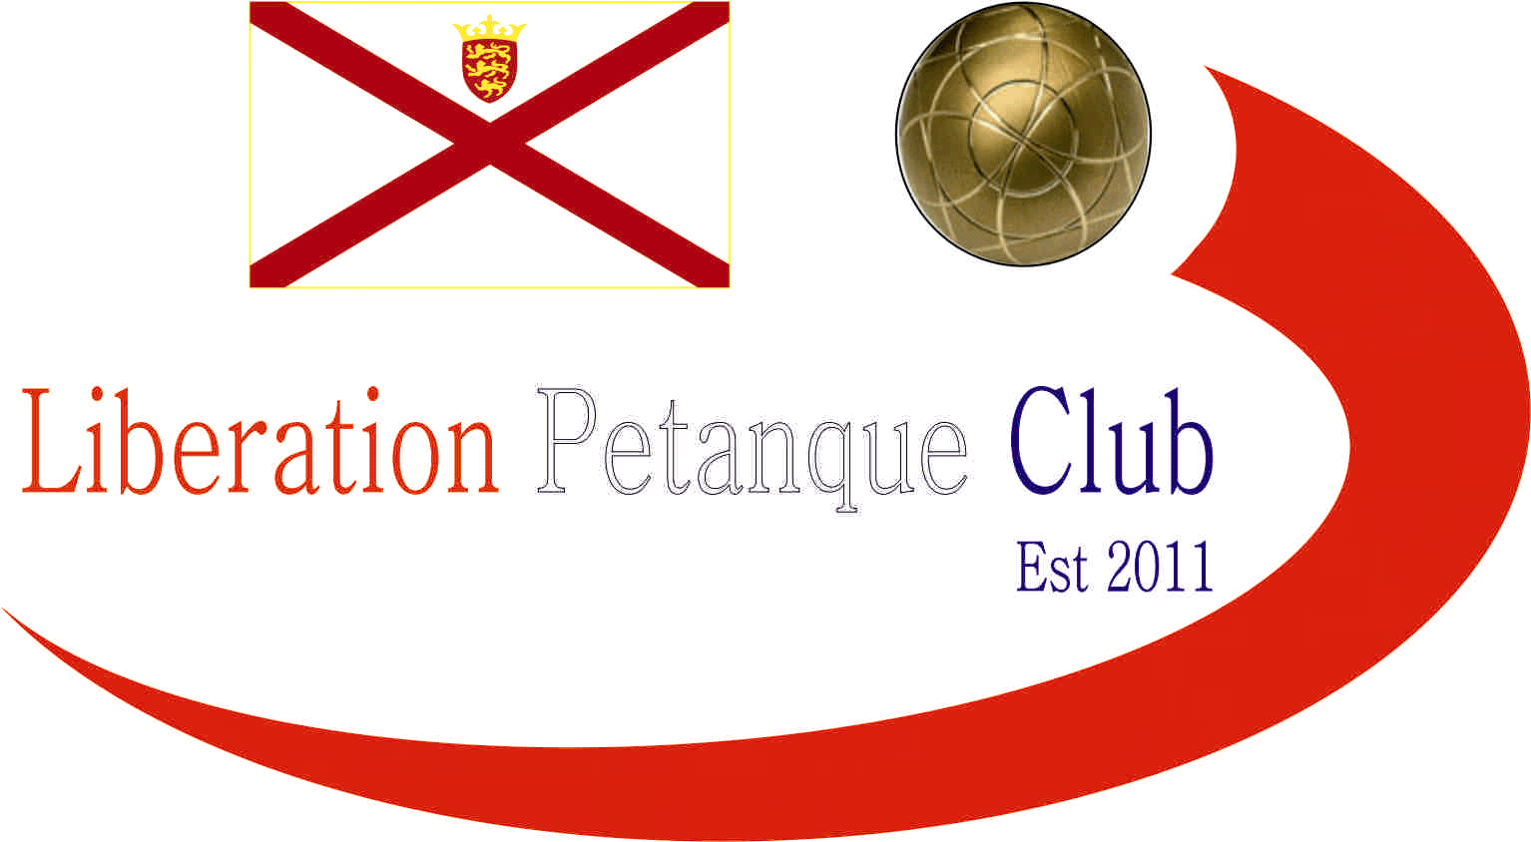

Summer 2022
End of Season
Report
What another great season it has been again this season with more new faces creating waves amongst the experienced members, we hope you all enjoyed it.
Premier League Double Champions
Laurent Pellaton & Matthew Pinel
Well, its now a hattrick of titles and undefeated in three consecutive championship seasons. Neil Selby & Ross Payne again finished in the top three, taking second place two seasons in a row. Andrew Bellamy-Burt & Callum Stewart finishing third.
Commiserations to Alan Mitchell & Mike Robinson and Cassie & Chris Stewart Le Gallais who returned to Division 1.
Division 1 Double Champions
Andrew & Lorna Limbrick
Wow, Andrew & Lorna stole the title from under Alice Dilks & Brigitte Ibitson nose, taking it on points difference in the final match against each other. Brande De La Haye and Tim Jackson also took third on points difference over Dawn Buckley & James Gennoe whose title and promotion chances fell off the tracks in the last three matches of the season.
Commiserations to Luc Rochefort & Martin Schwartz, John McGaw & Nick Pallot and Colin Floyd & Jim Waddell who were relegated.

Premier League Singles Champion
Andrew Bellamy-Burt
Winning his fifth Premier League title and doing so unbeaten for a remarkable Summer season for Andrew.
2021 Champion Laurent Pellaton missed out on retaining his title by one point, with Geoffroy Buffetrille finishing third.
Commiserations to Gavin Scott relegated after his first season in the top flight with Joey Le Clech also relegated.

Singles Division 1 Champion
Andrew Limbrick
Andrew defeated Callum Stewart in his last match to snatch the title from Callum who had to settle for second place.
A surprise was Matt Buesnel who lost his last match which meant Tim Jackson win over Cassie Stewart Le Gallais saw him finish third.
Commiserations to Mo De Gruchy on relegation.
Singles Division 2 Champion
James Villalard
James Villalard won a maiden title taking the Division 2 title, father Daniel made it a one two finishing second with Lorna Limbrick placing third.
Commiserations to Martin Schwartz, Luc Rochefort and Ian Black on relegation.

Club Singles Cup Winner
Geoffroy Buffetrille
Geoffroy won his second Singles Cup beating Ross Payne in the final with Andrew Bellamy-Burt in third.

Club Doubles Cup Winners
Laurent Pellaton & Toby Northern
This was Toby fifth win in the competition with Laurent winning his first one. They beat Gavin Scott & James Rondel in the final with Neil Selby & Ross Payne finishinh third.

Club Super 7’s Cup Winner
Toby Northern
Toby won his second Super 7’s title beating Callum Stewart in the final with Geoffroy Buffetrille taking third for the second successive year.

Club HandyCap Cup Winner
Neil Selby
Neil Selby beat Callum Stewart in the final with Kat Stewart finishing third.

Club Precision Shooting Cup Winner
Keith Pinel
Keith was the only player to score the minimum points required to go through. Matt Pinel took second in a play – off against Ross Payne.

Liberation Singles Open Winner
Laurent Pellaton
Laurent beat Carrefour player Alan Lahiffe in the final with Gavin Scott in third.
Liberation Doubles Open Winner
Neil Selby & Ross Payne
Neil & Ross beat fellow club members Brian Harris & Gary Cowburn in the final, with Andrew Limbrick & Matt Pinel finishing third.

Liberation International Singles Open Winner
Laurent Pellaton
Laurent beat Matt Pinel in the final with Toby Northern taking third place.

Liberation International Doubles Open Winners
Matthew Pinel & Matthew Ryan
Matt & Matt beat Andrew Bellamy-Burt and Geoffroy Buffetrille in the final with third place going to John Wilson & Robert Stronach from Scotland.

Liberation International Triples Open Winners
Matt Buesnel, Geoffroy Buffetrille and Laurent Pellaton
Matt, Geoffroy & Laurent beat Toby Northern, Callum Stewart and Paul Bell in the final with Neil Selby, Ross Payne & James Gennoe finishing third.

Player of the Seasons

To be confirmed at the end of season meal.



None club tournaments won by members
Island Singles Championship
Mark Nicol

Island Doubles Championship
Matt Pinel & Geoffroy Buffterille

Island Open Triples Championship
Matt Buesnel, Geoffroy Buffetrille and Laurent Pellaton

Island Mens Triples Championship
Andrew Limbrick
Andrew and his team
Carrefour Singles Open
Andrew Bellamy-Burt
Carrefour Doubles Open
Geoffroy Buffterille & Laurent Pellaton

Carrefour Triples Open
Geoffroy Buffterille & Laurent Pellaton & Gavin Scott

Special Thanks

Club Committee – Toby Northern, Matt Ryan, Matt Pinel, Matt Buesnel, Geoffroy Buffetrille and James Rondel for their hard work making this club a success.

Other Helpers –Laurent Pellaton for their hard work on the terrains and support throughout the season. Anyone else who has helped out setting up the terrains for competitions/leagues etc and running competitions, very much appreciated.

Well, I hope you have all enjoyed the season and are looking forward to playing again in the Winter 2022 / 23 season.

Kind Regards

Toby Northern

Chairman

Liberation Petanque Club

