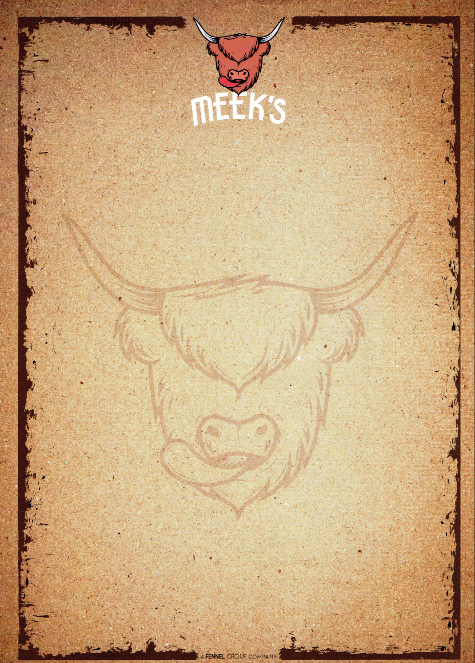

Fennel BBQ

Welcome to your summer! – Our fully catered BBQ menus below will give you a no hassle experience as our skilled team provide a locally sourced, beautifully seasoned feast for your event.The package includes all equipment, set up, service, professional BBQ equipment and that delicious food you’ve come to expect from The Fennel Group.

BBQ A
(£17 per person + VAT)
for 50+ guests

Homemade 4oz beef burger in brioche bun
Pork & leek sausages (2 per person)
Peri peri chicken skewer
Falafel and spinach burger (v)

Plus

1 Seasonal salad
1 ‘Fennel’ slaw
1 Fried onions
Sauces & dips

BBQ B
(£23 per person + VAT)
for 40+ guests

Homemade 4oz beef burger in brioche bun
Pork & leek sausages (2 per person)
Smokey BBQ chicken thigh
Minute steak
Peri peri chicken skewer
Falafel and spinach burger (v)
Bratwurst hot dog

Plus

2 Seasonal salad
1 ‘Fennel’ slaw
1 Fried onions
Sauces & dips

Staff, BBQ equipment, paper plates, gazebo, set up & clean down are all inclusive.

These menus provide 1 of each item per person (unless stated). We are happy to discuss varying these menus to suit and extra items can be added/swapped for a fully tailored experience.

Events / Festivals / Shows

Our professional team can cater BBQ and hog roast for any size of show, from food forums to music festivals – we have experience in many types of events such as Meldrum Sports & the Banchory Beer Festival. For details and prizes please contact us on 01467 67 00 65.

