PPL 330
Borders: policies and global geographies
Spring 2019
Tue-Thu 11.00-12.15

Lott 213

Dr. Christian Sellar
Associate Professor of Public Policy Leadership
csellar@olemiss.edu

“the concept of the border follows a “dialectical movement” [full of] … contradictory viewpoints and practices.”
Herald Bauder (2011, 1127)

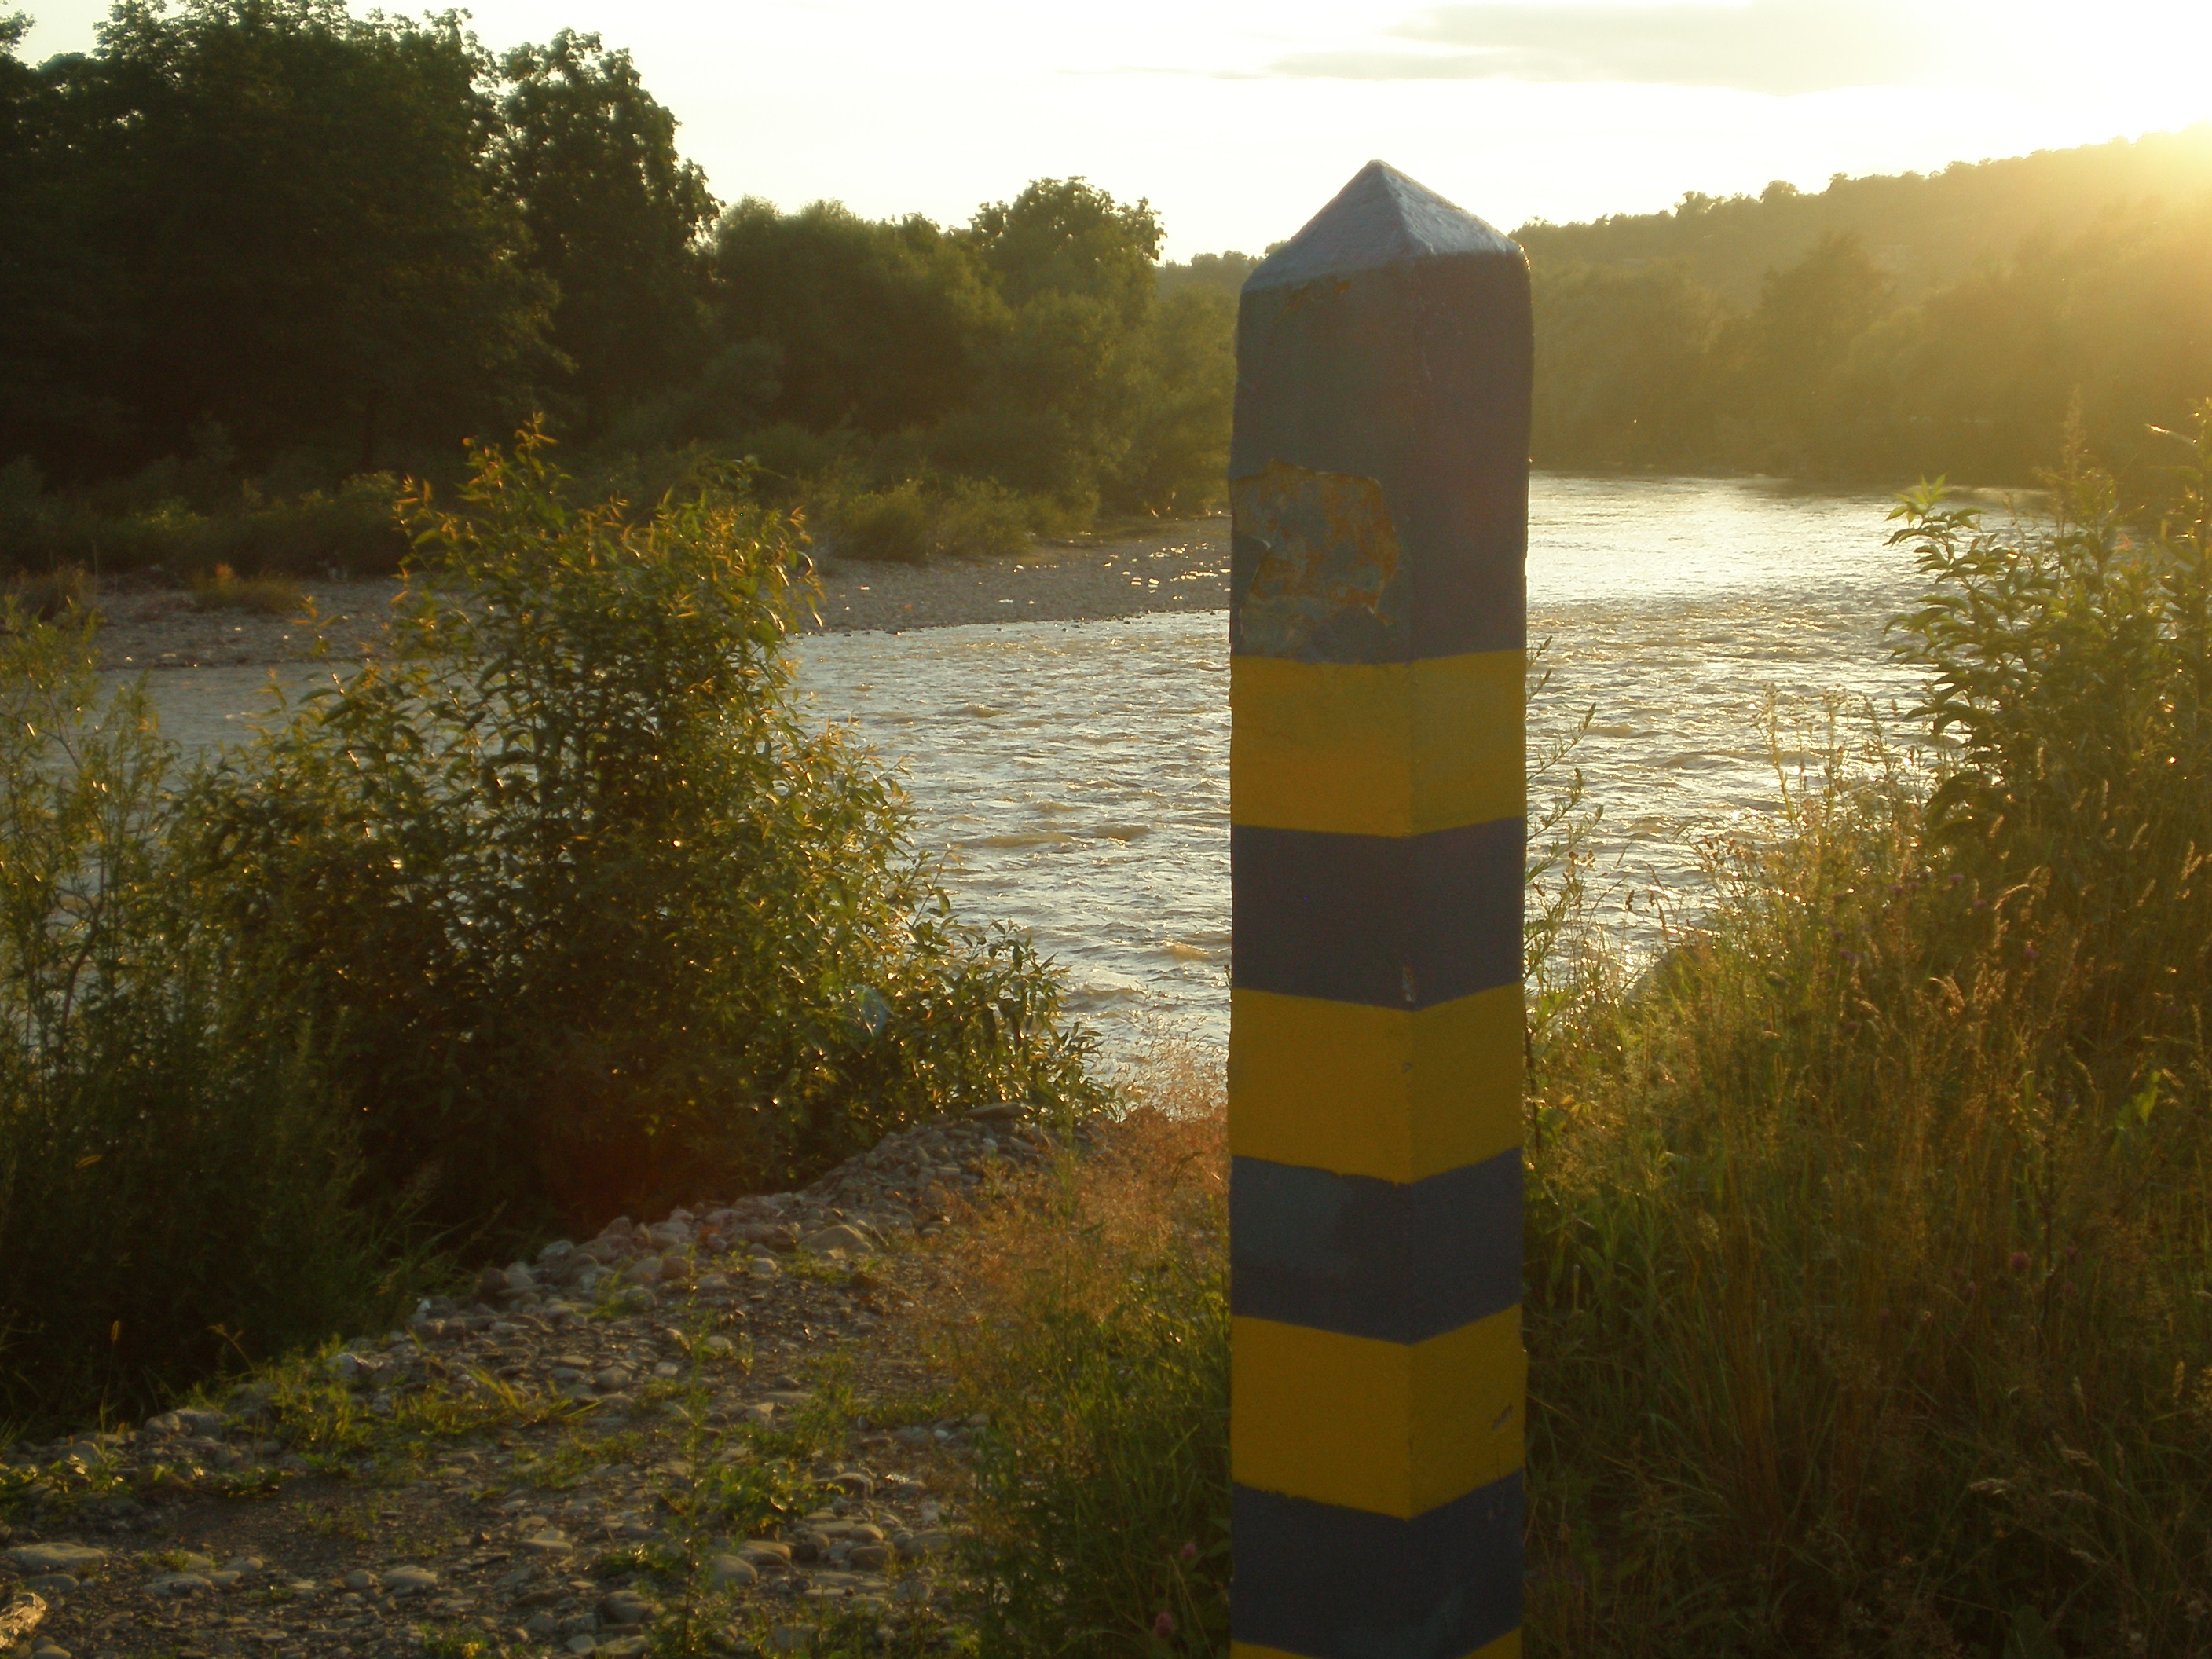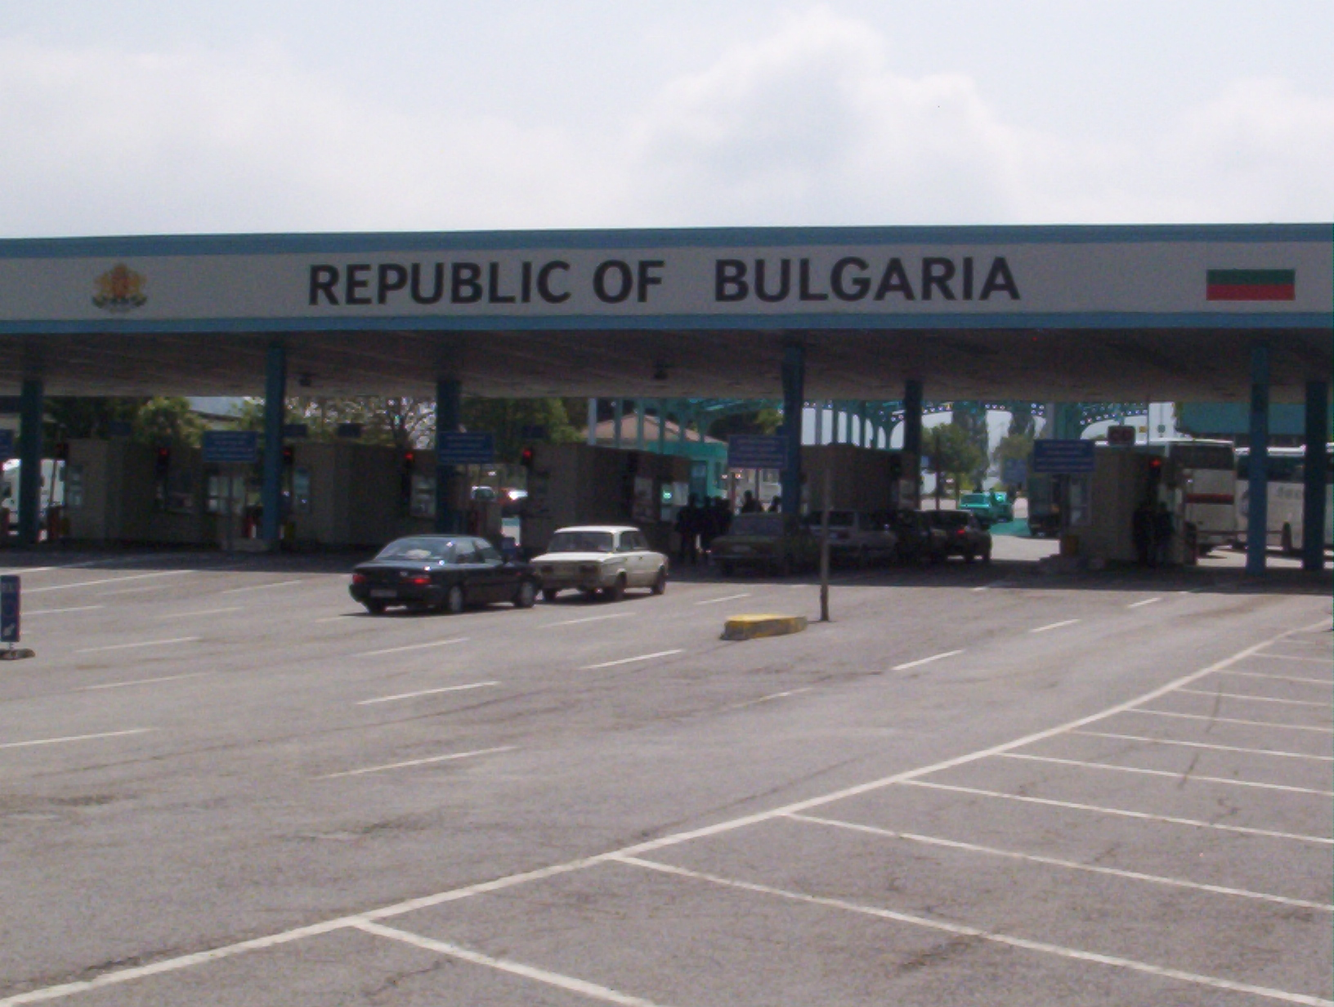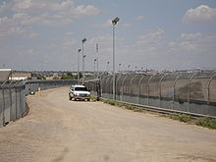

Photos: left to right: border pole between Ukraine and Romania (C. Sellar), border checkpoint between Serbia and Bulgaria (C. Sellar), fence between US and Mexico (www.wikipedia.org). The three pictures represent traditional views of national borders: a land checkpoint (in Europe; a more recent photo would add the EU flag to the national flag), a border pole, used to mark national borders in remote areas (again, in Europe: the pole has the colors of the Ukrainian flag), and the well known fence between the US and Mexico. Passport checkpoints in airports are less obvious kinds of borders, but most of us have experienced them (NOT photographed: it’s illegal). Drawing on examples from North America and Europe, this course analyzes global changes in the nature of borders and in the institutions overseeing them since the end of the Cold War. Students’ independent research will focus on the policy implications of those global changes.

Course focus and goal
National borders are only apparently simple concepts. Cartographers represent them as dividing lines on a map, citizens experience them as checkpoints where to show passports and visas, or places in the wilderness where they cross illegally. Instead, borders are both highly complex and changing over time. For example, during the Cold War era, borders divided rather separate economic systems, and managed by usually completely independent sets of institutions. Thus, in those years they were as close as possible to actual ‘dividing lines’.

In the post Cold War era, the increased financial, trade, and migration flows presented enormous challenges to the ways countries regulate and manage their borders. Borders became more porous, and the institutions managing them more complex: often they work cross-nationally via international agreements; they extend border policing within countries (airports, but sometimes also shopping malls); and they adapt to new technologies (an example from Europe is the ‘Virtual Border Program’ in the UK). At the same time, issues related to borders – such as illegal immigration, citizenship rights, and international trade – became an increasingly hot topic of debate in the US and elsewhere.

Learning objectives
This course analyzes the nature of international borders and border policies, using the perspective of geography, and drawing on international case studies. By the end of this class, students should be able to:
1) Understand various theories of borders and border geography.
2) Apply these theories to specific cases: the US/Mexico, US/Canada, and various European borders
3) Analyze border policies and some of their implications, such as migration, citizenship, and economic globalization
4) Evaluate current US border policies

Required Readings
Course Pack

Description of examinations

Final course grades will rely heavily on student involvement with the course materials. Each course goal will be evaluated as follows. Goal #1: a test focusing on theories; #2; #3: a second test on border policies; #4: a research paper. Participation grade will be awarded through homework and presentations. These will receive a pass/fail grade (partial or no points will be awarded for exercises executed carelessly). Together, these exercises will be used to evaluate your attendance and participation. So do not skip classes or miss homework. I will NOT allow to make up for missing homework, especially towards the end of the semester:
Tests : 40% [20% each]
Attendance/ presentations: 30%
Research paper: 30%

Grading Scale

A + | 97-100 |  | C+: | 77-79%
A: | 94-100% |  | C: | 74-76%
A-: | 90-93% |  | C- | 70-73
B+: | 87-89% |  | D: | 60-69%
B: | 84-86% |  | F: | Below 60%
B-: | 80-83%

Grading standards
A range: the task has been fully completed, bringing new and original insights to the work. Basically, you need to go beyond what is expected in the assignment. The A range will be graded on a curve, comparing A level works in each given assignment.
B range: an upper B grade corresponds to a perfect execution of the task assigned (consisting of a combination of style and fulfillment of instructions, as well as persuasiveness when needed). A low level B means there are some minor areas of improvement in the execution of the task.
C range: various levels of imperfection in style, fulfillment of instructions, or persuasiveness (for example, student writes a good paper, but uses a smaller amount of sources than required, or uses sources not appropriate to the level of the assignment).
D: Obvious deficiencies in understanding the assignment, highly problematic stylistic choices.
F: Student did not carry on the assignment as requested

Attendance and assignments:
The University requires instructors to verify the attendance/participation of students in ALL courses within the first two weeks of the semesters. Formal verification of student attendance/participation will be done in the second week of classes.
In this class, attendance is mandatory throughout the semester. Homework assignments will count as verification. Unjustified continuous absence for more than two weeks will result in an F grade at the end of class. Cumulative unjustified absence for more than eight classes (30% of class) will result in an F grade.
‘Unjustified absence’ is an absence without previous agreement with the instructor via email, phone or other means.
Unjustified late assignments (except homework) are not accepted. “Unjustified late assignment” is an assignment turned in after the deadline without previous consent of the instructor. Late homework are NOT accepted. Instead, students will be able to miss up to 4 homework with no penalty.
Queries on grades may result in a lower grade.
Honor code applies.

Disability Access and Inclusion: The University of Mississippi is committed to the creation of inclusive learning environments for all students. If there are aspects of the instruction or design of this course that result in barriers to your full inclusion and participation, or to accurate assessment of your achievement, please contact the course instructor as soon as possible. Barriers may include, but are not necessarily limited to, timed exams and in-class assignments, difficulty with the acquisition of lecture content, inaccessible web content, and the use of non-captioned or non-transcribed video and audio files. If you are approved through SDS, you must log in to your Rebel Access portal at https://sds.olemiss.edu to request approved accommodations. If you are NOT approved through SDS, you must contact Student Disability Services at 662-915-7128 so the office can: 1. determine your eligibility for accommodations, 2. disseminate to your instructors a Faculty Notification Letter, 3. facilitate the removal of barriers, and 4. ensure you have equal access to the same opportunities for success that are available to all students.

Course Schedule
The expected readings for this course are on average two scientific articles / book chapters per week (one per each lecture)
Schedule subject to change

Part I: theories of border

January 22-24
Week 1 Introduction: The meaning of borders

Biggs, M. (1999) Putting the state on the map: Cartography, Territory, and European State Formation. Comparative Studies in Society and History, 41(2) April 1999: 374-405.

Jan 29–Jan 31 – February 5– Feb 7 – Feb 12- Feb 14 – Feb 19 – Feb 21
Week 2-3-4 Borders: taxonomies
Kolossov, V (2005) Border Studies: Changing Perspectives and Theoretical Approaches Geopolitics, 10, 4: 606-632

Brunet-Jailly, E. (2005) Theorizing borders: An interdisciplinary perspective, Geopolitics 10, 633–49.

Bauder, H. (2011). Toward a Critical Geography of the Border: Engaging the Dialectic of Practice and Meaning. Annals of the Association of American Geographers, 101(5), 1126-1139.

Sidaway, J. (2002) Signifying Boundaries: Detours around the Portuguese-Spanish (Algarve/Alentejo-Andaluciá) Borderlands , Geopolitics, 7, 1, 139-165

On Feb 7 watch TV shows:
UK Border Force Season 2 Episode 1 https://www.youtube.com/watch?v=-I3Mf2qTr1w
Australia Border Security https://www.youtube.com/watch?v=Z4C8lnPsppg
Homeland Border Security USA Season 1 Episode 1 https://www.youtube.com/watch?v=4PTHvg48xsM

Please write a two page double space essay explaining how the three shows represent the idea of ‘border’, where are those ‘borders’ located throughout the shows, how the institutions dedicated to managing borders work. Explain also what are the major challenges facing those institutions and what are the main infringements of the law. Finally, explain what (if any) are the differences in managing borders between the three countries

February 26-28
Week 5 Borders’ concepts: bordering and borderland

Konrad, V. Nicol, H. (2008) Beyond Walls: Re-inventing the Canada-United States Borderlands Hants, UK, Ashgate, Ch 1

Sparke, M. (2005) In the space of theory: Postfoundational geographies of the nation-state. Minneapolis: University of Minnesota Press. (ch on Acadia)

Test 1 (covers material up to week 4)
Tue March 5 midterm prep

Test 1 will occur on Thu March 7– date subject to change

MARCH 9-17 – SPRING BREAK

Part II: Case studies of globalizing borders

March 19-21
Week 6 US/Mexico
US/Mexico
Documentary: ‘389 miles living the border’, Director LuisCarlos Davis, http://www.youtube.com/watch?v=3alzDhJQ2qs

March 26-28
Week 7
Jones, R. (2014). Border Wars: Narratives and Images of the US-Mexican Border on TV. ACME: An International E-Journal for Critical Geographies, 13(3), 530-550

Iskander, Natasha and Nichola Lowe (alphabetical). 2010. Hidden Talent: Tacit Skill Formation and Labor Market Incorporation of Mexican Immigrant Workers in the United States. Journal of Planning Education and Research. 30 (2): 132-146.

APRIL 1-7 PROFESSOR AWAY AT CONFERENCE –watch film ‘Frozen River’ (2008)
Prepare a three page film review essay to explain how the border is represented through the main characters. How many kinds of borders are there? How does the movie confirm or challenges the views of the border expressed by Konrad and Nicol?

April 9-12
Week 8 US/Canada

Konrad, V. Nicol, H. (2008) Beyond Walls: Re-inventing the Canada-United States Borderlands Hants, UK, Ashgate.
Chapters 3-4-5

April 12: research step 1, in class discussion on writing a policy memo

April 16-18
Week 9 European borders: the case of the European Union

Rumford, C. (2008) Cosmopolitan Spaces. Europe, Globalization, Theory, New York, Routledge. (chapter on borders

Balibar, E. (1999) At the border of Europe. Lecture delivered at the Aristotle University of Thessaloniki, Greece, 4 October. [WWW document]. URL http://makeworlds.org/node/80 (accessed January 12, 2012).

Johnson C (2009) Cross-border regions and territorial restructuring in Central Europe: Room for more transboundary space, European Urban and Regional Studies 16 (2): 177–191.

April 18: research step 2 – write a three pager choosing your topic

April 23-25
Week 10 European borders: the case of the European Union the ENP

Kuus, M. (2011b) Policy and geopolitics: bounding Europe in EUrope, Annals of the Association of American Geographers, 101:5, 1140-1155.

Test #2
Test # 2 will take place on Thursday, April 25– date subject to change

April 30-May 2nd
Library presentation – class completion

Final exam: Tuesday, December 4, 8 am
Final exam: research paper

POLICY MEMO : Border issues in the United States

PPL students: this research paper builds upon what you have learned in PPL 101, and especially in Kraft Furlong, Public Policy. Politics, Analysis, and Alternatives, Washington, CQ Press, 2007. Part 2 ‘Analyzing Public Policy’ pp92-179

STEP 1. In class exercise: discussion about how to write a policy paper (PPL 101 refresher)

STEP 2. Choose the broad issue you want to research. Your research topic MUST FOCUS ON how the United States government (federal government, but also state government, or specific agencies) deals with border issues, writ at large: not limited to patrolling borders, but extended to how borders, borderlands, and cross border flows of any kind are managed and regulated.

Examples of possible research topics include (but are not limited to) US trade policies in specific sectors, and how international trade is regulated; how specific migration policies have been developed and enforced; how specific states on the US border (with Mexico, but also Canada) deal with border issues; how border issues in specific ports of entry are managed (for example, major ports or airports). Tip: a successful paper will identify a clear policy problem. For example, Alabama’s migration law caused a conflict between the need to enforce migration policies, and the economic interest of some employers and foreign investors; therefore, any U.S. policy must solve the problem of compromising between fiercely opposing interests.

Please write a three page report defining A) the broad area you will investigate and B) the policy problem and the reasons why it is important. Papers should quote an appropriate number of sources (at least five) and display statistical data where it is possible.

A paper citing only web sources is NOT acceptable. You MUST use at least some scholarly sources.
If needed, training on how to use the library: http://www.olemiss.edu/depts/general_library/instruction/

The following websites contain useful information on various border issues. Please use them to gather ideas on a possible topic:

US border policies and enforcement
Border policy reports: http://www.utexas.edu/law/centers/humanrights/borderwall/communities/municipalities-US-Mexico-Border-Policy-Report.pdf

http://www.fas.org/sgp/crs/RL32399.pdf

National association of Manufacturers on border policies http://www.nam.org/Issues/Trade-Regulation/Customs-and-Border-Policy.aspx

Us Homeland security http://www.dhs.gov/index.shtm

US/Canada border security http://www.publicsafety.gc.ca/prg/le/bs/index-eng.aspx

US economic and trade policies
US trade representative: http://www.ustr.gov/

US Department of State – trade policy programs http://www.state.gov/e/eeb/tpp/

International trade administration (part of the Department of Commerce) http://www.trade.gov/about.asp

US Department of Commerce http://www.commerce.gov/

Statistics on foreign trade: http://www.census.gov/foreign-trade/index.html

US Trade and Development Agency http://www.ustda.gov/

US International Trade Commission http://www.usitc.gov/

Foreign Agricultural Service http://www.fas.usda.gov/ustrade.asp

Think Tanks directory http://www.hks.harvard.edu/library/research/guides/think-tanks-directory.htm

US migration policies
CBO – US immigration policies http://cbo.gov/sites/default/files/cbofiles/ftpdocs/70xx/doc7051/02-28-immigration.pdf

Overview of US migration: history and policies http://www.mapsofworld.com/usa/immigration/

Maps on migration
http://migrationsmap.net/#/USA/arrivals
world bank: http://www.migrationinformation.org/datahub/wmm.cfm

Think tanks on migration
Migration Policies Institute http://www.migrationpolicy.org/
Immigration Policy Center http://www.immigrationpolicy.org/
Council of Foreign relations http://www.cfr.org/immigration/us-immigration-policy/p20030

STEP 3
Investigate the various kinds of policy proposals that think tanks and advocacy groups put forward to solve the policy problem. Assess the policy options and explain which option the US chose and why. Prepare a ten page policy analysis, merging step 2 with additional work that A) discusses the various policy options; B) describes the chosen policy and why the U.S. chose it; C) assesses the success of the policy by looking at evaluations and/or statistics

The format must be the following:
Cover
Table of contents
executive summary or abstract
introduction
background
context
policy options
policy chosen by the U.S.
evaluation
references.

