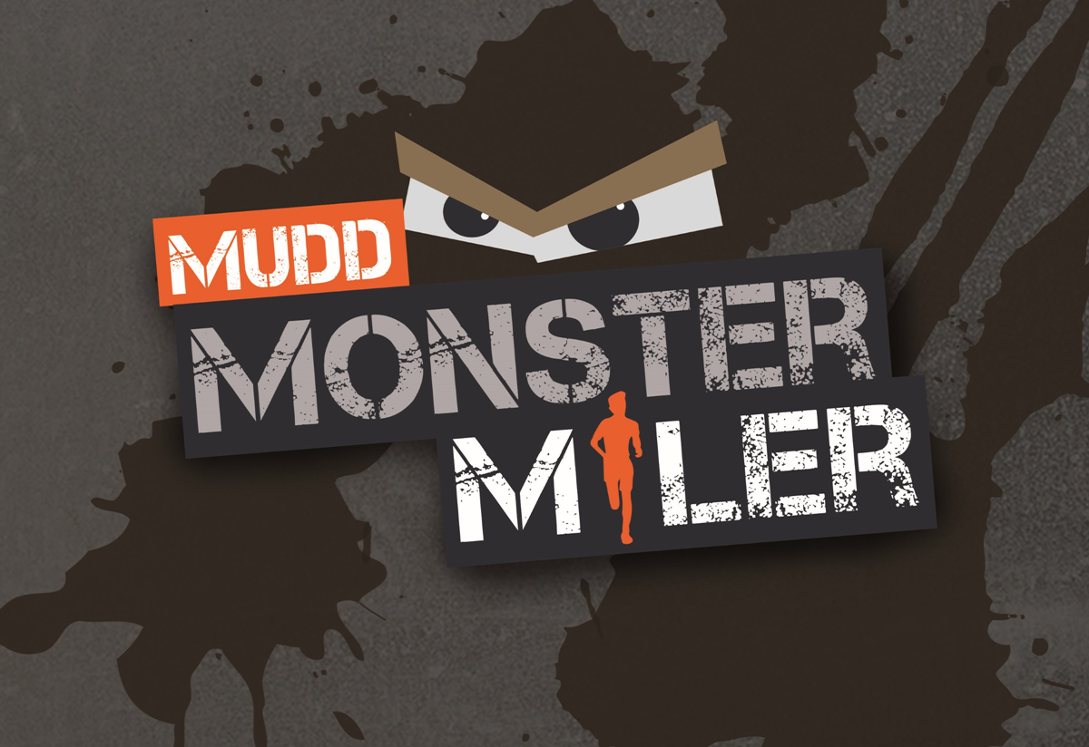

August 17, 2019

A ministry of IBC Blairsville and Shank Family Ministries.

Dare you to run it!

IBC’s 4th Annual MUDD Monster Miler

Saturday August 17th, 2018 at 10:00AM.

**Work your way through an obstacle filled, mountainous 5k+ course that will test your strength and endurance. This course is built on the side of Penn View Mountain where there will not only be obstacles, but plenty of mud and a 400+ foot elevation climb.**

**Race Start: 10:00 am (staggered start times according to age groups)**

**Fee: $30.00 per runner or $75.00 per family. Pre-register cost of $25.00 and $70.00 per family and guaranteed shirt if registered by August 3rd.**

Race Day Registration/Check-in: begins at **9:00 am on Aug. 17th** at 1382 Barr Cemetery Road, approximately six miles east of Blairsville Wal-Mart on the north side of Rt. 22. Signs begin at Barr Cemetery Road.

Awards: Overall top 3 male and females.

Men: Top 3 of each age group (U14, 15-19, 20-29, 30-39, 40-49, 50-59, 60+)

Women: Top 3 of each age group (U14, 15-19, 20-29, 30-39, 40-49, 50-59, 60+)

We are also offering a new category this year called the **competitive flight**. This is open to both males and females of all ages. If you want to be challenged by other participants, and take home the title of MUDD Monster Champion, please be sure to check this category on the registration form.

**If you have any questions, contact Pastor *Rob Ingmire at 724-459-7868*.**

**You can download registration forms at ibcblairsville.com and mail them care of: *Jenn Reaugh***

***955 Blair Road***

***Blairsville, PA 15717***