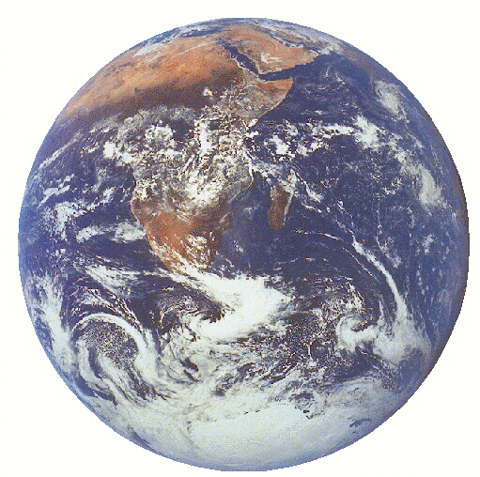The Energy Budget

In the year 2005, you are elected Energy Czar of the planet. Your job is to manage the planet's remaining non-renewable energy resources and project how new energy resources will be utilized.

What in the world does a Czar have to worry about?

Our Standard of Living: Generally, the more energy a society has available to it, the healthy and happier its people. As Czar, can you bring global prosperity to our planet by increasing global per capital energy? Or will supplies suddenly dry up, sending the human race down a path of broken cities and hungry people? Or, maybe there is another path that you can discover.

Our Sources of Energy: What do you want the world to use? Oil, Coal, Natural Gas, Nuclear Fission, Hydroelectric, Wind and Solar are currently "in". As Czar, will you keep the status quo, or will you explore new technologies such as nuclear fusion, space based solar platforms, or energy mines in the Ocean?

Our People: Currently, there are over 6 billion people on the planet Earth. This number is growing at almost 100 million a year. Will you be able to provide energy for all of these people? Or will you use your power as Czar to try to change the rate at which our population grows?

Our Cost: Do you want more energy for your people? If so, how will you pay for it? Will you create new taxes or will you cut existing expenditures?

Per Capital Energy and Standard of Living:

The column below shows per capita energy data for the past half century. As Czar, this column is going to be very important to you. Notice that the energy consumed per person has more than doubled in the past half-century. The result of this plentiful supply of energy has been an era of prosperity unmatched in all of human history--never before has the human race lived as long, as healthy, and with so much opportunity to explore the universe in which we live. This era of opportunity in which we live has only been possible through the exponential exploitation of new energy sources realized in the past two centuries.
 | PerCap Energy
Year | kW*hours per person
1950 | 4366
1955 | 5289
1960 | 6422
1965 | 7300
1966 | 7572
1967 | 7612
1968 | 8128
1969 | 8419
1970 | 8881
1971 | 9097
1972 | 9303
1973 | 9790
1974 | 9753
1975 | 9389
1976 | 9878
1977 | 10032
1978 | 10070
1979 | 10336
1980 | 9935
1981 | 9596
1982 | 9265
1983 | 9193
1984 | 9522
1985 | 9607
1986 | 9737
1987 | 9773
1988 | 10087
1989 | 10076
1990 | 9926
1991 | 9726
1992 | 9695
1993 | 9544
1994 | 9470

However, notice that this growth in per capita energy over the last fifty years hasn't been constant. For example, there was a slight dip in 1975. This dip was due to an oil embargo that the majority of oil producing nations placed against European and North America nations. This relatively small and quick per capita energy drop resulted in near chaos in the affected nations: gun fights broke out between people waiting in kilometer long gasoline lines in the U.S.; border skirmishes between Germany and France occurred due to people illegally transporting oil; and saber rattling between middle-eastern and western nations reached a crescendo.

A larger and longer per capita energy drop occurred in the early 1980's. This drop was caused by a global economic recession and the collapse of the African continent largely due to the refusal of the U.S. to pay its United Nation Dues. (20 years later, the U.S. still refuses to pay its U.N. dues--the only remaining reason for this is that the U.S. disagrees with the United Nations' education efforts that teach birth control). This drop in per capita energy consumption resulted in the starvation of millions of people--the effects of this are still being felt today.

If you continue down the column, you'll notice another long-term drop took place in the 1990's. Can you figure out the cause and effects of this drop?

As Czar, one of your chief responsibilities is to consider how this number changes (or doesn't change) over time. Your one major constraint is that you are not allowed to drop below 5000 kW⋅hrs per person. With six billion human living on the Earth, dropping below this value would probably end the human race as a technological species. Beyond this one constraint, you are allowed to increase, decrease or keep the per capita energy spending level constant--in your final write-up, you need to clearly discuss how your energy spending plan affected the people of our planet.

Standard Living and Energy Consumption
Germany
Cuba
Belgium
USA
Canada
Norway
Switzerland
Japan
U.K.
Italy
Poland
Ecuador
The graph to the right compares barrels of oil consumed per person in various countries to the Gross Domestic Product of those countries. Note the near linear relationship. It is also true that generally, the GDP of a country is proportional to the standard of living found within that country. Thus, as Czar, if you want to ensure an era of global prosperity, you might choose to increase per capita energy to the greatest extent possible.
Sweden
Iceland

You might notice that two countries in particular fall off the normal oil/GDP line. The US and Canada consume, by far, a lot more oil per person than any other country. Despite the high consumption rate, these countries have a rather mediocre GDP--the U.S. also is bemoaned for its rather low standard of living (as measured by infant mortality rate, life expectancy, diet, housing, and health). Meanwhile, countries like Switzerland, seem to be able to generate a high GDP (as well as standard of living) while consuming a relatively modest portion of energy.

The United States' low standard of living to energy consumption ratio can be explained by its dependence on the relatively fuel-inefficient transportation network focused on the automobile. Personal automobile transportation is hugely expensive in energy terms, but does little to improve the national standard of living.

Switzerland, meanwhile, maintains its high standard of living to energy consumption ratio by having instigated many national energy savings programs due to the "energy crisis" of the 1970's.
Interesting Energy Factoids:
- With only 5% of the human population, the U.S. consumes almost 30% of the yearly global energy supply.
- The typical U.S. citizen consumes over 150 times the energy of the typical Nigerian.
- Driving 65mph consumes approximately 6% more gasoline than driving 55mph.
- Recycling an aluminum can consumes one-tenth the energy required to create a new aluminum can from aluminum ore.
- A Compact Fluorescent Light Bulb consumes 80% less electricity than a standard incandescent bulb.

It was the oil-crisis of the mid '70s that really first brought energy issues to a level of global and public consciousness. During this time, the Greens became a strong political force in Europe, a nuclear engineer was elected president of the United States, and energy was a common topic of dinner conversation.

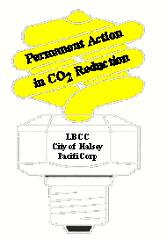
After the embargo, however, the world faced almost 15 years of the lowest oil prices ever. In some countries, most notably the United States, energy almost dropped off the public radar screen. Interestingly, today (1.Sept.2000) in the news are reports of French rioters holding British citizens hostage protesting the high prices of gasoline.

Global Population:
Per Capita energy is defined as the energy consumed per person. If we were to write this as a fraction, we would see:

$\text{PerCapitaEnergy}=\frac{\text{TotalEnergy}}{\text{TotalPeople}}$
One way to increase the per Capita Energy is to make the numerator of the above fraction larger--that is, to increase the total energy available to people.

Another method available to you as Czar is to increase per capita energy is to decrease the denominator by affecting population growth rates.

There are many methods in which you, as Czar, can change the human race's population growth rate. Some possibilities that other countries have attempted include:
- One Child per Couple laws
- Birth Control Education Programs
- Simple Education

China's One Child Per Couple Law: In the late 1960's China, home to almost 20% of the human race, started enforcing economic incentives for those couples who choose to have only one child. This law has been highly successful in reducing the population growth rate of what used to be the fastest growing country in the world.

The advantages of China's law have been astounding. For almost two decades, China has maintained double-digit economic growth leading to an era of prosperity in a country that was facing millions of deaths a year due to famine only a couple of decades earlier. In 1985, the average Beijing family lived in a one-story house with dirt floors, without telephone, television and spotty access to electricity. By 1995 the common middle-class family was finding themselves in new modern homes fully equipped with cell phones, satellite television, and technology that was almost unheard of in China only a few years earlier. A large part of China's economic boom can be directly linked to the one-child per couple law--no longer is China struggling to build new infrastructure to support tens of millions of new people each year; instead, China can now focus their energies on making what already exists better.

Of course, like almost all decisions that you will make yourself as Energy-Czar of the world, the one-child per couple law has had negative social consequences as well. In some parts of China, ancient culture economically favors boy children in such areas as property and dowry rights. Consequently, it has been found, particularly in poor and remote areas of China, that some families would resort to female infanticide due to economic and social pressures created by the one-child per couple law. Although the number of these cases are small compared to the total population of China, these rare cases have been found egregious enough to make world news headlines and to bring strong criticism again the Chinese law.

Birth Control and Family Planning Education Programs:
Many might desire to resort to sex education and other family planning programs to reduce population growth. This method of reducing population growth has had mixed success. In some countries, such as Ghana, Sweden, and parts of Thailand, sex education has been very successful in reducing population growth as well as helping in the loosely related issue of reducing the spread of sexually transmitted diseases.

However, for almost every success story, there is also a horror story. In west-coast Africa, black Africans found themselves being preached to by white Europeans as to the benefits of smaller families. Many of the black family took this as a new form of racial bigotry. Meanwhile, in India, doctors were given cash bonuses for every man they could talk into getting a vasectomy--some doctors abused this and began giving vasectomies without the patients' full consent. One the global front, the United States has refused to pay it United nation dues in twenty years--an action that has all but paralyzed that institution and has often lead to large scale misery. The sole reason the U.S. cites for this continued renege of paying its past dues is that the United Nations supports family planning in some of its educational programs.

If, as Czar, you decide to resort to family planning as a method of reducing population growth, you have to realize that this issue in the past has affected different cultures in sometimes very unexpected ways.

Simple Education:
It turns out that there is one sure way to reduce population growth that also tends to bring about increased standards of living and has almost near universal support by the overwhelming majority of people. Regardless of culture or country, it has been discovered that increasing the general education level of the populace always brings about a reduction in the population growth rate.

Consequently, if as Czar, you want to reduce global population growth rates, you could instigate a global school building plan. This would be expensive, the results would be slow, but in the long run would lead to a higher global standard of living.
Action Taken: | Resulting 2030 Population Growth Rate:
No Action Taken | 2.0%
Increased Education | 1.5%
Family Planning | 1.0%
One Child Per Couple Legislation | 0.0%

In summary, you have many ways in which to influence population growth. For purposes of this model the author would argue that the below values are appropriate. Of course, it is always recommended that the individual Czars do further research to improve the precision of the model to their liking.

Questions to ponder:
1) Since 1970, the overwhelming majority of couples in China have had only one child. However, the population of China is expected to continue to grow through 2020. How can China's population keep growing for 50 years, even though they are having less than replacement numbers of children?
Costs and Taxes:
The world as a whole, spends about $5 billion a year on new energy resources. As a result, as you operate your spreadsheet, you'll notice that each year you can create 0.5 PW-hrs of new energy each year without incurring any costs.

As Czar, if you want to create more new energy than 0.5 PW-hrs per year, you will have to find funding for you construction. To do this you can either raise new or existing taxes, or you can cut current expenditures to pay for your energy initiatives. You may wish you use the below information in figuring your financing plan, or you may wish to research your own initiatives. If you come up with some cool tax scheme, let me know at the "Energy Budget Web Page".

Some numbers that may come in handy:
- Almost every country in the planet has a gas tax of around $3.00 per gallon. The U.S. and Mexico are the two major excepts. The U.S. consumes approximately 300 billion (=3⋅10¹¹) gallons of gasoline a year. The whole world consumes approximately 900 billion gallons of gas a year.
- The world consumes about 50 trillion kW-hrs of energy a year. In Oregon, a kW-hr of energy costs the consumer about 6 cents. In the rest of the U.S. a kW-hr of costs about 15 cents.
- The global economy was about $40 trillion in 1999.
- Major Current Governmental Taxes (warning: these numbers have some inherent distortions; for example, the value for U.S. health care does not include some treatments that Americans do pay for but aren't considered in standard accounting practices. The next version of The Energy Budget will attempt to correct these values):

 | U.S. expenditures | Global Expenditures
Military | $450 billion | $850 billion
Health Care | $300 billion | $800 billion
U.S. Social Sec. | $300 billion | n.a.
Education | $300 billion | $1.5 trillion
Welfare | $50 billion | n.a.
Prisons | $100 billion | $300 billion
Telephone Psychics | $30 billion

The Sources of Energy
Notice that the Energy Budget Spreadsheet calculates some of the effects of choosing different energy sources. For example in the imaginary year described below, 35 new nuclear reactors were built and almost 130 coal power plants were taken off-line.

Solar and Wind meanwhile, are described by the amount of surface area of the planet that will need to be covered by solar cells or wind generators. The units of surface area are given in Oregons. It turns out that the total surface area of the planet Earth is approximately 1000 Oregons with 700 Oregons of that being Ocean and the other 300 Oregons being land. It also turns out that all the rooftops in the world are about equal to one Oregon.
#Nuclear Reactors Built | Land Mass (Oregons)-Wind | Land Mass (Oregons)-Solar | Coal Plants Built | New Energy Added | Global Cost (billions of US dollars)
35.2 | 0.092 | 0.02 | -129.6 | 0.78 | 56.00

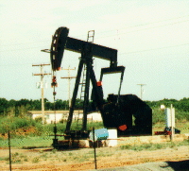
Oil
The original source of energy that created today's oil deposits originated from the Sun. Over millions of years, light from the Sun was converted into chemical energy through photosynthesis. As partially decomposed plant-matter fell to the bottom of shallow seas and proceeded to be buried by sediments, the compressed and heated organic material degraded into the simple hydrocarbon chains that we now harvest as fossil fuels. Oil, and all fossil fuels can thus be considered “canned sunlight”.

Despite some negative environmental consequences of oil usage, such as oil spills and air pollution, oil is one of the more environmentally friendly of energy sources.
Country | Production:  10³ barrel/day | Proven Reserves  10⁶ barrels/day | No. of active wells
Saudi Arabia | 8231 | 257504 | 858
Former USSR | 6550 | 57000 | 145000
USA | 6530 | 26177 | 603000
Iran | 3735 | 92850 | 361
China | 3015 | 24000 | 43700
Venezuela | 2940 | 59040 | 12752
Mexico | 2618 | 51983 | 4740
U.K. | 2489 | 3825 | 762
Nigeria | 2160 | 17100 | 1432
Iraq | 0 | 100000 | 820
Oil production statistics--early 1990's. Source: Ristinen and Kraushaar "Energy and the Environment".
Petroleum oil was nothing more than a rare oddity until the 1860's when the first modern style oil wells came on line. By 1862, the U.S. was producing 3 million barrels of oil a year and by 1909 this number had increased to over 180 million barrels of oil per year.

The U.S. saw its peak in oil production in the early 70’s where it hit over 3,300 million barrels a year. Today, the U.S. is no longer the top producer of oil and the U.S. imports around 50% of the oil to suit its own domestic consumption.

It turns out that it is a fairly long process to estimate the amounts of various non-renewable resources, such as oil, remaining to us. If you are interested in the calculation, please read the March 1998 issue of Scientific American or some of the other resources listed at the end of this article.

In the Energy Budget, the values for the remaining Oil, Coal, and Natural Gas values are given at the bottom of their respective columns. These given values are the “P50” values. In the statistical analysis done to derive the fossil fuel reserves, “P50” stands for “50% probability”. This means that there is a 50% probability that there is more of the resource available than reported and a 50% chance that there is really less of the resource available than estimated. An important feature of this number is that it includes not only the remaining known reserves of each energy source, but it also includes the reserves of that energy source not yet discovered but expected to be found as technology and exploration continue.
Estimated Amount of Remaining
Non-Renewable Resources

Oil: 640 PW*Hrs
Gas: 430 PW*Hrs
Coal: 53,000 PW*Hrs
Source: Kraushaar/Ristinen "Energy and Problems
of a Technical Society" 1993

Questions to ponder:
- How many years of oil would each country have at current production levels and current proven reserves?
- What are we not taking into account in the calculation above if we really want to have a good estimate of how many years of oil the world has remaining? (There are of course many, many variables to the answer of this question. If you want to go into depth on this question, visit the book and web-site references listed below.)
- Saudi Arabia produces significantly more oil per year than the U.S. does, however Saudi Arabia has only 858 producing wells compared to the 603,000 in the U.S. What does this tell us about oil reserves in the U.S.?


Coal
Coal has been heavily utilized by the human race for the past two-and-a-half centuries. The world’s coal deposits formed similarly to its oil deposits in the fact that the initial input of energy came from sunlight energy into chemical energy via photosynthesis.

Utilization of coal as an energy source made possible the industrial revolution that has profoundly changed human society.

The environmental impact of coal has been dire. Compared to all the other major sources of energy utilized today, coal is by far the most dangerous from both personal and worker safety as well as from an environmental point of view.

Some of the many drawbacks of utilization of coal are: injuries to miners due to coal dust or mine accidents; tens of thousands of premature deaths due to air pollution; acid rain destroying forests, rivers and other ecosystems; large emissions of carbon dioxide.

To give you a measure of the global impact of coal as an energy source, the air quality of Seattle, Washington exceeds DEQ standards several days a year due to the emissions from coal burning plants in China.

Currently, coal produces about half of all the electricity in U.S. (with similar statistics for the rest of the world). The reserves of coal are in no danger of running out anytime soon.

Questions to ponder:
- It is often said about the remaining reserves of coal, “The good news is that there is a lot of it, the bad news is that there is a lot of it.” Explain this statement.

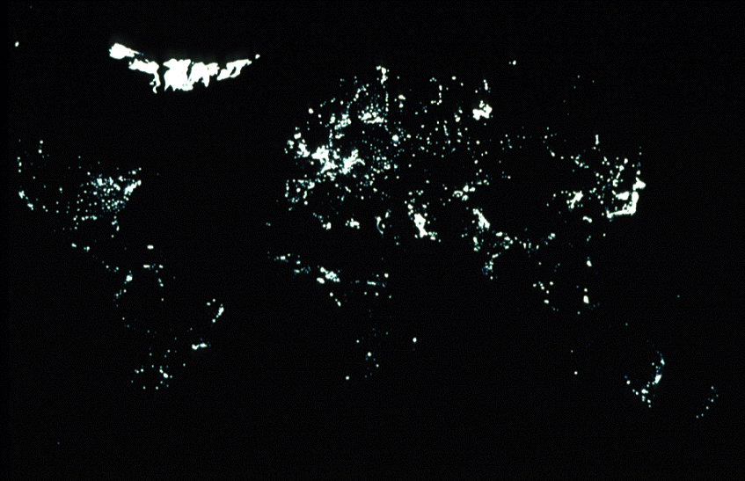
Natural Gas
Of the three main fossil fuels, methane (also called natural gas) is the cleanest, cheapest, and very easy to use. Its main drawback is the limits on its supply. Like all fossil fuels, the world’s natural gas supply was created through geologic processes storing energy from the sun over hundreds of thousands or millions of years.

It is true that Natural Gas from organic short-time-scale processes or human activities can be harvested. Degrading bio-matter releases methane--this methane can be collected and used for energy. Most modern garbage dump facilities in the world collect methane. Unfortunately, the amount of methane that can be produced in this manner is miniscule compared to the total energy stored in Natural Gas deposits. Consequently, for all intents and purposes, natural gas is just as non-renewable as the other fossil fuels.

Questions to ask yourself:
- Show that it would be impractical, if not impossible, to produce enough natural gas to fulfill the human race's total energy needs through short-time-scale methane production schemes such as garbage dump methane traps? (Hint: check out the questions at the end of the discussion on Solar Energy)

Nuclear Fission
Nuclear Fission has been used as an energy source by the human race for the past half-century.

Currently, nuclear fission has the best safety record of all energy sources.

However, many people have concerns about the long-term effects of utilizing fission as an energy source. The three main concerns are:
- long term storage of spent fuel rods
- plutonium production and nuclear proliferation
- chernobyl-style accidents

Questions to ponder:
- The table at the end of this article compares the safety record of the different sources of energy. Do you think that the average American is fully conscious of the safety record of the various energy sources?

Wind
Wind has been the fastest growing of all the major energy sources for the past decade. Even with a doubling time of 18 months, wind still only produces a tiny, fraction of the energy consumed by the human race, however, it is widely felt that we are currently at the front end of a "Wind Revolution".

The environmental impact of wind power is minimal. However, remember that wind generation plants require surface area. Your Energy Budget Spreadsheet keeps track of how much surface area of the planet must be covered with wind generators as you build your energy future. The units of surface area are given in Oregons. As a reference, you might note that all the rooftops in the world would be equal to about one Oregon in surface area.

Before you start covering several Oregons worth of landmass with wind generators, you should ask yourself if you are willing to cover places such as the Cascade Mountains with a blanket of wind generators.

Questions to ponder:
- Note that in the table at the end of this article, that Wind power has resulted in more deaths per kW•hr than natural gas and nuclear. Most of these deaths have occurred through accidents such as people falling off ladders while building wind structures. Still, the number of these accidents must be quite small--how is it then that Wind is currently so relatively "unsafe"?

Solar

Solar energy comes in two main "flavors". Active Solar is the utilization of solar voltaic cells in order to directly produce electricity from sunlight. Passive Solar, meanwhile, includes such activities as using a black hose to heat water which can then be utilized to wash dishes, take showers, or other common household activities.

Passive Solar energy has next to no negative environmental impacts. Active Solar, however, does require some nasty chemicals in order to produce the solar voltaic cells. Too, solar energy takes up space similarly to the way that wind power does.

Currently, the human race derives only a tiny, tiny fraction of its energy directly from solar.

Questions to ponder:
- Here is a cool calculation to do: On average, 100 Watts of power hit each square meter of the Earth facing the sun. Meanwhile, the average American is consuming just under 20,000 Watts (this includes all actives that support the U.S. economy--this is probably a slight underestimate due to the fact the we import many of our goods). If all 6 billion (6•10⁹) people on the planet were to consume energy to the magnitude of American, what percentage of the planet's surface would need to be covered by 1% efficient solar cells (with current technology, this is a very good efficiency) in order to power the planet. The radius of the planet Earth is approximately 6500 km (6.5•10⁶ meters).
- From the calculations in the question above, do you think that solar energy can be a global solution?


Hydroelectric
Hydroelectric power has been heavily utilized by the human race for more than a century. Its advantages include: very little emitted pollution, flood control capacity, and an inherent ability to change its electrical output capacity to match peaks and dips in demand.
Recently, we have become aware of some of the negative environmental impacts of the hydroelectric dams such as the endangerment of the Pacific Northwest Salmon as a species and the destruction of the Yellow River dolphin in China.

One of the most interesting stories of the human race and its search for history is currently unfolding in the building of the Three Gorges Dam in China. The Three Gorges Dam will be one of the greatest feats of human engineering. However, even before its completion, over a million people have had to be relocated due to newly created reservoirs and several species have gone extinct.

With the building of the Three Gorges Dam in China near completion, the human race has tapped most of the world's available rivers for their energy production capabilities.

You will note that hydroelectric energy is not included in your energy budget spreadsheet.

Questions to ask yourself:
- The "Energy Budget" doesn't include Hydroelectric in the energy sources that you, as Czar, gets to manipulate. Why is it acceptable for the Energy Budget model to ignore Hydroelectric power?
- It's been said that Hydroelectric Power is really nothing more than another form of Solar Energy. Explain that statement.

Other possible sources of energy:
There are several other possible sources of energy for the human race.

Nuclear Fusion Power:
Nuclear fusion combines small atomic nuclei rather than splitting them as nuclear fission does. The advantages of nuclear fusion are:
- there is no radioactive waste (if done correctly)
- there is zero possibility of nuclear explosion or meltdown
- there is zero danger of nuclear weapons proliferation
- the fuel source of nuclear fusion is most abundant element in the universe--hydrogen.
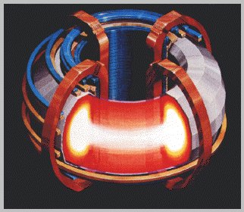
Nuclear Fusion is considered by many as the next step in energy evolution and a potential source of cheap and clean energy for all.

However, it has not been cheap to research fusion energy. If you would like to utilize fusion as an energy source in your future, I would estimate the cost to be $10 billion ($10¹⁰) each year for ten years. After these ten years of research, you can start building fusion plants at the same cost as current fission plants. (For practical purposes, just make a note in your final write-up that indicates at what year new nuclear plants were actually fusion plants rather than fission plants).

Space Based Solar:
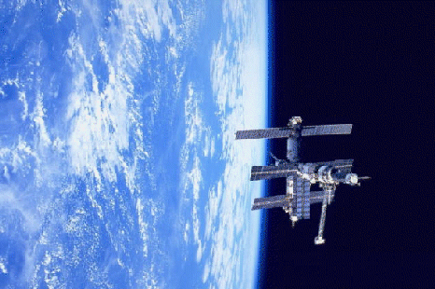
If you surf the NASA web pages, you will come across research papers looking at the issue of deriving solar energy from space based platforms. In space, at Earth's orbital distance from the sun, you can get 1470 Watts/meter² (this is the so-call solar-constant). (Bonus Question: Why is this number so much larger than the average of 100 Watts/m² found on the surface of the Earth?)

If you want to incorporate this energy source into your future, I estimate that the cost would be $1 trillion ($10¹²) a year for 10 year (this may be a low estimate). After these 10 years, you can start adding solar energy from these space-based collectors for the normal cost of solar energy.

Geothermal:
The human race currently utilizes geothermal power as an energy source. Iceland, for example, derives a significant part of its nation's energy from geothermal. However, planet-wide, the total amount of energy derived from geothermal is even less than solar.

Some people have discussed plans to tap the Earth's mantle to derive large amounts of energy from geothermal. The author of this article does not know much about such plans. If you want to dream big, and incorporate geothermal as a new major energy source in your budget--research the issue and send the author what you find.

Ocean Thermal/Electric Conversion:
It turns out that electrical current can be derived directly from thermal differentials in the Ocean. Experimental electricity producing plants have already been constructed in Hawaii. If you want to know more about these try visiting

There are other possible sources of energy that human race may choose to tap in the future. If you come across one that you think the world should more seriously pursue, tell me about it by visiting the Energy Budget Web-Site.

Questions to Ponder:
- You might have heard about Hydrogen Fuel cells that are being used to power buses in Colorado. Why would a hydrogen fuel cell be appropriate to list with the above other possible sources of energy?

Miscellaneous Information

Question to ponder:
- Suppose that a salesperson came to you and said that she had a new energy source. The source of energy could be used cheaply and cleanly in one's home for such activities of home heating, cooking food, air conditioning, etc… The only drawback would be that 1,000 of people a year in the U.S. would be killed due to its use. Would you want the energy source used in your home?

