12/04/2016 December 10, 2016

There are some events that occur on 12/10/2016 that may be of prophetic significance.

1. 12/10/2016 is the 99th anniversary of General Edmund Allenby walking into Jerusalem on 12/10/1917 and taking control after 400 years of Islamic rule. First Viscount Allenby was a type of Israel's Messiah, YAHUSHUA, who will also walk into Jerusalem at some time in our future.

2. 12/10 2016 is the 7th anniversary of President Barak Obama receiving the Nobel Prize for Peace in Norway on 12/10/2009.

3. 12/10/2016 is the 7th prophetic anniversary (7 x 360 days = 2520 days) of the discovery of the strange "X" comet, P2010 A2. The numerical quantity 2520 was encoded into the "Handwriting on the Wall", Mene Mene Tekel Upharsin, of Daniel chapter 5 that signaled the immediate demise of ancient Babylon on October 11, 539 BC. The strange comet P2010 A2 was shaped like an "X", an ancient Paleo Hebrew Tav. The Hebrew letter "Tav" has the meaning "the end" or "end marker".

4. 12/10/2016 is also the day that comet P2010 A2 will appear to sharply reverse course in the sky, pointing to the constellation Leo. The constellation Leo signifies the Lion of Judah, Israel's Messiah and King.

The above mentioned events all concerning 12/10/2016 are shown in the graphic below. In each case the anniversary date is actually the 1st day of the next measured year, that is, the 7th year anniversary date of 12/10/2016 is actually the 1st day of the 8th year.

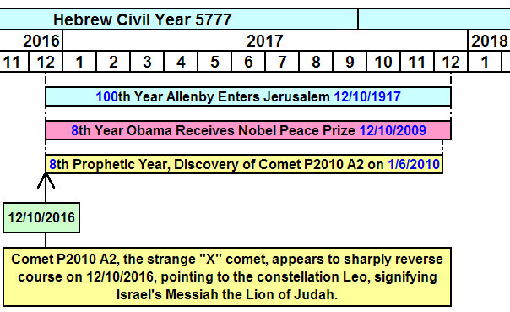

Below is a photo of comet P2010 A2.

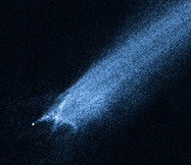

Below is a graphic showing the path of comet P2010 A2 as it appears to sharply reverse course precisely on 12/10/2016, pointing to the constellation Leo.

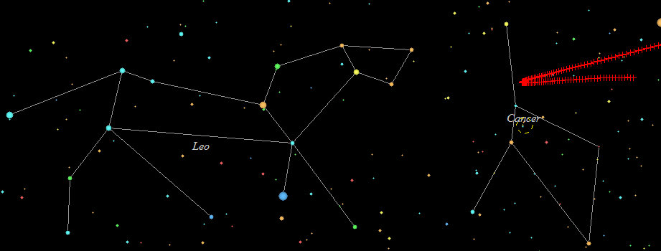

Below is a graphic showing the expanded and dated path of the comet shown above with 12/10/2016 at the reversal point.

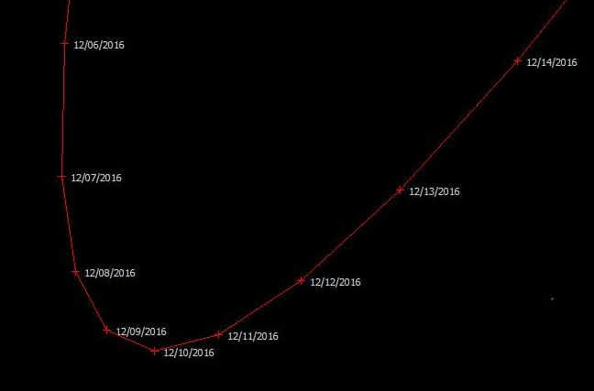

The timeline graphic information presented above will overlay with the information in the previous article of December 3, 2016, titled "The Culmination of Years".

Other relevant information will follow in a future article, as it would all probably be a bit overwhelming if presented all at once.

