Camelot Park Homeowners Association
Architectural Committee
Garbage and Recyclable Containers Fencing
Guidelines and Requirements

Summary:
The current covenants and Restrictions states:

18. No fencing shall extend beyond the building line of any residence. If a residence is built behind the front building line of a Lot, a fence may not extend beyond that point nearest the street at each end corner. Fences shall be constructed of wood, brick, stucco, wrought iron or natural stone, not exceed seventy-two (72) inches in height and be approved by the Architectural Committee. Chain link, barbed wire, meshed or other metal fencing shall not be permitted. The Addition, its successors, or its assigns may erect a fence along the North boundary adjacent to East 101st Street South in the fence easement shown on the Plat of the Addition. All fences must be maintained in good condition with no visible holes or loose or missing pickets. Wood fences must be the dog-eared or finish cap style on top, no pointed end pickets are allowed.

We recently approved a fence extension for Lloyd Benedict (10125 S Fulton Ave). The stipulations were:

- The fence should be constructed using the same material/fencing, consistent with what is currently installed.

- The fence doesn’t have to be as tall as the current fence max (6ft), but high enough to cover the cans so they are not visible from the street at any angle.

Based on this review, below are following guidelines and requirements that must be followed:

The current requirements for All Trash/Recycle Containers state they must be properly stored from street view and stored behind the fence of the homeowner’s property ---- Covenant and Restrictions # 25.

This requirement is being expanded to include the following for Garbage and Recyclable Containers Fencing.

1. Fence should be constructed using the same material/fencing, consistent with what
is currently installed at home.
2. The height should be at least 2 feet above the height of the larger of the two
recyclables (Trash/Recyclable) containers, and high enough to cover the cans so not
visible from the street at any angle.
3. Fence must be installed on a concrete pad or pavers. It can have a latch gate, but not required.
4. Fence must be attached to the home.
5. Fence should be built at least 5 feet back from front of home or garage. (see example below)

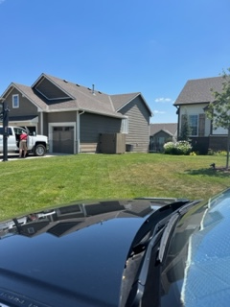
Effective Date: July 30, 2023

