Kennedy High School
Advisor: Barry Wilson
Location: 4545 Wenig Rd. NE, Cedar Rapids, IA, 52402
Phone Number: 319-784-7697
bwilson@cr.k12.ia.us
Bryan Becker, Grade 12, Crew Chief
Isaac Hofferber, Grade 9, Assistant Crew Chief
Elizabeth Severson, Grade 10 Driver
Rodrigo Sagastume, Grade 11, Driver
Kaleigh Martin, Grade 10, Documentation writer
985/A985 (50 car) April Monthly Report
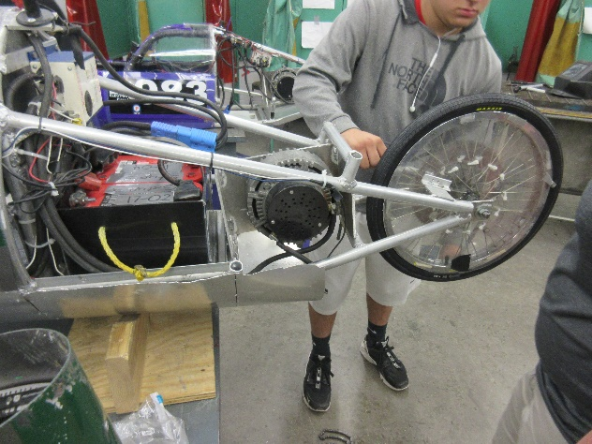
This month the work done on the 50 car was mainly limited to minor fixes and adjustments found during races. Bryan Becker and his assistant Isaac Hofferber have cleaned up the steering and adjusted the rear wheel. They have also checked ands rechecked the various systems to ensure peak performance at the races.
The team has been very successful this season. At our first race in Hastings, NE, Rodrigo Sagastume got first place Endurance in the (A)985 and John Tedesco got second place Endurance in the (A)983. At the next one in Platteville, WI, Kaleigh Martin got first place Endurance in the (A)983 and Elizabeth Severson got second place Endurance in the (A)985. This was both driver’s first race.
The documentation team has been working overtime to finish the books for Wisconsin, as well as figure out the multimedia from scratch.

