The Bellringer
Publication of St Andrews Presbyterian Church
2015 Christmas Issue

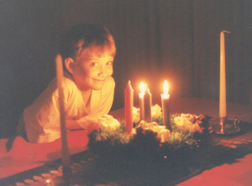

From the Pulpit. . . What is Advent?
The word “Advent” is derived from the Latin word adventus, meaning “coming.” It begins four Sundays before December 25, this year it begins on November 29th.
By the 6th century Roman Christians observed Advent as preparation for coming of Christ. But the “coming” they had in mind was not Christ’s first coming in the manger in Bethlehem, but his second coming in the clouds as the judge of the world. It was not until the Middle Ages that the Advent season was explicitly linked to Christ’s first coming at Christmas.
We are a people of promise. For centuries, God prepared people for the coming of his Son, our only hope for life. At Christmas we celebrate the fulfillment of the promises God made—that he would give a way to draw near to him. The wreath of Advent comes from a desire to express joy at the coming of Jesus, who is the “light of the world,” into our lives. For this reason light is a very important part of the celebration of Christmas.
Advent wreaths have many variations as far as traditions are concerned. For example, in Germany the four candles are red. In the Scandinavian countries the candles are white. Presbyterians usually use three purple candles, one pink candle, and a white Christ candle which is lit on Christmas Eve. From the earlies times Advent was a time of penance, forgiveness, and prayer, a time to prepare the heart for the coming of Christ.
Each Sunday we will light the candles on the Advent wreath and tell the story of God’s people as it unfolds in the Biblical narrative. Submitted by Pastor Sheila
ESTIMATE OF GIVING
This Sunday we will dedicate our Estimate of Giving during the worship service. This information will be used to develop our financial planning for 2016 so that we can determine our ability to pay our utility bills, the Continued on page 2
Estimate of Giving from page 1 . . . mortgage, the insurance and our few employee salaries. This is an amazing congregation that obviously loves this church because, in spite of years of financial challenges, has been able to provide the support needed to keep that ugly word “deficit” from hurting us. Thanks to members, friends of the church, gifts, grants and fund raisers, the bell tower has been removed with funds remaining to provide a permanent resting place for the bell. In 2016, we will turn our attention to determine if we can secure any relief from the terms of our mortgage. To do this we must provide a budget for 2016 thereby adding additional emphasis to the importance of the Estimate of Giving as a basis for the church’s revenue. Planning will also begin on replacing the roof over the Fellowship Hall and education building
Giving is a touchy subject that is avoided by most Sessions and pastors. But your Session does spend a lot of time discussing spending and other financial matters. This is only the second year that we have asked for an Estimate of Giving and recognize that is an uncomfortable process for some. Studies have shown that giving is something that makes one feel good, you want to do it rather than have to do it. In that spirit, something wonderful has been happening in this church.
If you are unable to turn in your Estimate of Giving this Sunday, please mail it in as soon as possible. Submitted by George Carothers
DECEMBER

01 Robyn Perry
09 Charles Charette
16 Chuck Martin
18 Patsy Moates
19 Bonnie Charette
24 Patty Fuller

JANUARY

01 Daphne Watkins
04 Gloria Rowell
06 Maxine Priester
09 Kevin Veldhuisen
16 Dianne Vaughn
18 Scott Perry
30 Fleta Dean

FEBRUARY

04 Bob Nixon
08 Tom Douglas
12 Mary Lou Douglas
14 Kimberly Howell
28 George Carothers

Where to find Coordinating Presbyter
Paul Luthman
Please keep Paul and his family in your prayers as they travel to New Jersey this weekend to remember and honor the life of his mother, who died last weekend at age 97.
Recent visits in our area have been:
Thursday, Nov. 19 – Panama City
Friday, Nov. 20 – Chipley pluthman@presbyteryofflorida.com
229-347-6416
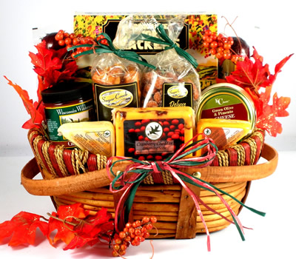

Thanksgiving Basket
Each Thanksgiving we stop for a minute to reflect on all of the blessings that we have received this year. We also realize that sometimes circumstances put families in need of a little help. This year we are collecting all the items needed for two families to enjoy a Thanksgiving Dinner. We also add items that will help the family for many days after Thanksgiving.
This year we received names of families that could use a little help from St. Andrews Elementary School and Oakland Terrace Elementary School. Each year when we deliver the baskets to grateful families we are blessed with the knowledge that we are only doing what the church was called to do.

Advent Decorations

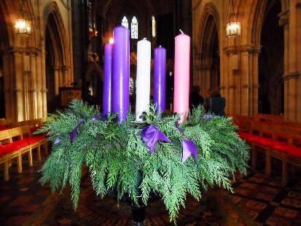
Advent season officially begins on November 29th this year. On November 23rd at 9:00 AM Jimmy and Jennifer Whisenant and others, decorated the sanctuary and the fellowship hall.. We will also take this time to do a little cleaning. The team requested some additional supplies such as gold, silver, or white decorations for the Christmas tree.

SPECIAL CHRISTMAS PROGRAM

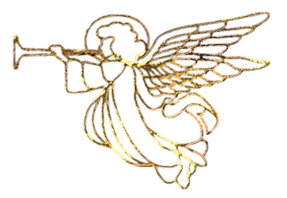
Our annual Christmas candle lighting worship service will be held on Sunday December 20th at 5:00 PM. It will feature a concert of familiar Christmas music- THE CORELLI CHRISTMAS CONCERTO - performed by the Bay Arts Quartet. Please be sure to attend and bring friends and family with you.
Light refreshments will be served following the service.

LAUGHTER PROTECTS
When a little boy on his scooter, hit a bump in the sidewalk and took a tumble, he paused and then burst out laughing. A passerby who saw no fun in the bruises asked: "What's so funny? Why laugh about it? The boy replied, "Mr., I'm laughing so I won't cry."
Occasionally we adults hit a rough place in life and suffer a spill; now that is a good time to laugh, lest we lose self-possession. Laughing is a safety-valve which lets off the tensions of irritations; if the value doesn't work, we become as grim as an owl, but without his proverbial wisdom.
Our sincerest laughter with some pain is fraught; Our sweetest songs are those that tell of saddest thought. Percy Bysshe Shelley 1792-1822
Even in laughter the heart is sorrowful - Proverbs 14:13

Submitted by: Maureen Wade
When GOD solves our problems, we have faith in HIS abilities. When GOD doesn't solve our problems HE has faith in our abilities.
God's accuracy may be observed in the hatching of eggs. . . . .
-those of the canary in 14 days; -those of the barnyard hen in 21 days; -eggs of ducks and geese in 28 days; -those of the mallard in 35 days;
The eggs of the parrot and the ostrich hatch in 42 days. (Notice, they are all divisible by seven, the number of days in a week!)
God's wisdom is seen in the making of an elephant . . . .
The four legs of this great beast all bend forward in the same direction - no other quadruped is so made. God planned that this animal would have a huge body too large to live on two legs. For this reason He gave it. . .
. . .four fulcrums so that it can rise from the ground easily. The horse rises from the ground on its two front legs first. A cow rises from the ground with its two hind legs first.
How wise the Lord is in all His works of creation! -Each watermelon has an even number of stripes on the rind.
-Each orange has an even number of segments. -Each ear of corn has an even number of rows
- Each stalk of wheat has an even number of grains.
Every bunch of bananas has on its lowest row an even number of bananas, and each row decreases by one, so that one row has an even number and the next row an odd number. Life without God is like an unsharpened pencil - it has no point.

Yard Sale Is a Success
The first Annual Great St. Andrews Yard Sale was a qualified success. Vendors sold and sold and sold. The Bake Sale sponsored by the WOC sold out. The crowd especially enjoyed the cookies. 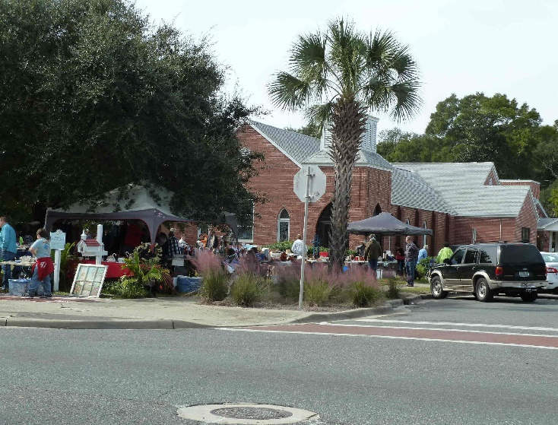
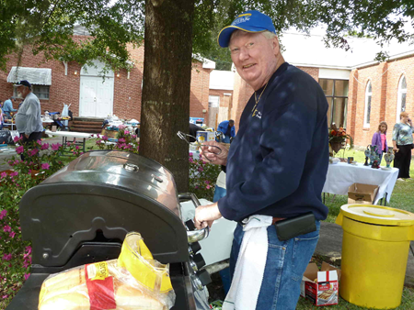
The smell of hotdogs cooked on the grill drew the crowd and 212 hotdogs were cooked and eaten. With over 30 vendors the front lawn of the church was filled almost to capacity.

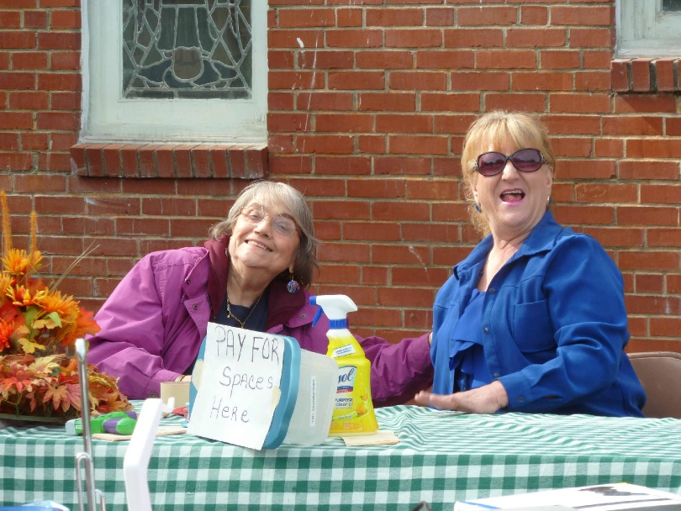
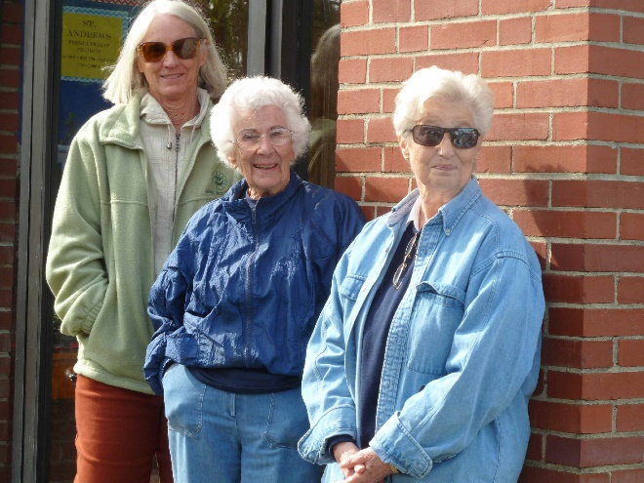
Those coming to buy could choose from a wide variety of items. Thanks to all that came and parked cars, put up tents and tables, manned tables both outside and
inside the church to welcome visitors and tell them about the church and invite them to visit, supervised and sold at the church yard sale site, and stayed to clean up and get the yards and building ready for Sunday Services. The yard sale brought in over $1000.00 which will help to balance our budget. The yard sale was a lot of hard work and planning but all of our guests and vendors enjoyed it.

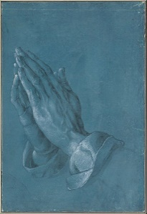
The POEM

I knelt to pray but not for long, I had too much to do.
I had to hurry & get to work for bills would soon be due.
So I knelt and said a hurried prayer, and jumped up off my knees.
My Christian duty now was done, My soul could rest at ease.
All day long I had no time to spread a word of cheer, No time to speak of Christ to friends, They'd laugh at me I fear.
No time, no time, too much to do, that was my constant cry,
No time to give to souls in need, but at last the time, the time to die.
I went before to Lord, I came, I stood with downcast eyes,
For in His hands God held a book; it was the book of life.
God looked into his book and said "Your name I cannot find.
I once was going to write it down....but never found the time"

Submitted by Margie Nelson

Presbyterian Women
Our Bible study lesson for November was entitled “Absence of Water – Thirst and Longing”, with scriptures from Exodus 17: 1-7, Psalm 42:1-2, 63: 1, and John19;28. Our lesson focus was that we have dry spells in our lives, our bodies and our souls thirst!! He teaches us how to hunger and thirst for righteousness.

This month the women of the church are assisting with our first Community Yard and Bake sale, hosting our annual Church Thanksgiving lunch, assisting with our Church Thanksgiving baskets for needy families and financially supporting a table of 20 for a Thanksgiving meal at the Panama City Rescue Mission. We will also be taking a Thank Offering that is used to provide clean water, alleviate homelessness, provide educational opportunities, promotes health and improves the lives of women and children throughout the world in so many other ways, Please give now so that others will be blessed.
Submitted by Dixie Retherford

Presbyterian Women Bake Sale
Our women of St. Andrews Presbyterian Church held a Bake Sale on Saturday November 14, 2015 during the Community Yard Sale event.
We sold fresh baked pies, cakes, cookies, brownies and bagels along with hot coffee, hot chocolate and porag juice.
Coffee was popular item because of the cold wind blowing across the Church front lawn. This was a good time to buy goodies for the Thanksgiving season to save on baking.
They will all freeze, if need be. The church, also had tables displaying yard sale items of all types.
This was a great day of good fellowship with our neighbors in the community as well as our church family.
Hopefully we have set a trend that will occur annually.

The Andrew Family A Fall Scarecrow Festival
Headlining the 2015 Scarecrow Festival was the Andrew family – as far as the St. Andrews crew working our entry into the Festival was concerned.
The Andrew family did take 2nd Place…and that was pretty good, if we don’t think so ourselves.
One year we came in 1st place but that was in our division. This year we were competing with everyone else on Beck Ave for ‘best all round’.
Angie Tucker’s sister, Charlotte Smith – the other sister of Two Sisters shop, started the Fall program several years ago before she passed away. St. Andrews Presbyterian has had a ‘soft spot’ for the program ever since.
Jennifer Whisenant got the PEWS committee involved with this very first scarecrow event. The winning entry’s name is Andrew and he was a winner in his category.
This year the Andrew family consisted of Andrew (the father), Big Bertha (mother), Lem (son), baby EllieMae, cat (unnamed) and Juniper (dog).

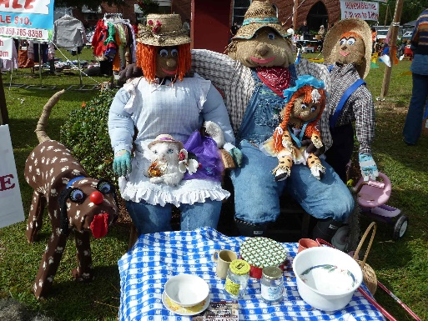

The Festival of Trees
. . . .is offering Christmas by the Bay benefiting Bethel Village. This Benefit is a fundraiser held annually to help with a residential treatment program for women and women with children who have substance abuse issues. This program has the capacity to house up to 23 women and children at a time.
You’re invited to join in on silent auctions and there will be the bakery plus boutiques. The beautifully decorated trees the Festival gets its name, are available for purchase. Other planned happenings are: a brunch on Wednesday, December 2 from 9-11am that features live music; fashion show and auction. Later that afternoon a tea will be held from 2-4pm.
The Christmas by the Bay Festival of Trees is being held December 1 thru 4 at Downtown Marina Civic Center.
A Night in Bethlehem
Grace Presbyterian has invited us to ‘A Night in Bethlehem’ where we will enter the city gates while Roman soldiers stand guard. After registering with the census taker, families will stroll the streets on the night of Jesus birth.
There will be many authentic sights, sounds and smells of this busy little city.
As families the city, they will encounter the stable and the newborn baby. ‘
‘A Night in Bethlehem’ is December 11 and 12 at 6pm to 9. Ask Pastor Sheila for info.
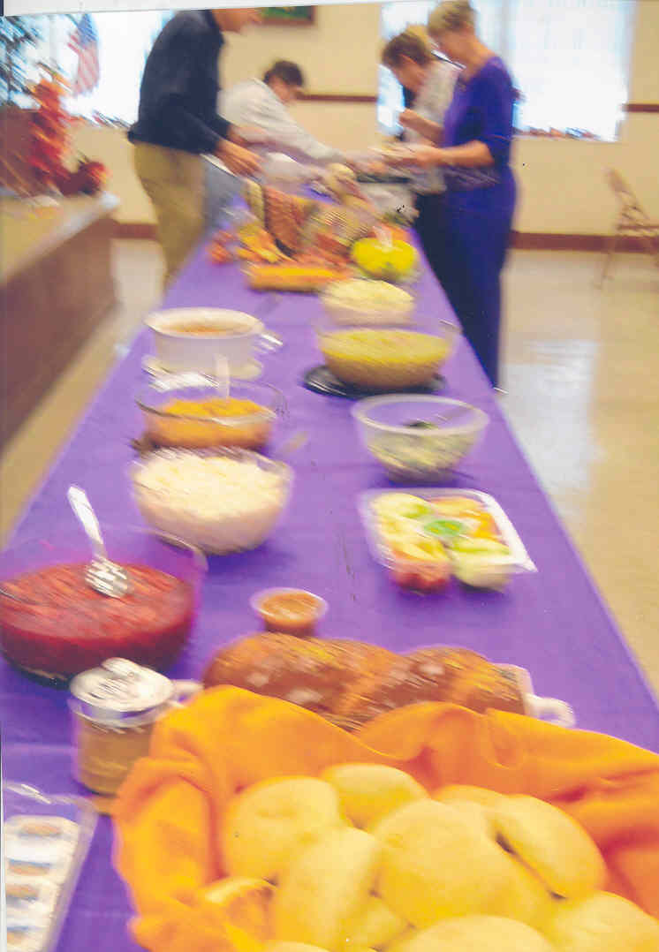
Thanksgiving at St. Andrews Presbyterian

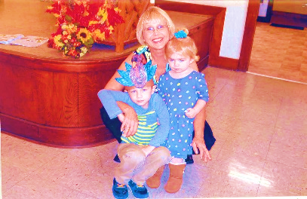
Finn & his little sister Lulu, Jimmy & Jennifer Whisenant's grandchildren, were among our visitors & guests at our Thanksgiving luncheon on November 22nd.

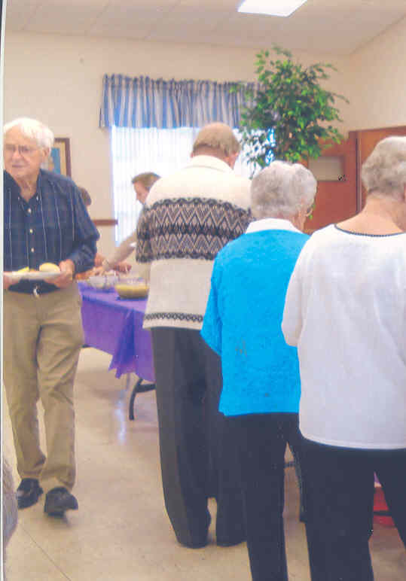
After we feasted on lots of turkey and ham and the trimmings plus wonderful desserts, Sheila taught us how to put together beautiful Advent Candles

Advent this season begins Sunday, November 29.

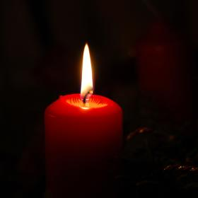
Presenters are: Nov.29 – the Wades; Dec. 6 – Sally Teer & Rose Stallin; Dec. 13 – Leo Nelson & Dixie Rutherford; Dec. 20 – the
Whisenants

GOBBLE GOBBLE
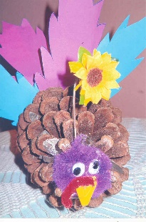
Jennifer went across the street to St. Andrews School with a bunch of pine cones from her yard. The kids took them and did a great job of making "Thanksgiving Turkeys" with them.
They were all very cute and creative and were used to decorate our Fellowship Hall, making it very festive for the fall season and our Thanksgiving meal.
Many thanks to all the kids at St. Andrews School. They did a wonderful job. Each pine cone represented that child’s and all cones were different/
Presbyterian Women Bake Sale

Our women of St. Andrews Presbyterian Church held a Bake Sale on Saturday November 14, 2015 during the Community Yard Sale event.
We sold fresh baked pies, cakes, cookies, brownies and bagels along with hot coffee, hot chocolate and porag juice.
Coffee was popular item because of the cold wind blowing across the Church front lawn. This was a good time to buy goodies for the Thanksgiving season to save on baking.
They will all freeze, if need be. The church, also had tables displaying yard sale items of all types.
This was a great day of good fellowship with our neighbors in the community as well as our church family

More Photos of Yard Sale

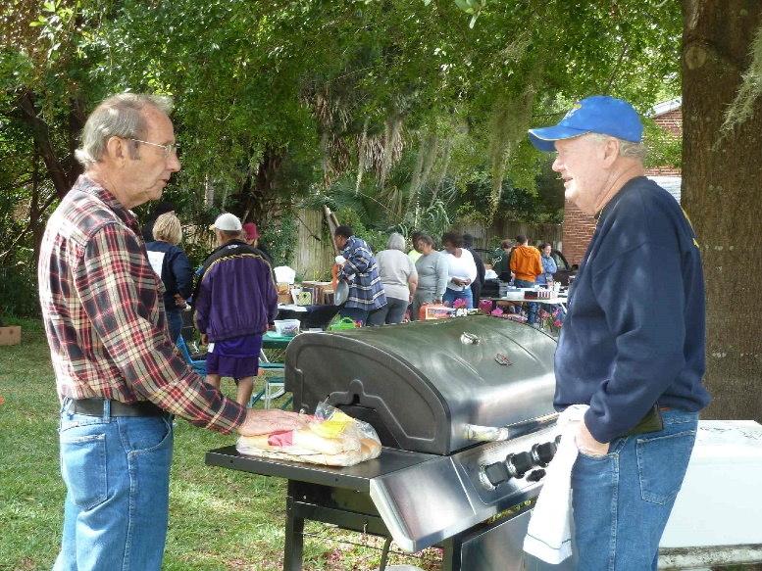
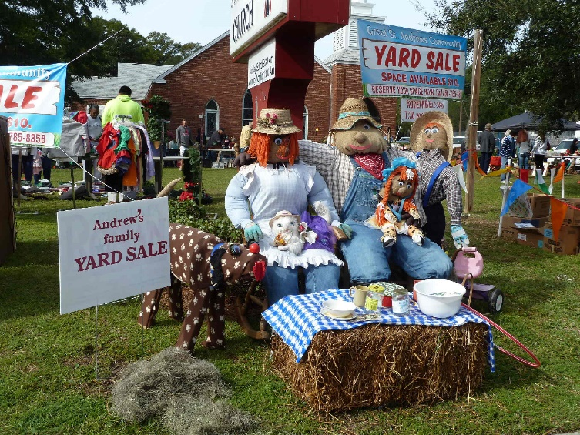
‘What a crowd’, says Andrew

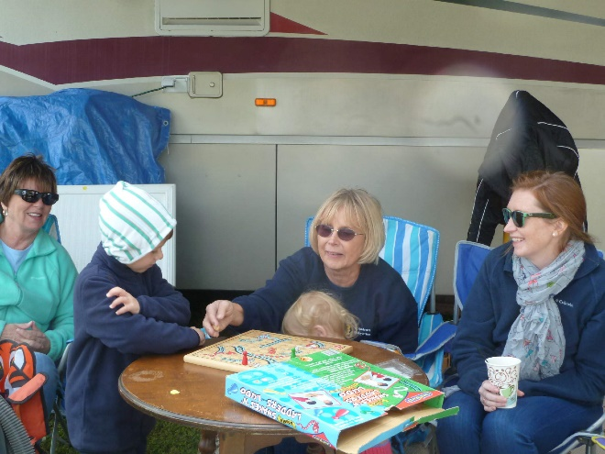
‘When you grow up. . .”

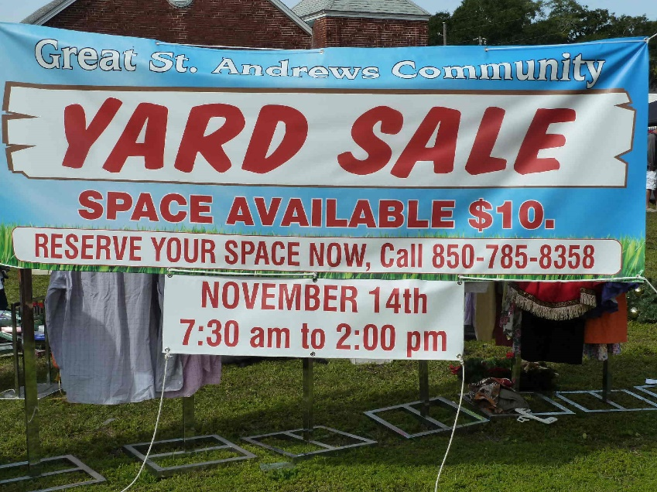
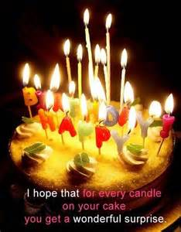
The Bellringer A Publication of
St Andrews Presbyterian Church
Christmas 2015
3007 West 14th Street, Panama City, Florida 32401 Phone: 850/785-5263
standrewspresch@knology.net http://www.saintandrewspc.com

Fitness & Line Dance
Maureen Wade and Jane Perry decided back in October that they would wrap things up for Line Dancing for the season. With Thanksgiving and Christmas upon us and having families to be attended to, they postponed activities to Thursday, January 28 at 4:30pm.
Meanwhile, Fitness with its 5 programs will continue to have its winter program - two days a week.
The programs consist of chair Yoga, a unit on Strength, one on Stretching and two on Core development (very important for Seniors). Programs are on: Tuesdays @ 9:30am in the fellowship hall. Wednesdays we Walk about St. Andrews and get our stooping exercises in by carrying bags and picking up trash. At 9:30am, we’re back in the fellowship hall doing the Senior fitness program.

CHURCH CALENDAR
Sundays 9:30am, Sunday School
11am, Worship Service,

Mondays, 9am, TOPS #217,

Tuesdays, 9:30am.
Wednesdays, 8:30am, Walk about St. Andrews, 9:30am, Fitness ; 3pm, Choir Practice, choir room.

Programs Not Happening Weekly
Tuesdays: 2pm,2nd Tuesday Presbyterian Women; 5pm,1st & 3rd Tuesday Girl Scouts #400

Wednesdays{:
1pm, 3rd Wednesday, Session

Thursdays:
2pm,2nd Thursday Presbyterian Women

Coming Events;
December 1-4
Festival of Trees @ Downtown Marina Center December 11-12 ‘A Night in Bethlehem’ @
Grace Presbyterian

December 22 Special Christmas Program The Cotelli Christmas Concert with traditional candle light service. Our sanctuary.

