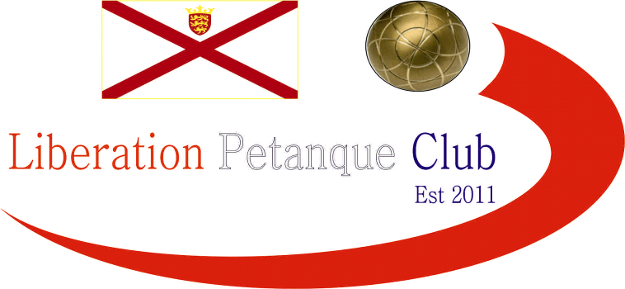

**WINTER 2024 / 25 SEASON**

**WEEK 3 – 16TH November 2024**

**DOUBLES LEAGUE**

# Week 2 in the Doubles league saw Andrew & Callum win comfortably again over Gary & Wendy and a second win also for Keith & Mo over Cassie & Jean.

# Alan & Mike played their first match beating Daniel & James and Jake & Ross got a close win over John & Nick.

# NEXT WEEK - SINGLES LEAGUE

# Club email address - [liberationpc@gmail.com](mailto:liberationpc@gmail.com)

# Club Website - [www.liberationpetanque.co.uk](http://www.liberationpetanque.co.uk)

# Kind Regards

# Toby Northern

# Chairman

# Liberation Petanque Club