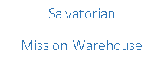

Winter 2017
“Be Joyful! Be moved by this joy to spread the message of Christ through all ways and means!”
Fr. Francis Jordan, Salvatorian Founder
Dear Friends,
This past October, I was blessed to have an opportunity to visit Guatemala and journey with our missions there. The Salvatorian Mission Warehouse sends containers to two locations in Guatemala: Guatemala City and San Marcos. The containers to Guatemala City arrive at the Valley of the Angels, which is a mission run by my very good friend, Fr. Michael Della Penna, OFS. The Valley is a boarding school where children from extreme poverty, neglect, and abuse come to live and receive an education in a loving, supportive environment. The second container recipient is a collaboration of ministries that serves the remote areas near the Mexican border, organized by Maryknoll sisters, Dr. Jane Buellsbach and Sr. Mary Lou. They essentially have established working medical outposts for the many people who do not have easy access to healthcare providers. They have trained local villagers who voluntarily provide basic medical care for free and prescriptions at cost. Jane and Mary Lou’s work is truly amazing, as they are transforming Guatemala one person at a time; working from within their culture.
There is wonderful meaning I learned while spending time with these incredibly inspiring places: God truly loves us all, reaching within each of us to touch our individual given talents, and somehow and in some way, gently nudging us to challenge our ignorance of other people, other cultures, and to share collaboratively all our given gifts to see God’s graces shine! It is true what they say in Guatemala, “Los chapines somos muy alegres." – Guatemalans are very happy.
I bring to you, through this newsletter, the great happiness and joy I so often talk about. The Guatemalan missions are just two of the more than 35 missions we continue to serve. The Mission Warehouse continues to be blessed with great financial contributions, wonderful corporate donations, and incredibly dedicated volunteers. Whether we live here or in missions like Guatemala, we are truly united in the name of Jesus Christ using all our gifts from God.
The Holy Spirit has set the Salvatorian Mission Warehouse afire… it is alive and thriving! As always, visit our website www.salvatorianmissionwarehouse.org and our Facebook page https://www.facebook.com/salvatorianmissionwarehouse/ to see the many emails and pictures we receive from the missions. God bless you all!
Peace in Christ,
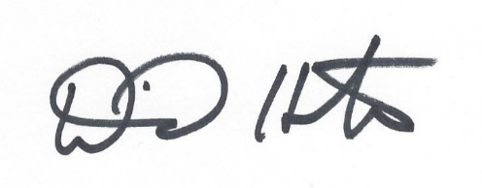

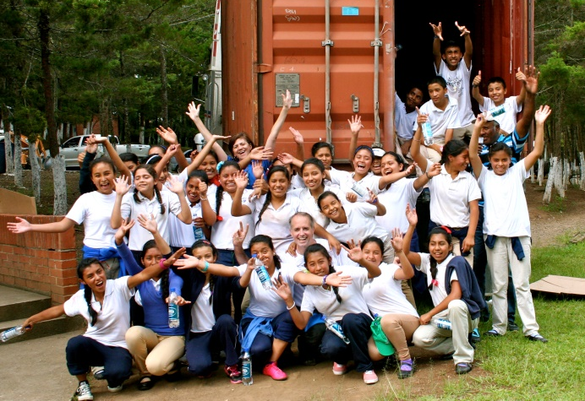
Valley of the Angels,
Guatemala
Some of the Many Letters of THANKS!
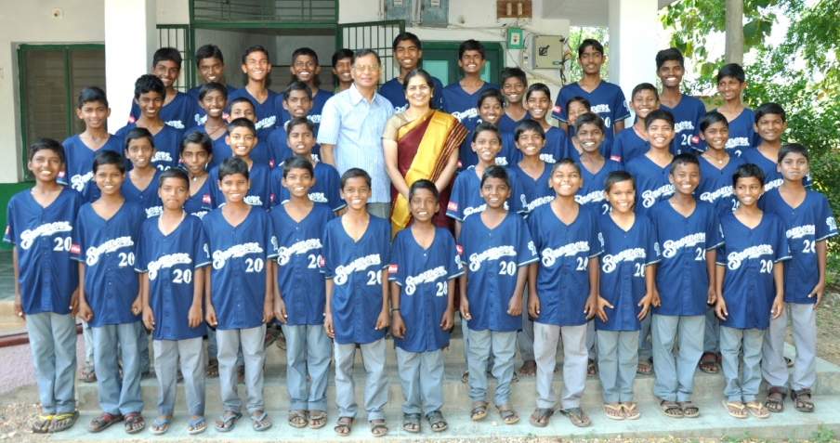
Greetings to you! Many thanks for all your support. We are very grateful to you for all the supplies that you have generously given to our needy children. Words are not sufficient to thank you for all that you do to many around the world. More than 400 enjoyed the chocolates. Also about 50 got T shirts.
Thanking you for all your support.
With Love, Prayers and Much Gratitude,
Tom and Geetha, India

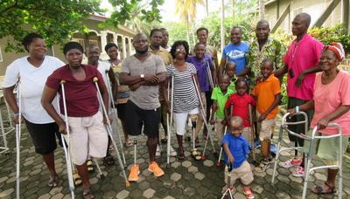
Thanks for sending the ace bandages, I am sending a picture of the amputees, these are only the ones that are on admission at the moment. We make several hundred legs a year and they all need bandaging to keep their stump in shape.
Sister Elizabeth, OTC Nsawam Ghana

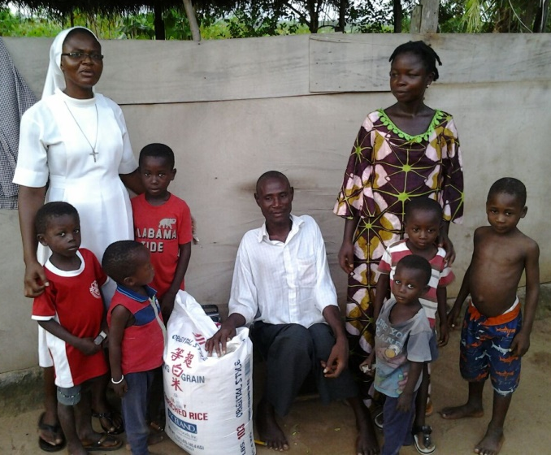
Peace and joy to you all and I pray you are good, as we are here.

I write to acknowledge the safe arrival of the two containers you sent, one with rice and the other with assorted items. We are most grateful to you and your team members for the tremendous work you are doing for mankind.

As usual we have done our duty by sharing what we received from you and our children at our home also getting their share. The rice and others came at the right time as the rains delay here in Ghana, and so we are privileged to have you always intervening when the going becomes tough. We remain forever thankful for your support in times of urgent need for our poor and less fortunate ones.

Do remember us always; we need rice, corn meal and anything good for us. May God richly bless you all and your work for humankind and be assured of our continuous prayers.

Sincerely yours,
Sr. Matilda, Ghana

2016 Mission Support Efforts
Location | Number of Missions | Shipped  Containers  Of Relief Goods | Total Pounds of  Relief Goods | Containers of Rice  (40,000 lbs. each) | Total Pounds of Rice
Chile, Central America | 1 | 2 | 29,585
Chuuk, Micronesia | 1 | 1 | 18,500
Congo, Africa (New) | 1 | 1 | 15,500
Ghana, Africa | 20 | 29 | 447,319 | 11 | 440,000
Guatemala, Central America | 2 | 4 | 103,830
Honduras, Central America | 1 | 5 | 128,159
Iraq, Asia (New - Refugees) | 1 | 1 | 14,045
Panama, Central America | 1 | 2 | 48,530
Paraguay, South America | 2 | 3 | 43,920
Peru, Central America | 1 | 2 | 54,285
Tanzania, Africa | 3 | 4 | 49,118 | 3 | 120,000
Syria, Asia (New - Refugees) | 1 | 1 | 14,045
Total | 35 | 55 | 1,002,836 | 14 | 560,000

Total Containers Sent = 69
Total Shipped = 1,562,836 lbs.
1,119,099 lbs. of Relief Goods Donated:
- Community Bike Program of Oshkosh
- D’Orazio Cleaning Supply – toothbrushes & soap
- Figis - candy & sweets
- Fleet Farm – clothing
- Georgia Pacific – paper products
- Hershey’s – candy, beef jerky
- Kohler Company
- Land’s End – clothing, shoes, backpacks & jackets
- Milwaukee Brewers – clothing & caps
- Sargento Foods – cookies & crackers
- Southwest Medical Aid
- St. Vincent de Paul
- Willow Dale Nursing Home – beds
- Personal Support: bikes, medical supplies, blankets & furniture

THANK YOU TO ALL OF OUR DONORS!

2016 Financial | Contributions
Families/Personal | $230,506
Funds/Foundations | $379,601
Churches/Groups | $ 40,942
Small Businesses | $ 1,912
Recycling Revenue | $ 8,645
Total | $661,606

Expenses for 2016
Mission Goods Purchased, Shipping Supplies, Freight Expense | $525,799
New Holstein Warehouse: building & equipment maintenance, business operation costs | $ 55,277
Postage, Printing, Salaries, Marketing, Mission Travel, Misc. | $ 44,613
Total | $625,689
Our Founder, Fr. Francis Jordan
For more than 125 years, the Salvatorians have worked to preserve the Church and make Jesus Christ known to all people. Through peacetime and social upheaval, through challenges and change, we remain true to the founder’s vision.
- The Society’s mission is to proclaim and teach by all ways and means the goodness and kindness of Jesus the Savior.
- Salvatorians are active in over 30 countries.
- Through diverse cultural membership and ministry, more than 1,200 priests and brothers worldwide carry on the Salvatorian mission.
- Fr. Jordan arrived in St. Nazianz, Wisconsin in August of 1896

Please visit the Society of the Divine Savior’s website for more information. www.salvatorians.com
Online store also available:
http://bit.ly/SalvatorianStore

We invite your group or business to come volunteer!
The SMW is looking to book groups of 5-50 volunteers from your Church, School, or Business. It's a perfect activity for team building or community awareness.
Volunteer Opportunities
Monday – Friday 8:30am – 11:30am
Monday – Tuesday 12:30pm – 3:30pm
Closed on Weekends & Holidays
Visiting volunteers can expect an introduction, two hours of repacking and 30 minutes of clean up.
Contact Development Director, Beth Holbrook for group scheduling:
BethHolbrook@SalvatorianMissionWarehouse.org or call 920-898-5898

The SMW is in specific need of:
Bikes (In good working order)
Soap (especially Ivory), Toothpaste, Toothbrushes, Detergent or Deodorant
Band-Aids & Aspirin
New School or Office Supplies
Please contact Dave Holton if you or someone you know can assist with these needs.
DHolton@Salvatorians.com

Thank you for your continued support!

Donor Name (s)
Mailing Address
City State Zip
Phone ( ) Email
Please accept my gift of $
Salvatorian Mission Warehouse
1303 Milwaukee Dr. New Holstein, WI 53061
Donations also accepted through PayPal at www.salvatorianmissionwarehouse.org

