2017 Paint A Pallet ~ Valley Lake Leader/Daughter Event
April 8, 2017
Noon-3pm – Valley Middle School

All leaders and their daughters are invited to join us for a fun afternoon of pallet painting! At the end of the day, you will take home your pallets to decorate your home!

Each leader/daughter combo will receive 4 pallet boards to paint (up to 2 additional boards may be purchased, or an additional set of 4 boards). Boards will be approximately 15 inches long, and will vary in height. You will choose in advance your words, and that day we will stain and paint your boards! Page 2 of this flyer contains the word options and font choices. You will get 1 font choice for all of your words. If you would like additional fonts – there will be an additional $1 charge per font.

Please bring a dish to share for snacking and lunch! Special fun patch will be included in registration.

Please complete this registration form by 3/1/17. It can be mailed to: Kristin or Bethany ~ 14184 Belfast Ct ~ Rosemount, MN 55068
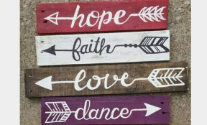

Adult/Leader Name: __________________________________________ Troop #: ______________________
Scout Name: ________________________________________________ Grade/Troop: __________________
Scout Name: ________________________________________________ Grade/Troop: __________________
Scout Name: ________________________________________________ Grade/Troop: __________________
Scout Name: ________________________________________________ Grade/Troop: __________________

Font Choice (for all words): _________ **Font choices are on the next page

Option 1 $38: 4 boards: (If you would like different fonts, there will be an additional $1 charge per board, mark below)
Word 1: _________________________Font: _______Word 2: ___________________________Font ______
Word 3: _________________________Font: _______Word 4: ___________________________Font ______

Additional board $5 each:
Word 5: _________________________Font: _______Word 6: ___________________________Font ______

Option 2 $73: 8 boards:
Word 1: _________________________Font: _______Word 2: ___________________________Font ______
Word 3: _________________________Font: _______Word 4: ___________________________Font ______
Word 5: _________________________Font: _______Word 6: ___________________________Font ______
Word 7: _________________________Font: _______Word 8: ___________________________Font ______

I would like my boards: screwed together separate

Word Options:

LOVE
FAMILY
HOPE
BELIEVE
DREAM
FAITH
HOME
JOY
LAUGH
ENCOURAGE
FOREVER
SMILE
HEART
CHERISH
MEMORIES
BLESSINGS
RESPECT
TOGETHER
INSPIRE
THANKFUL

Font options:

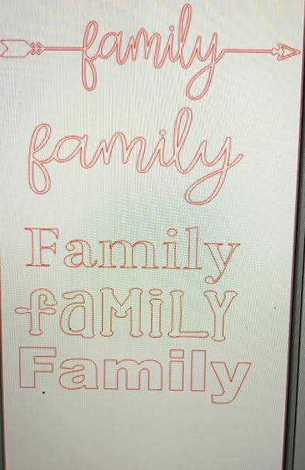
1:

2:

3:

4:

5:

