****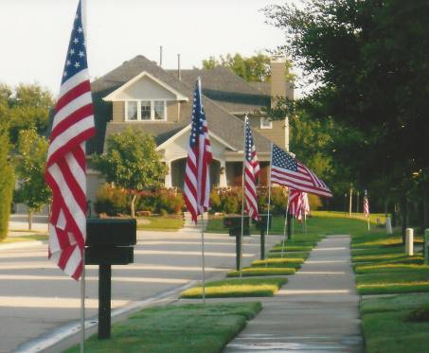**Fairview High School Flyin’ Yellow Jackets**

**Fairview High School Marching Band US Flag Fundraiser**

Join your neighbors and help support your community high school Marching Band program.

For your Tax deductible donation of only $50 or $90, FvHS band students will install a large US Flag in your yard on the following national holidays:

5 Installations – for $50 or **Bonus Deal!!! 10 installations – for $90**

* Veterans Day (observed on Saturday)
* Memorial Day
* Flag Day
* Independence Day
* Labor Day

**Show your pride and support for our country and your community with a small tax-deductible donation.**

If you have any questions please email us at president@fairviewhighschoolband.org

To pay online: Use this web address to provide us with your contact information and to pay online with PayPal.

<http://www.fairviewhighschoolband.org/us-flag-service.html>

Or Mail in the form along with your check

First Name: ________________________________________ Fairview High School

C/O Fairview Band Committee

Last Name: ________________________________________ 2595 Fairview Blvd W.

Fairview, TN 37062

Address: __________________________________________

City: _____________________________________

Subdivision: _______________________________________ 5 installs for $50 ________

Email: _________________________________ __________ **Bonus deal!10 installs for $90 _______**

Phone # _____________________Check # _________ or Cash ________ Card _________PayPal____  
   
Sales person ____________________ Make checks to FvHS Band Committee