Eco Orca MAY 2024 Lifecycle’s and Lakes
SUNDAY |  |  | MONDAY | TUESDAY | WEDNESDAY | THURSDAY | FRIDAY | SATURDAY
 |  | 28 | 29 | 30 | 1 | 2 | 3 | 4
Baby Animals |  |  | 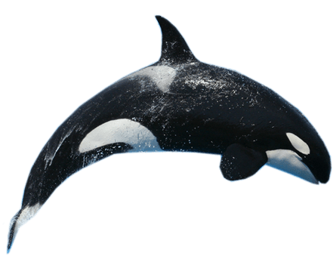 |  | Ruby Creek Trail | Elk  Lake | Beacon Hill petting Zoo $2
 | 5 |  | 6 | 7 | 8 | 9 | 10 | 11
Frogs |  |  | Swan Lake Nature House $3 | Prospect  Lake | Matheson Lake | Young Lake  Sooke | JDF Playground | 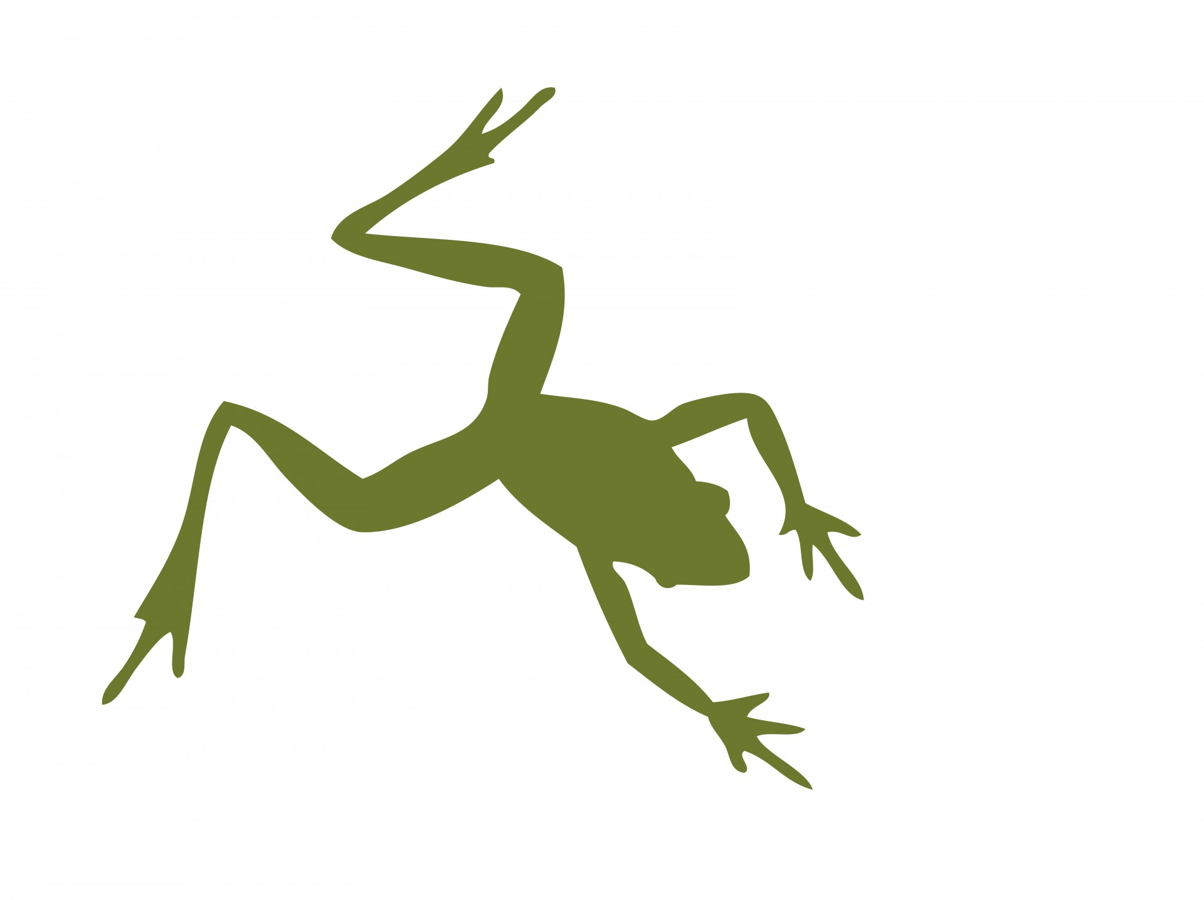
 | 12 |  | 13 | 14 | 15 | 16 | 17 | 18
Butterflies |  |  | Beaver  Lake | Butterfly World $5 | Thetis Lake Trail | Goldie  Park | Pro Day  No Orca Class
 | 19 |  | 20 | 21 | 22 | 23 | 24 | 25
Birds |  |  | Closed  Victoria Day | Witty’s Lagoon | Centennial Park | Raptors $8 | Sooke  Park | 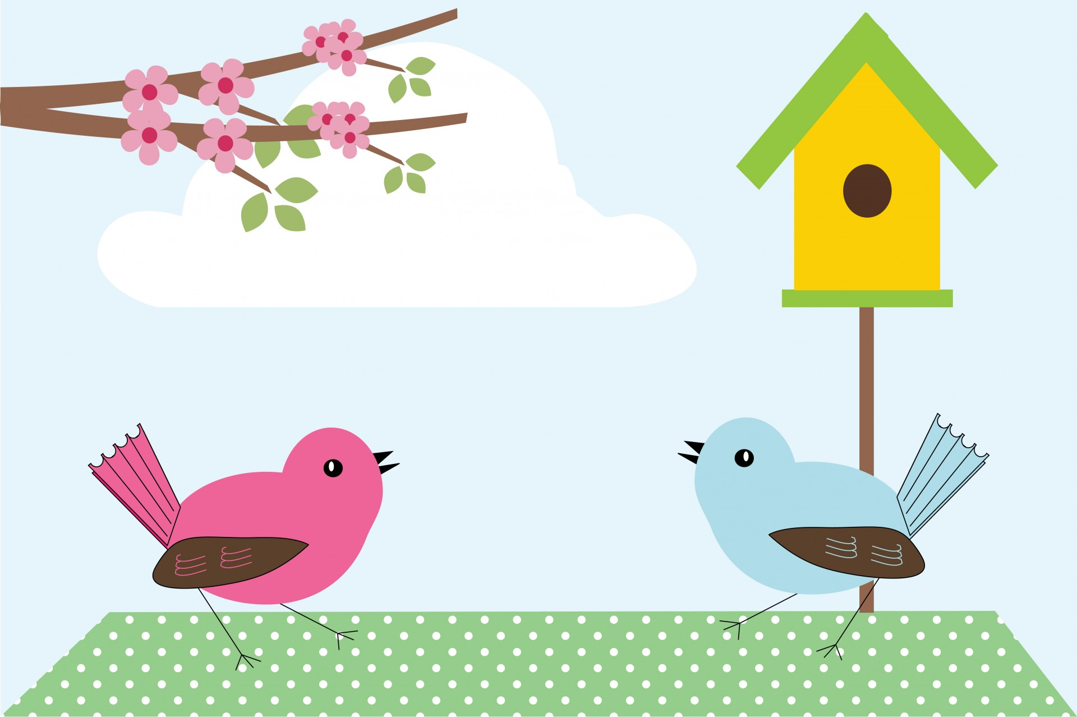
 | 26 |  | 27 | 28 | 29 | 30 | 31 | 1
Lakes |  |  | Lower Sooke River | Thetis Lake Trail | Glen Lake Water Park | Butchart Gardens $3 | Langford Lake  Water Park

