[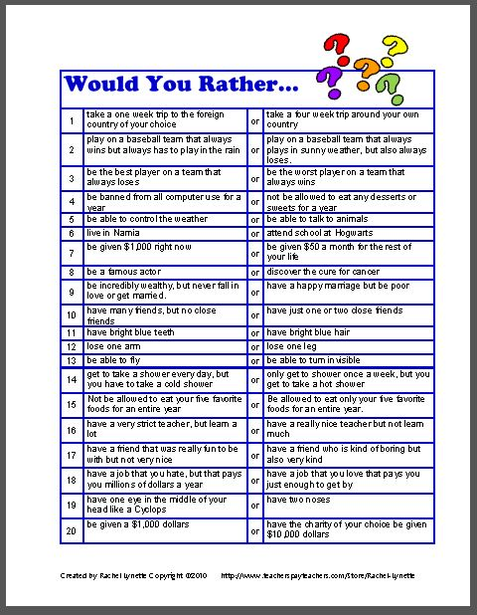](http://www.teacherspayteachers.com/Product/FREE-Would-You-Rather-Questions-for-Kids)