1. Click on the student’s black chicklet.
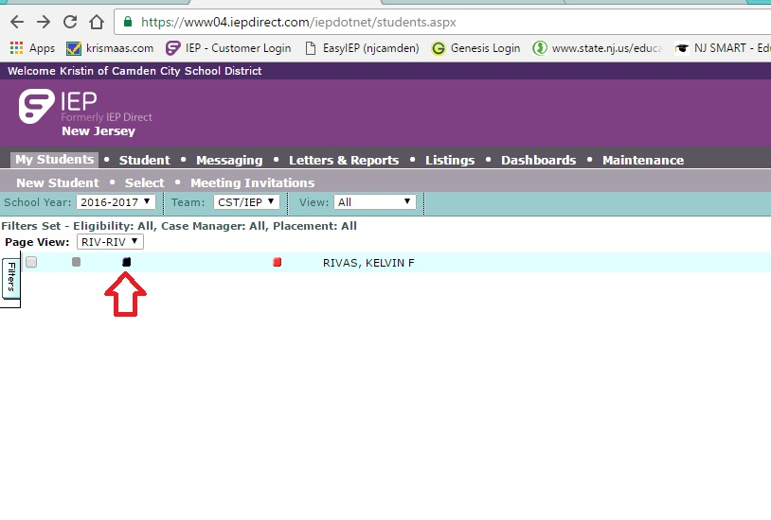

2. Scroll down to Status for the Duration of the Plan. Click the pencil.
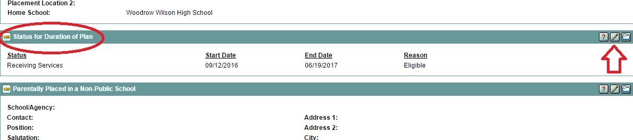

3. Choose “YES” you want to edit the document.
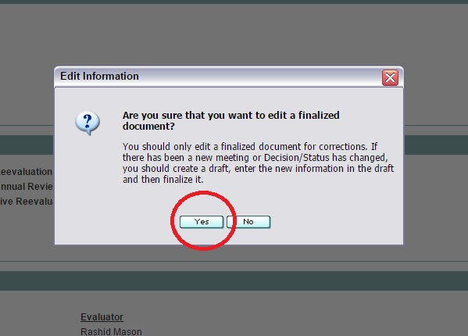

4. Click the “Add” button.
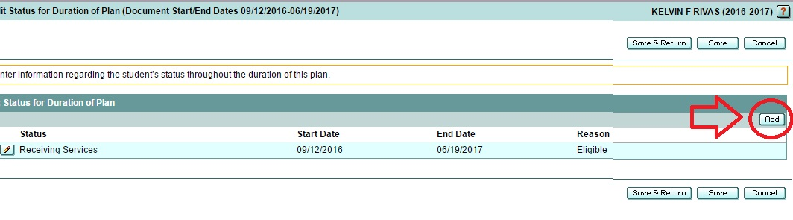

5. Choose “Exited” if the student has left the district, or whatever is the correct status for the student.
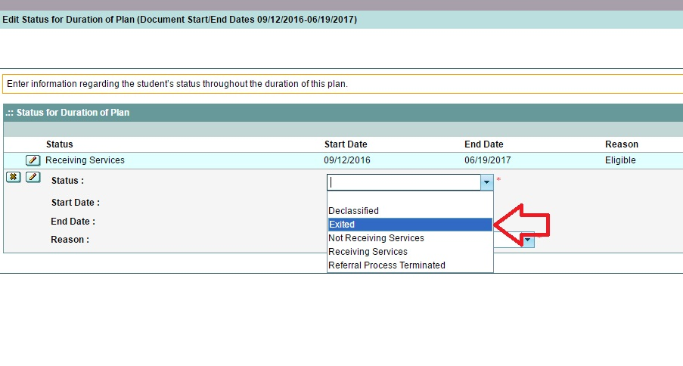
6. Enter the date the student exited and the reason. Check Genesis for this information.
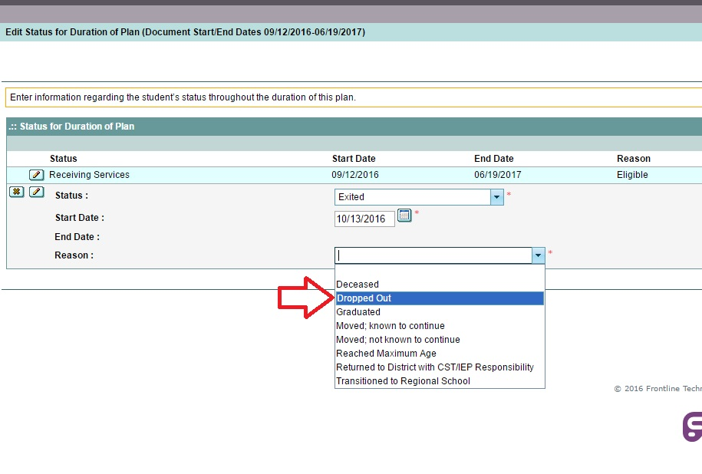
7. Click Save & Continue

8. Go to Process Tracking.
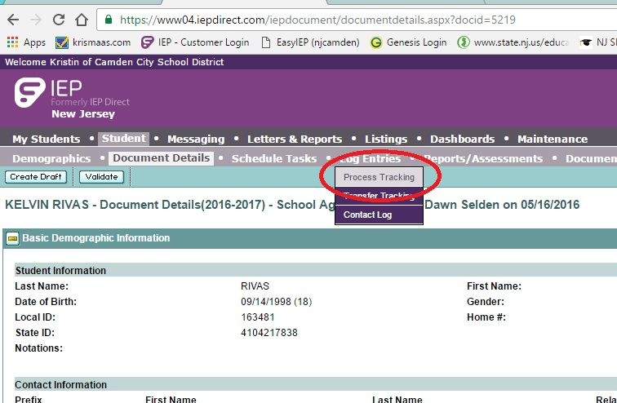

9. Choose NO for Meeting Agreement. For New Action Type choose “Student Exited.”
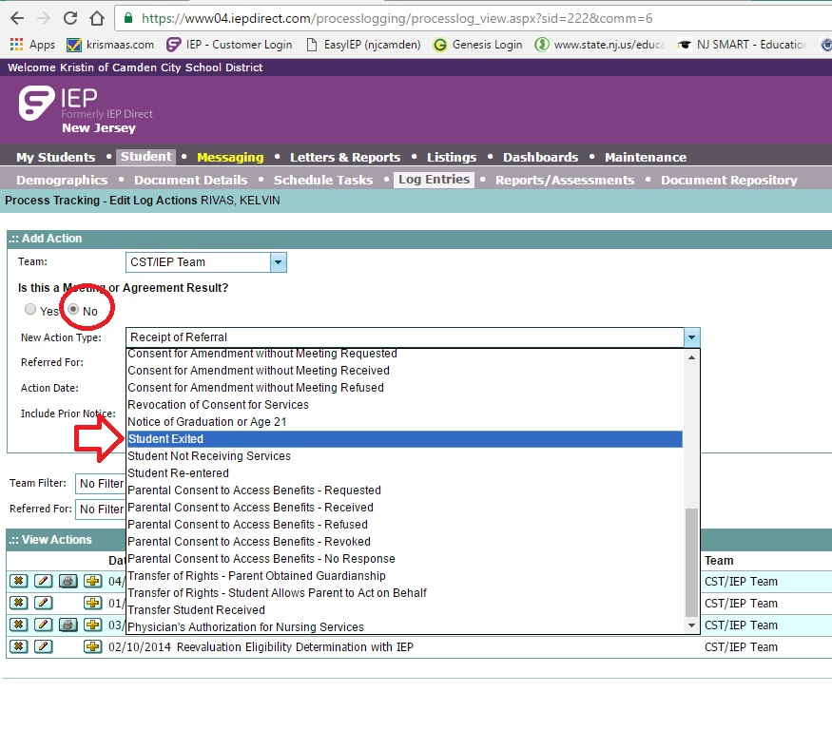

10. Fill in the date, click the “Add” button, and then save.
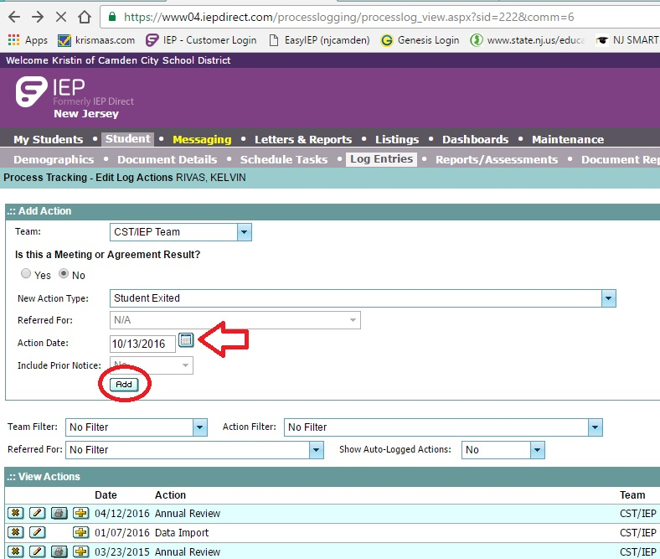

11. Search for the student again in My Students. His name should now be grey.
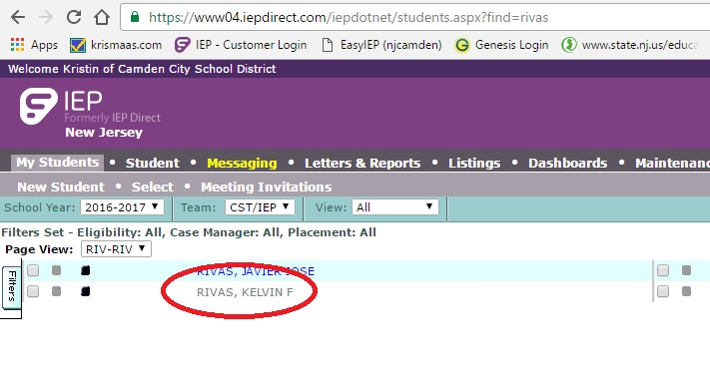
Troubleshooting: If the student’s name is not grey, check Status for the Duration of the Plan again. If the student’s Exit date is before his Receiving Services date, then on the RS date, the system will make him active again.
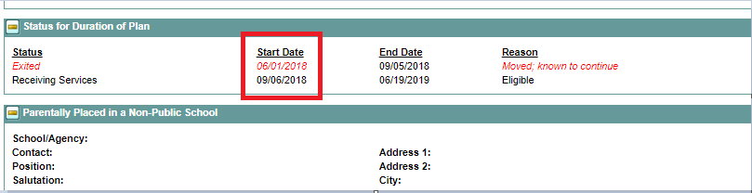
To correct this, delete the “Receiving Services” entry from Status for the Duration of the Plan.

