Indiana School Social Work Association’s

Eighteenth Annual Fall Conference

Reconnecting: Getting Back to Basics
Friday, November 7th, 2014
Conner Prairie Interactive History Park
13400 Allisonville Road
Fishers, IN 46038

6 CEUs available

Reconnecting: Getting Back to Basics

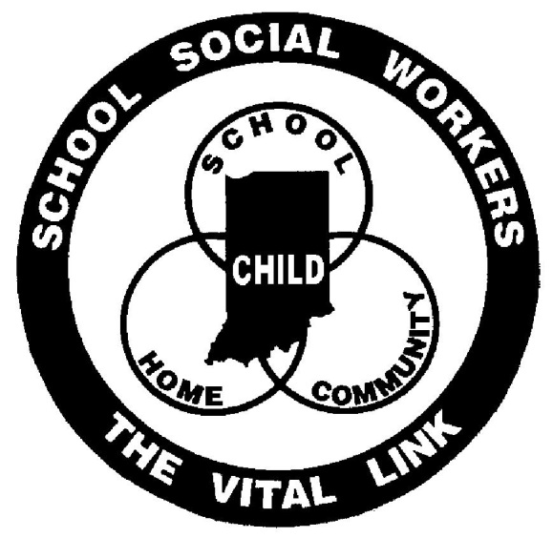

Agenda
Registration 7:30-8:30

Keynote Speaker 8:30-10:00

Workshop Session I 10:15-11:30

Lunch and Business Meeting 11:45-1:15

Workshop Session II 1:30-2:45

Workshop Session III 3:00-4:15

*This will be a “green” conference. Handouts will be available as they are received starting two weeks in advance at www.insswa.org.
Please download or print the handouts you would like.*

For more information or questions, contact Patrice Uminski at puminski@yahoo.com.

Keynote Presentation
Ostracism: Effects of Being Ignored and Excluded
Kipling D. Williams
Ostracism—being ignored and excluded—is a method of social control and punishment that exists in all social animals. Experience and threat of ostracism is thought to be one of the primary means to ensure civility, communal action, and cooperation. Burdensome members are ostracized resulting in corrected behaviors or permanent removal from the group; either result serving to strengthen the group. The effect of ostracism on the individual plays out in three temporal stages, the first two of which are: (1) reflexive, in which the target of ostracism detects ostracism, feels pain, threat to fundamental needs, and negative affect, and (2) reflective, in which targets make sense of the ostracism experience filtered through the context and their individual differences. This sense-making process results affects the speed of recovery, and the method by which the individual chooses to cope with it. Coping efforts are aimed at fortifying one or more of the threatened needs (belonging, self-esteem, control, and meaningful existence). Individuals who suffer long term exposure to ostracism enter a third stage, resignation, in which their desire and ability to fortify thwarted needs is depleted, thrusting them into states of despair, alienation, depression, and helplessness. Preventing entrance into the resignation stage is the focus of current research aimed at speeding recovery and directing the individual to effective functional coping responses.

Kipling Williams is Professor of Psychological Sciences at Purdue University, where he has taught since 2004. He earned his B.S. from the University of Washington—Seattle (1975) and his PhD in Social Psychology at The Ohio State University (1981). Prior to coming to Purdue, Williams was on faculties at Macquarie University and University of New South Wales (both in Sydney, Australia), University of Toledo (Ohio), and Drake University (Iowa). He is a pioneer and world-leading expert on social and psychological dynamics of ostracism. In addition to his authored book, Ostracism: The Power of Silence, he has edited nine books, including The Social Outcast, and the soon-to-be-published Handbook of Ostracism, Exclusion, and Rejection. He has been an associate editor of Group Dynamics: Theory, Research, & Practice, as well as Personality and Social Psychology Bulletin, and Journal of Experimental Social Psychology, and is currently the editor of Social Influence. Since 2003, he has taught an annual one-week intensive course on Ostracism at the Free University-Amsterdam and has also conducted ostracism workshops in Switzerland, Germany, Hong Kong, and Australia.

His research interests include ostracism, social influence, and motivation in groups. He has published over 140 articles and chapters, with articles in Science, Scientific American-MIND, Psychological Science, and other top journals in the field of social psychology. The Australian Research Council and the National Science Foundation have funded his research. In 2012, he was a Lorentz Fellow of the Netherlands Institute for Advanced Studies. He was a co-winner of the American Association for the Advancement of Science Socio-Psychological (AAAS), and Purdue University’s College of Health and Human Sciences Research Achievement Award (2011) and the College of Health and Human Sciences Faculty Engagement Award (2014). He is past president of the Society for Australasian Social Psychologists and the Midwestern Psychological Association.

Session I: 10:15-11:30

- Ethics
Speakers: Terry Miller, LCSW School Social Worker, Greenfield-Central Schools
Michael Williams, LCSW Social Worker/Behavior Therapist, Indianapolis Public Schools
While the NASW Code of Ethics is the primary source of ethical guidance for all social workers, it has long been recognized that the Code does not address some issues of significant importance to school social workers. To help meet the needs of those in the profession, the National Association of Social Workers, the School Social Work Association of America, and the Midwest Council of School Social Work have all developed additional supplemental ethical guidelines that are specific to school social work practice. The work of these three professional organizations will be shared and will include: The Use of Technology in School Social Work practice, Student Autonomy and Parental Involvement, Confidentiality, Consent for Services, Knowledge of Laws and Policy, and Evidence-Based Practices.

- Attachment: School Social Workers Supporting Adoptive Families
Speaker: Anne Johnson, MSW, LCSW School Social Worker, Catholic Charities
Attendees of this workshop can expect to learn about the attachment process as well as issues that may arise when students lack secure, healthy attachments to caregivers. While the content of this presentation is focused on attachment through adoption, school social workers are challenged to consider how an Attachment Framework might also apply to students who have experienced early neglect (in the absence of adoption). Attendees can expect to leave this workshop with strategies for assisting parents and educators, a list of resources surrounding attachment disorders, and instructions on helping parents connect with appropriate mental health professionals. This workshop is designed for those working in a K-12 setting.

- Service Providers Hope: Connecting to Purpose and Increasing Positive Outcomes for Clients
Speaker: Destinee Floyd, LCSW, PhD Student Program Manager, Community Health Network.
Parents of children with emotional disabilities face many challenges including: feelings of blame, increased rates of poverty, increased rates of single parent households, and having to navigate educational and mental health systems (Freedmond, 1999). With the various challenges that these families are exposed to, it can often be challenging for service providers to maintain hope and observe progress when working with these families. The purpose of this workshop is to educate service providers on the importance of maintaining hope while working with families who have intensive needs, and provide skills on how to increase hope and measure outcomes. This workshop is designed for those working in a K-12 setting.

Session II: 1:30-2:45

- Reducing Homophobia and Transphobia in K-12, Part One
Speaker: Graham Brinklow, BA Education Outreach Coordinator, Indiana Youth Group
This is part one of a two part session. Part two will be offered at 3:00pm.
This workshop, presented by Indiana Youth Group, explains how to reduce phobias in schools around LGBTQ students and families for ALL age levels, and why it’s so important. We also discuss effects of family support and rejections, and why there is a disproportionate amount of youth in the foster care and juvenile justice systems. Using real scenarios, attendees also learn what they can do to help LGBTQ clients feel welcomed and safe, while balancing their cultural, religious, and moral backgrounds with their professional obligations. This workshop is designed for those working in a K-12 setting.

- The Opioid/Opiate Epidemic
Speakers: Kimberly Kelsay, BS, School Safety Specialist School Liaison Officer, IMPD
Dave Spurgeon Patrol/Detective, IMPD
This workshop will contain information on the dangers of opiate based drugs and the relationship between opiate prescription medication and heroin. We are experiencing overdose deaths from this class of drug at an alarming rate in our city and nationwide. The presentation will help participants understand what the class of drug is and the dangers that are associated with it. We will also discuss how to empower youth to make the best choices. This workshop is designed for those working a 7-12 setting.

- Behavior 101
Speakers: Krista Fay, MSW, LCSW School Social Worker, Indianapolis Public Schools
Jennifer DeFelice, MSW, LCSW School Social Worker, Indianapolis Public Schools
This workshop is designed to get back to behavior basics. Participants will revisit the four functions of behavior, review multiple data collection methods and tools, and apply aligned interventions to extinguish problem behavior and teach matched replacement skills. There will also be a review of Dr. Laura Riffle’s data collection tool. This workshop is designed for those working in an elementary setting.

Session III: 3:00-4:15

- Reducing Homophobia and Transphobia in K-12, Part Two
Speaker: Graham Brinklow, BA Education Outreach Coordinator, Indiana Youth Group
This is part two of a two part session.
This workshop, presented by Indiana Youth Group, explains how to reduce phobias in schools around LGBTQ students and families for ALL age levels, and why it’s so important. We also discuss effects of family support and rejections, and why there is a disproportionate amount of youth in the foster care and juvenile justice systems. Using real scenarios, attendees also learn what they can do to help LGBTQ clients feel welcomed and safe, while balancing their cultural, religious, and moral backgrounds with their professional obligations. This workshop is designed for those working in a K-12 setting.

- A Tale of Two Disciplines: The School Worker Coach or The Coaching Social Worker
Speaker: Kelli Mondadero, MSW, LSW Therapist, Indianapolis Public Schools
In this workshop, participants will gain knowledge of ways to implement social work strategies into athletic practices and competition. Participants will develop skills to determine the best time and scenario to use each strategy and expand their knowledge of basic interventions of social work. A holistic approach to student engagement and participation will be discussed in order to gain a further understanding. This workshop is designed for those working in a 7-12 setting.

- Making It Real: Helping Legislators Understand What Students and Schools Really Need
Speakers: Mindi Goodpaster, MSW Director, Public Policy & Advocacy, MCCOY
John Brandon President and Executive Director, MCCOY
This presentation will introduce attendees to the Marion County Commission on Youth, Inc. (MCCOY), a non-profit intermediary organization serving central Indiana youth and youth development professionals. MCCOY staff will discuss their role in creating beneficial policies for youth and families at the local, state and national levels and give examples of how school social workers can influences policy decisions and help policy makers understand how to create policies that meet genuine needs. The objectives of this presentation are: to provide an understanding of the state’s legislative process, to provide an update of recent enacted laws that affect schools and students, and to provide tools to help school social workers become strong advocates for their students and schools. This workshop is designed for those working in a K-12 setting.

Conference Location and Lodging
Conner Prairie Interactive History Park
13400 Allisonville Road Fishers, IN 46038

Directions:
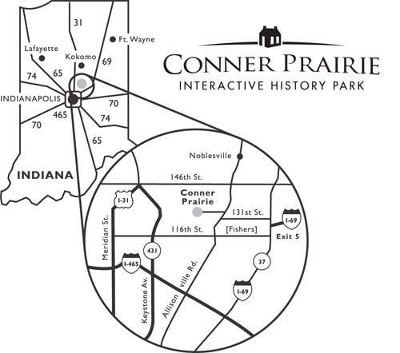
Conner Prairie is located in Fishers, Ind., about 25 minutes north of Indianapolis on Allisonville Road (exit 5 from Interstate 69). Welcome Center parking is free.
Shopping

The Conner Prairie Store and the Depot Store
Take home a taste of Conner Prairie, shop for unique gifts and browse books, games, toys, Prairie clothing and so much more. The Conner Prairie Store offers a local shopping experience where you can find old-time candy, locally-made preserves, retro games, and jewelry too. The store is located in the Welcome Center and no admission is required to shop.

The Self Esteem Shop/Conference Bookstore
Browse the selection of books and practice materials in the lobby conference area.

ACCOMODATIONS NEAR CONNER PRAIRIE

Prairie Guest House 13805 Allisonville Road. Fishers, IN, 46038 stay@prairieguesthouse.com 317.663.8728

Hampton Inn and Suites Indianapolis-Fishers

11575 Commercial Drive, Fishers 46038 317.913.0300

Comfort Suites Fishers 9760 Crosspoint Boulevard, Indianapolis 46256 317.578.1200

Staybridge Suites 9780 Crosspoint Boulevard., Indianapolis 46256 317.577.9500

Residence Inn 9765 Crosspoint Boulevard, Indianapolis, Indiana 46256 317.842.1111

****************************
Indiana School Social Work Association Membership
To qualify for INSSWA member rates for the Annual Fall Conference, your membership must be renewed up to date. The due date for renewal was August 31st, 2014. The yearly INSSWA membership fee is $60. Those qualified individuals who pay the non-member rate to attend the conference will receive a year’s membership with their conference registration, if desired. For information about becoming an INSSWA member, please email Jennifer DeFelice (jlmccune@alumni.iu.edu)

Registration Form
Deadline for registration: October 31st, 2014
Registration fee includes general session, workshops, lunch and snacks.
Please circle your registration rate.
Early Bird Regular
Postmarked by Postmarked after
10/17/14 10/17/14
INSSWA Member $90 $120

Retiree Member $60 $90

MSW Student Member $60 $90
(Membership dues paid)

MSW Student Non-member $95 $125
(Includes membership)

Non-member $150 $180
(Or if not renewed by Aug. 31st)

Make checks payable to: INSSWA
Mail registration to: INSSWA, P.O. Box 36826, Indianapolis, IN 46236

Cancellation Policy: After October 31st, 2014, no refunds given for cancellations
Important: If you are paying with a Purchase Order, please mail a copy of your registration form to the above INSSWA address with the Purchase Order or a letter (on letterhead) from the business office stating intent to pay with Purchase Order. At the time of the conference, we must have a copy of the Purchase Order or Letter of Intent in order for you to attend. School districts can email the PO or letter of intent to hudginsm@myips.org. Unpaid Purchase Orders will become the responsibility of the participant on February 1, 2015.

Name__________________________________________________________________________________

Address________________________________________________________________________________

City _____________________________________________ State __________ Zip ___________________

Phone ( ) ____________________ Preferred email ___________________________________________

Degree: MSW ______ BSW ______ Other (specify) __________________________________________

Job Title/Description: _____________________________________________________________________

1st Choice 2nd Choice
Workshop Session I ______ ______

Workshop Session II ______ ______

Workshop Session III ______ ______

I am willing to be a moderator: ______

I paid the non-member rate and would like to become a member since it is included in that rate: __________

Pictures will be taken during conference activities. Please indicate by initialing if you DO NOT want your picture used by INSSWA. ________________

INSSWA
P.O. Box 36826
Indianapolis, IN 46236
www.insswa.org

