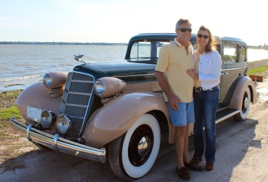
Real Restorations
By Pistorius Collectible Autos

We have been taking you through a process of restoration, step by step, from the cataloguing of the disassembly of your vehicle, to the video and photo documentation, and the sequential bagging and labeling of parts. We should be ready now to do some body work and prep for painting.
If you feel like this is out of your skillset, it’s time to find a reputable and skilled body man who will deliver on his promises, and on time. This is a critical issue among many restorations, as too often the attention to detail is lost at this very important juncture. Preparing your car before painting is the most important part of your restoration. This is when you fix your metal, remove old bondo, straighten your lines, and repair your dents.
Depending on your car’s condition, the first job is to get rid of all evidence of rust, which may include cutting out metal, including the running boards. With severe rust and pitted areas, you may need to sandblast to get back to rust free metal. Don’t forget to apply a rust prohibitory product before the day is over.
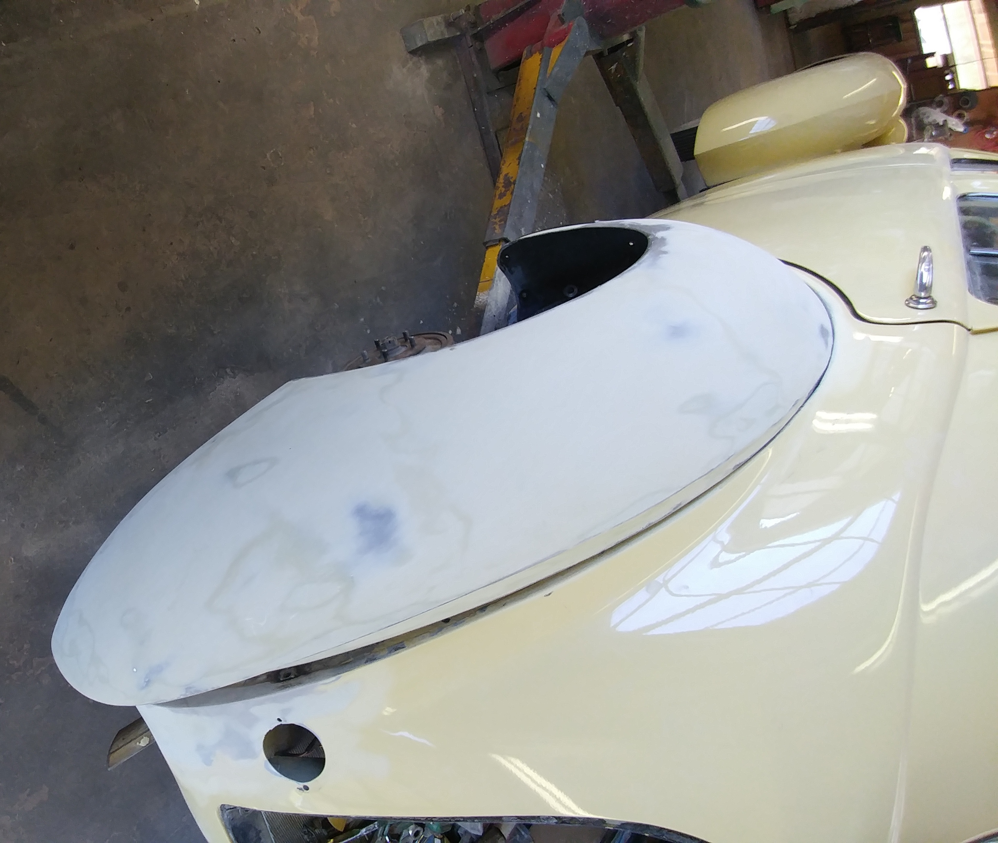
Depending on the type of metal you are working with, steel or aluminum, you must apply the correct adhesive materials before applying new bondo and/or primer paint.
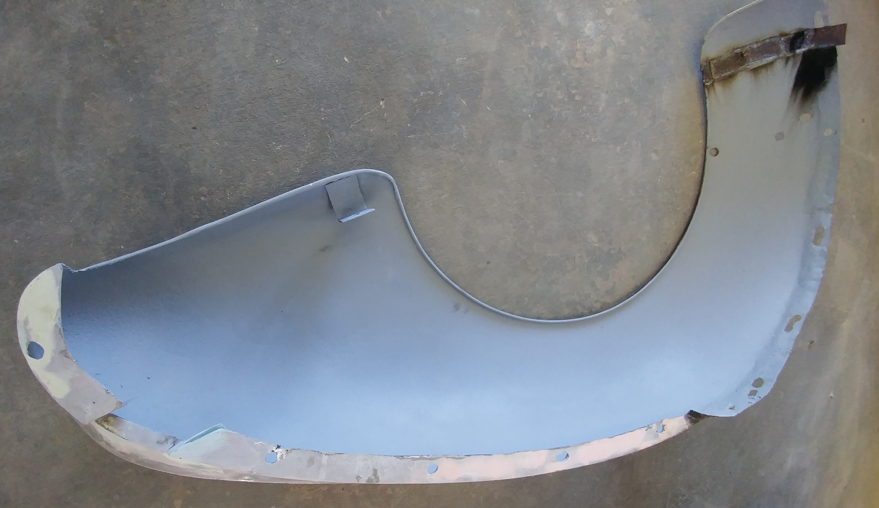
In the case of the 1941 Hupmobile that we are now restoring in our shop, this car came with fiberglass rear fenders, which is of course incorrect for the period. Luckily, the owner had already acquired 2 metal fenders to furnish to us. We are actively repairing the metal with the absolute minimum amount of bondo, something that should never be used in a thickness more than a matchstick!
Next time we will discuss how to fix the lines on your car.
Cheers!
Brando & Joanne Pistorius

