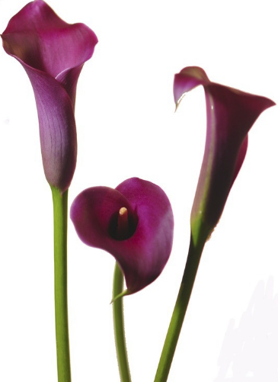

Antipasti

Parmigiana Pan seared zucchini & eggplant, tomato basil, mozzarella. 11

Calamari Fritti Crispy tender fried squid, Chef Nicola’s spicy tomato sauce. 13

**Tartare di Tonno** Yellow fin tuna, melon, Tuscan crisps, garden mint. EVOO. 13

**Antipasto Toscano** Tasting of Nicola’s Artisan Cured Italian Meats & Traditional Tuscan Pate.14

Mozzarella Capresse Classic Capresse, basil and our balsamic reduction.11

Zuppe e Insalate

Cesarina Romaine, Parmesan, classic caesar dressing, golden baked breadcrumbs, egg. 9

Arugula Baby arugula, gorgonzola, roasted fennel, walnuts, prosecco honey vinaigrette.10

**Zuppa Di Giorno** Chef Nicola’s chicken & garden vegetable. 8

Pasta ~ Carne ~ Pesce

**Gamberi alla Pavarotti** Jumbo tiger shrimp, lump crab, Parmesan, mozzarella, capellini al pesto. 34

Ravioli Quattro Formaggi House made four cheese ravioli, tomato basil. 19

Osso buco di Agnello Lamb shank braised in Chianti wine, rosemary roasted potatoes & sautéed green beans. 30

**Braciola di Pollo** Chicken breast rolled with pistachio, asparagus & Mortadella, Florentine style vegetables. 29

**Cernia alla Putanescca** Filet of grouper, grape tomatoes, carpers & olives, three color cous cous stuffed bell pepper. 34

**Fettuccini alla Pescatora** Homemade fettuccini, seafood medley, tomato basil. 33

Filetto Toscano Tuscan- style tenderloin filet, dolce forte reduction, roasted potatoes & asparagus. 39

For Younger Guests 10

Ravioli Quatro Formaggi

Pollo Parmesana & potatoes

This is the only menu we will be serving for the day along with our wine & cocktail menu. For your convenience, a 20% gratuity will be added to the check. All reservations will be confirmed by phone. If the restaurant cannot reach you by phone, we cannot hold the reservation.

Happy

Mothers

Day