Moss Hall Nursery School
Information about your child’s end of year report.
We do hope you have enjoyed reading your child’s annual school report. Your child’s key person has enjoyed writing them as it summarises their achievements while attending the nursery school.
You will have received two sheets that are summative assessments of your child’s attainment and progress.
Sheet 1 summarises your child’s Characteristics of Effective Learning and is illustrated with four snap shot pictures. At the end of the year you will also receive your child’s nursery book with more wonderful photographs of your child’s learning journey.
Sheet 2 summarises your child’s learning over the last three terms. The tracker is split into three sections
- Wellbeing and Involvement
- Characteristics of Effective Learning
- Areas of Learning
Understanding your child’s annual report?
Your child has been assessed at four points this academic year.
- Four weeks after they started (end of September/early October)
- At the end of the Autumn term
- At the end of the Spring term
- At the end of the Summer term
There progress is noted in the four colours as above. The score for the end of each assessment can be seen at the end of the tracker and gives each age range a score for the milestone.
The end of year cumulative score will be in Blue.

Well being and Involvement
They are assessed as being Low, Medium or High for Well Being and Involvement
Characteristic of Effective Learning
They are assessed for each Characteristic of Effective Learning
Curiosity/ Representing Experiences / Taking Risks / Concentration / Persistence / Sense of Achievement / Having Own Ideas Making Links / Reviewing
For more information about the Characteristics of Effective Learning look at the curriculum pages of our website.
Areas of Learning
Children are then assessed in broad 6 monthly developmental milestones
- Personal, Social and Emotional Development
- Communication and Language
- Physical Development
- Literacy
- Maths
- Understanding of the World
- Expressive Art and Design
The large wide black bands denote the child’s current age band and shows if they are achieving the current milestone. Children who are typically developing will be expected to reach these milestones.
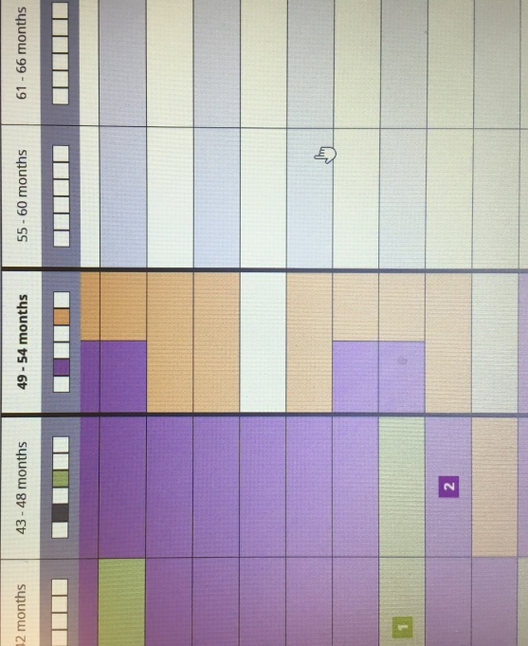
Children learn in different ways and at different times. All children are unique and different and so all children will not meet all the milestones.

